2016

CoderDojo

4/29/2016

Hangman door NeoMC

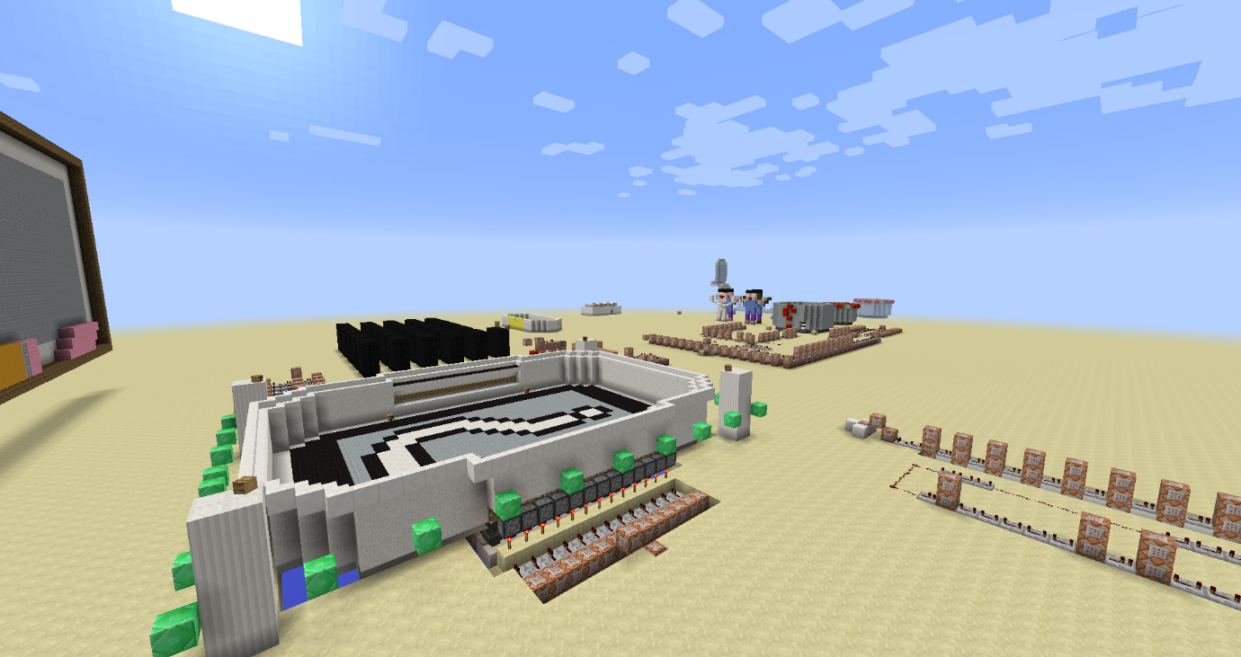

# Index

Contents

Index 1

Inleiding 2

Conventies 3

Onze eerste stappen 4

De ontvangstruimte. 4

Het pad van de woordenmaker 7

Wachtruimte voor de woordmaker 7

De ruimte waar het woord wordt gemaakt. 11

De Speelruimte 13

Het pad van de gisser. 14

De Speelruimte 17

Initialisatie van het spel 18

Initialisatie circuit 18

Eerste deel van het circuit 19

Tweede deel van het circuit 22

Derde deel van het circuit 25

De tikkende toren 27

Appendix A: Tell Raw/Tittle/Subtittle/Sign/Book het json formaat 30

Kleur 53

Vette tekst 53

Schuine tekst 53

Onderstrepen van tekst 53

Doorstrepen van tekst 53

Obfuscatie 53

Appendix B Block ID’s 55

# Inleiding

Welkom bij galgje (Hangman). Deze map is gemaakt door NeoMC. We zullen deze map gebruiken om stap voor stap het spel galgje te maken.

Men kan deze opdracht alleen of met 2 doen.

Naast de map Hangman is er ook een leerwereld. Hierin zijn bepaalde zaken uit de wereld.

Alle commando’s en blokken die moeten geplaatst worden zullen in dit document staan.

De commandos zullen via een pseudo taal vermeld staan.

Voor de coaches is er een afzonderlijke document met alle antwoorden in.

## Conventies

Hieronder vind u een aantal conventies terug.

Tekst op deze manier weergegeven toont de verschillende mogelijkheden van een commando in minecraft

<x> <y> <z> : coördinaten binnen de minecraft wereld

[<rot-x> <rot-y>]: optionele commando’s worden

[Tekst]: woorden in het commando die vervangen moeten worden.

Waardoor mende tekst moeten vervangen zal bij elke eerste gebruik van een commando uitgelegd staan.

***Doel***. Een doel, team naam,… wordt op deze manier weergegeven. Belangrijk is dat men het woord op dezelfde manier ingeeft als heet in het document staat. Dit wil zeggen inclusief de hoofdletters. Doel is niet hetzelfde als doel in minecraft.

De opdrachten worden in de vorm van pseudo taal weergegeven om de speler te helpen worden de woorden waar aan men aandacht moet geven schuin weergegeven.

VB:

* **Verplaats** de **dichtstbijzijnde speler** naar de volgende **coördinaten**

|  |  |
| --- | --- |
| X | 1052 |
| Y | 6 |
| Z | -91 |

Hieruit kunnen we afleiden dat we een teleporteer commando moeten uitvoeren op de dichtstbijzijnde speler.

* /TP @P 1052 6 -91

Commando’s die men rechtstreeks kan invoeren in de commando blok worden als volgt weergegeven.

/tellraw @a {"text":"","extra":[{"text":"[Hangman] ","color":"gold","bold":"true"},{"selector":"@p","color":"red"},{"text":" is ready to begin!","color":"dark_green"}]}

# Onze eerste stappen

## De ontvangstruimte.

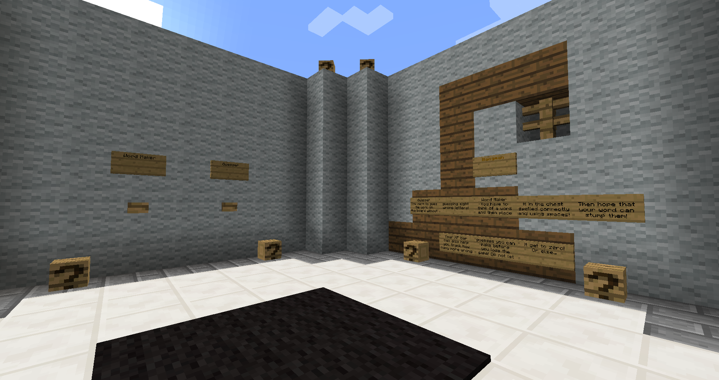

Wanneer we ons aanmelden op de map worden we gedropt in de ontvangstruimte. Hier kiezen de spelers welke functie ze willen uitvoeren in een partijtje galgje.

Aan de muur voor ons zien we 2 knoppen hangen. Elke knop moet de dichtstbijzijnde speler naar een andere locatie van de map zenden

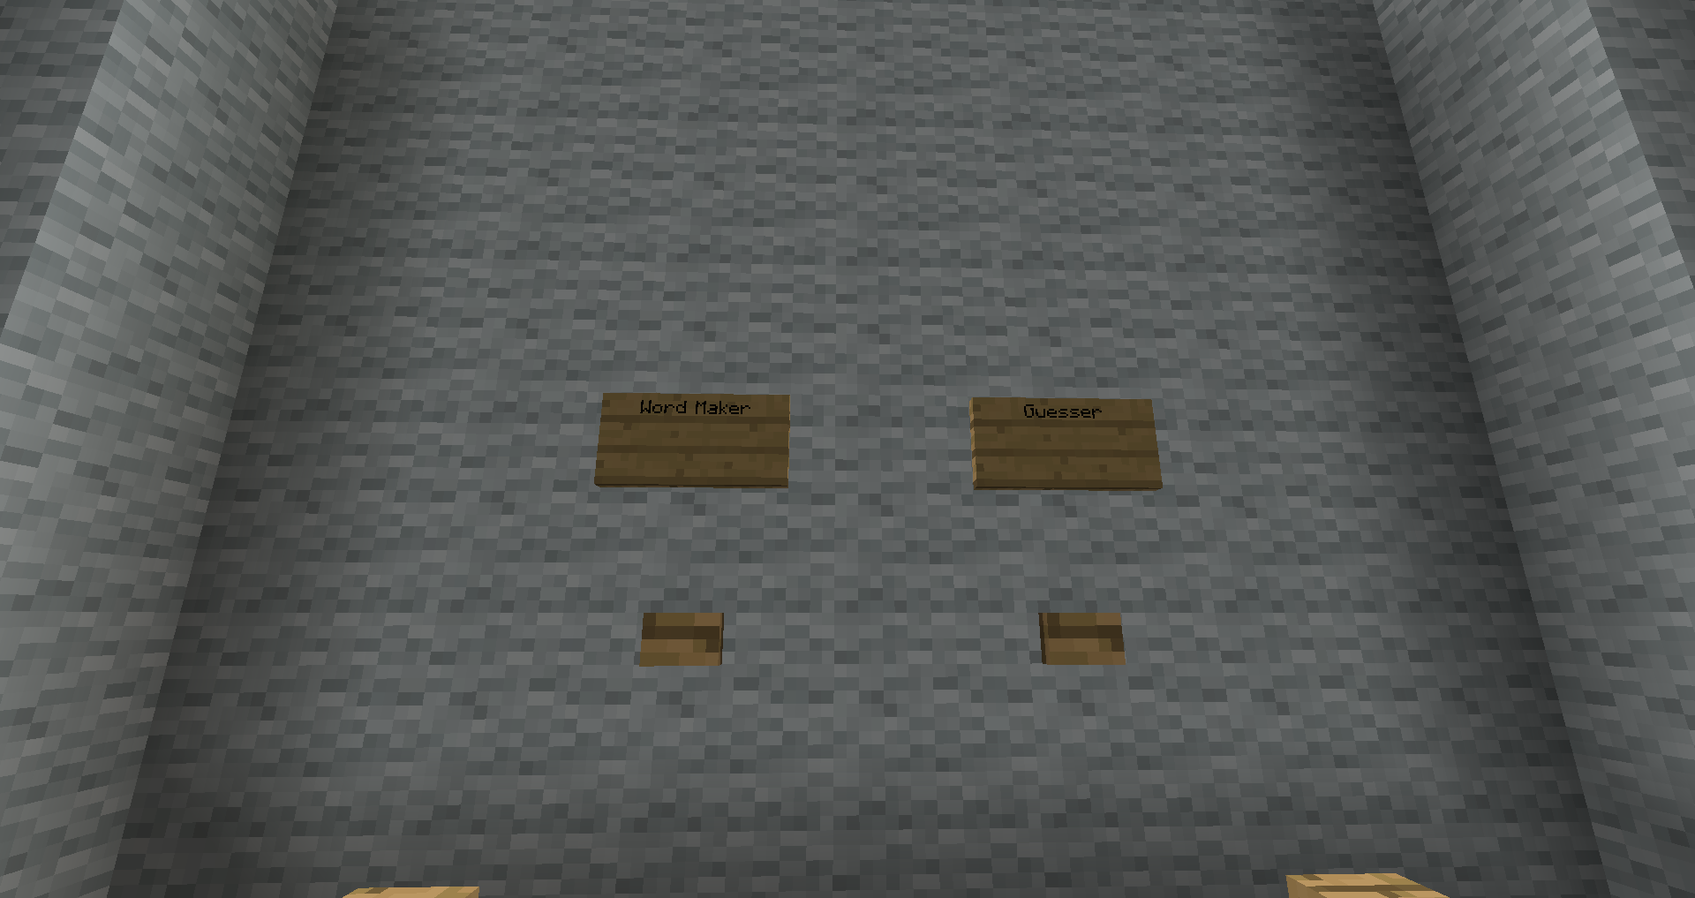

Opdracht 1.

Voorzie de knoppen van een commando block met teleportatie mogelijkheid.

Voor uw gemak zijn er een paar doorgangen gemaakt

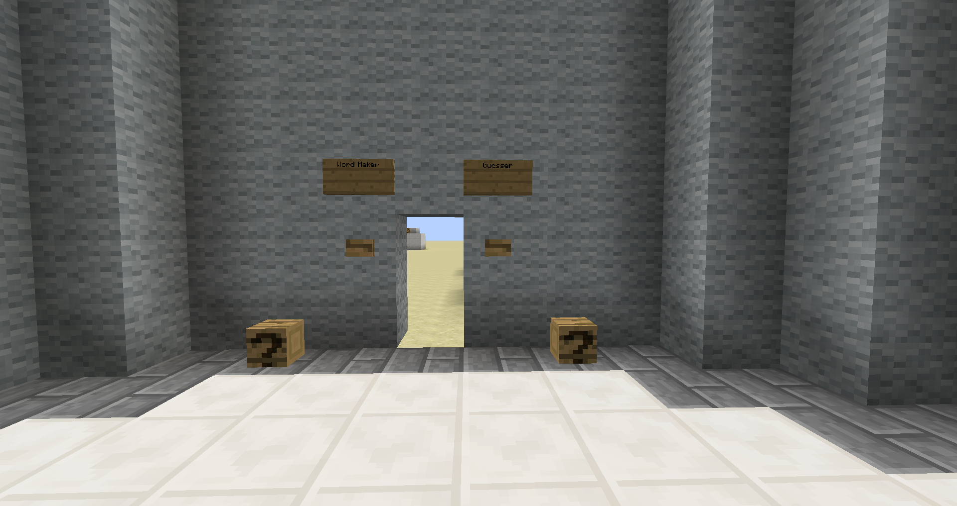

Plaats achter elke knop een commando blok.

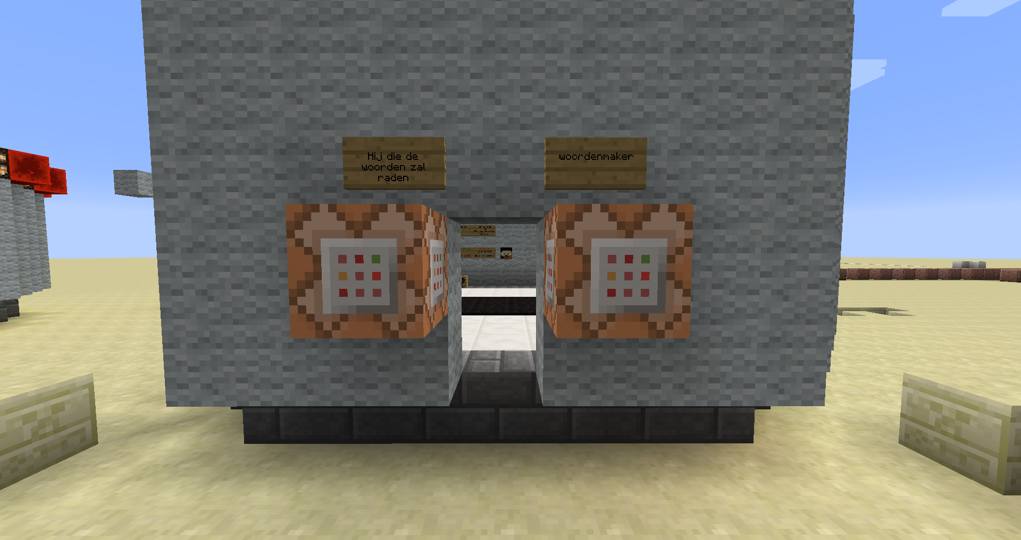

En voeg aan elke commando blok het teleportatie commando toe.

Opmaak teleportatie commando:

/tp [speler 1] [speler 2]

/tp [speler 1] <x> <y> <z> [<rot-x> <rot-y>]

/tp [selector] [speler 2]

/tp [selector] <x> <y> <z>[<rot-x> <rot-y>]

Speler1: De speller die geteleporteerd zal worden. Men kan hier een selector gebruiken.

Speler2: de speler waarnaar speler 1 geteleporteerd wordt.

<x> <y> <z>: de coördinaten naar waar speler1 geteleporteerd zal worden

[<rot-x> <rot-y>]: optionele parameter waarmee men speler1 kan draaien

Selector: een shorthand voorzien door minecraft.

@p Dichtstbijzijnde speler

@r Willekeurige speler

@a Alle spelers

@e Alle entiteiten

Commando voor woordenmaker

* **Teleporteer** de **dichtstbijzijnde speler** naar de volgende **coördinaten**

|  |  |
| --- | --- |
| X | 1052 |
| Y | 6 |
| z | -91 |

Commando voor “hij die de worden zal raden”

* **Teleporteer** de **dichtstbijzijnde speler** naar de volgende **coördinaten**

|  |  |
| --- | --- |
| X | 1052 |
| Y | 6 |
| z | -62 |

Om verder te gaan moeten we twee paden bewandelen.:

* Het pad van de woordenmaker.
* Het pad van hij die de woorden zal raden.

# Het pad van de woordenmaker

## Wachtruimte voor de woordmaker

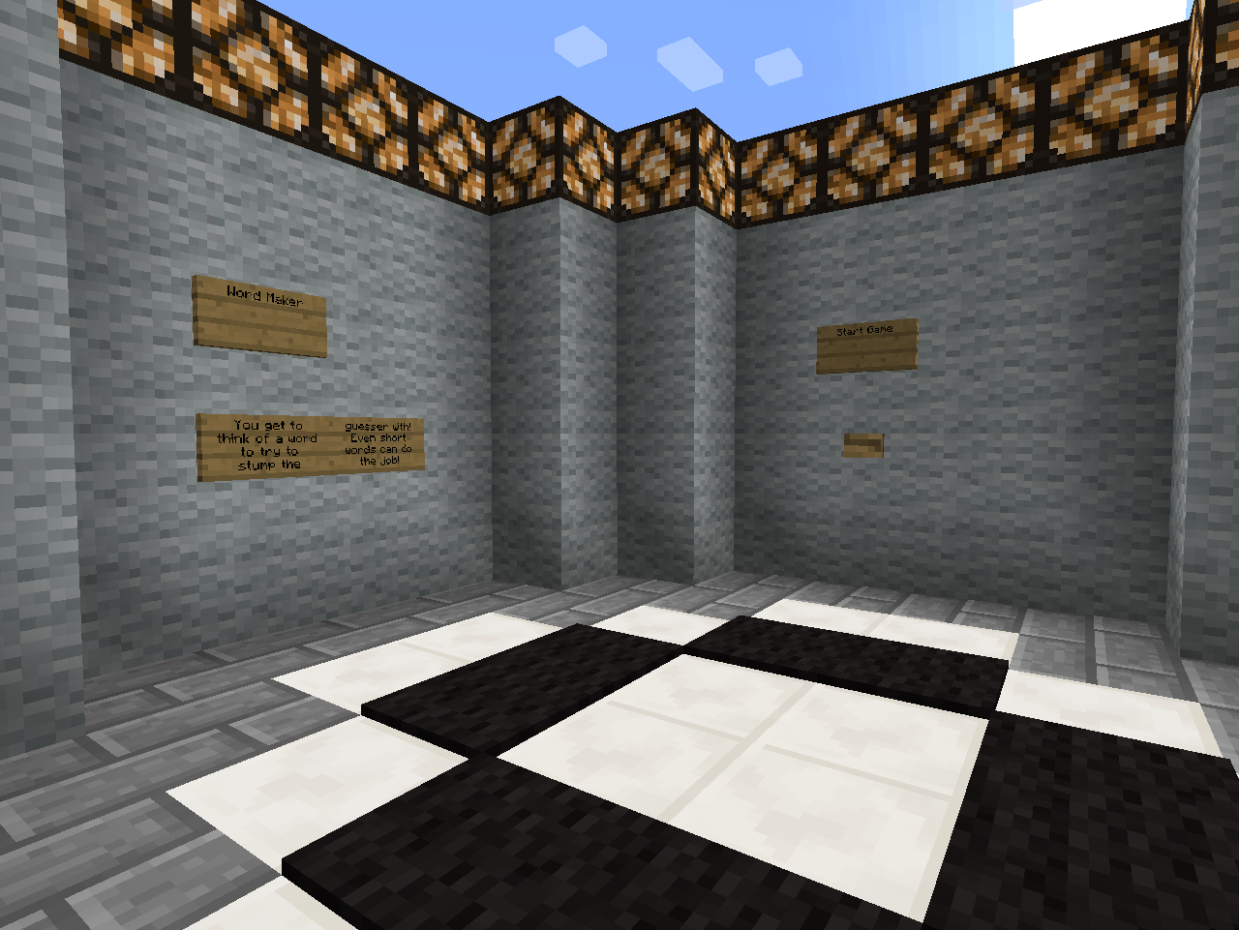

De woorden maker moet nu een woord bedenken van maximum 15 letters.

Eenmaal hij dit bedacht heeft kan hij op de knop start game klikken. Hierbij is het wachten tot de 2de speler “hij die de woorden zal raden” ook klaar is om te starten.

Opdracht 2

Maak de volgende opstelling.

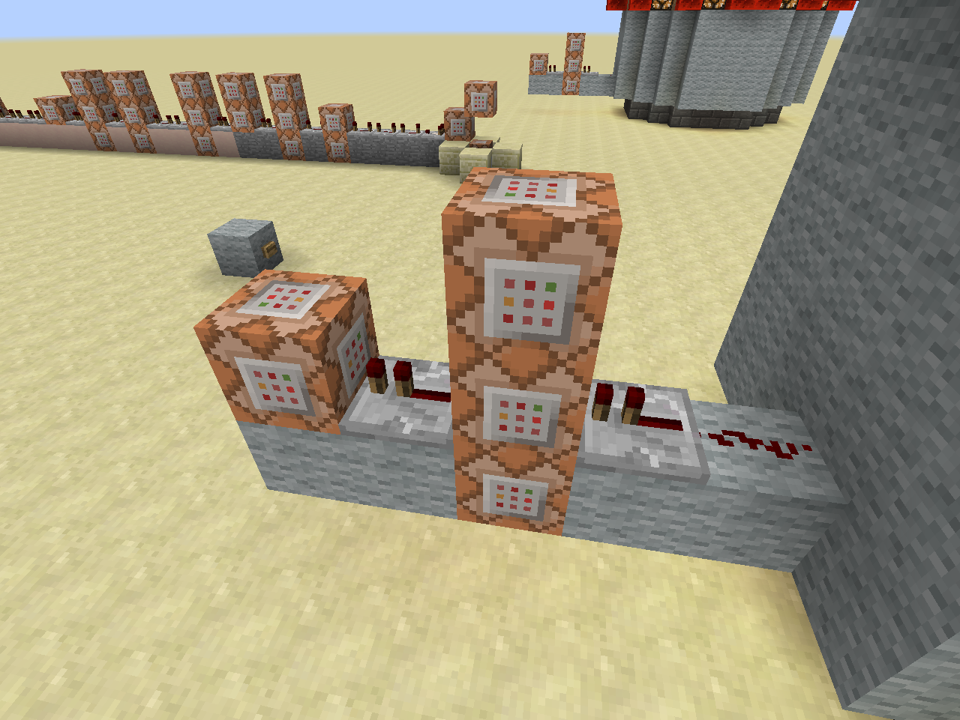

4

2

3

1

De drukknop op de muur zal via 1 redstone signaal naar een repeater gaan. Hierdoor voeren we eerst het commando van de middelste blok uit.

Eenmaal dit commando is uitgevoerd zullen de blokken onder en boven en de volgende blok hun commando’s uitvoeren. We gebruiken een overgang ’s repeater om het commando van de laatste blok niet meerdere keren uit te voeren.

Legende

|  |  |  |  |  |
| --- | --- | --- | --- | --- |
|  |  | C3 |  |  |
| C4 | R2 | C1 | R1 | RS1 |
| wol | wol | C2 | wol | Wol |

RS1: Redstone

R1 ,R2: repeaters:

1 Tick wachttijd

C1, C2, C3, C4: commando bokken

**C1:**

* Vertel het **scoreboard** dat **alle spelers** klaar zijn door het doel **Ready** met **één** te verhogen

/scoreboard players add <speler> <doel> <teller>

Speler: de naam van een speller of een van de selectors;

Doel: de naam van het doel

Teller: Met hoeveel moet de teller voor het doel optellen

**C2:**

* Vertel in het **chat venster** het bericht dat **de dichtstbijzijnde speler** klaar is om te beginnen

/tellraw <Speler> <raw json bericht>

Speler: de speller waarvoor het bericht is of een selector

raw json bericht: een manier waarop men een bericht kan opstellen, en kleuren zie volgende link voor alle mogelijk opties: <http://minecraft.gamepedia.com/Commands#Raw_JSON_text>. Zie de appendix voor een meer in detail uitleg.

Geef het volgende commando volledig in.

/tellraw @a {"text":"","extra":[{"text":"[Hangman] ","color":"gold","bold":"true"},{"selector":"@p","color":"red"},{"text":" is ready to begin!","color":"dark_green"}]}

Indien correct zien we volgende tekst

**[Hangman]** <speler> is ready to begin

**C3:**

* Vertel het **scoreboard** om de **dichtstbijzijnde speler** toe aan het **team *Maker***.

/scoreboard teams join <team> [speler(s)...]

Team: Naam van het team

Speler(s): de speler of spelers die men wil toevoegen. Om alle speler te selecteren kan “*” gebruiken.

**C4:**

* **Verwijder** de **drukknop** door deze te **vervangen** met een **luchtblok**.

Locatie van de drukknop

|  |  |
| --- | --- |
| X | 1055 |
| Y | 5 |
| z | -92 |

/setblock <x> <y> <z> <blok> [data] [oudeBlokAfhandeling]

<x> <y> <z>: de locatie waar men een block wil plaatsen.

Blok: de minecraft blok id naam. Informatie over de blok id’s vindt men in de appendix.

Data: waarde tussen 0 en 15. Indien niet nodig is deze 0.

oudeBlokAfhandeling: Wat te doen met de oude block. Vaste waarden binnen minecraft

Destroy: oude block wordt verwijderd net alsof het door een speler is verwijderd. Men hoort ook het blok breek geluid

Keep: enkel lucht blokken worden vervangen

Replace: de blok verdwijnt zonder een spoor na te laten.

Wol: wol blokken

## De ruimte waar het woord wordt gemaakt.

Deze ruimte vind je terug op coördinaten 1100, 3, -163.

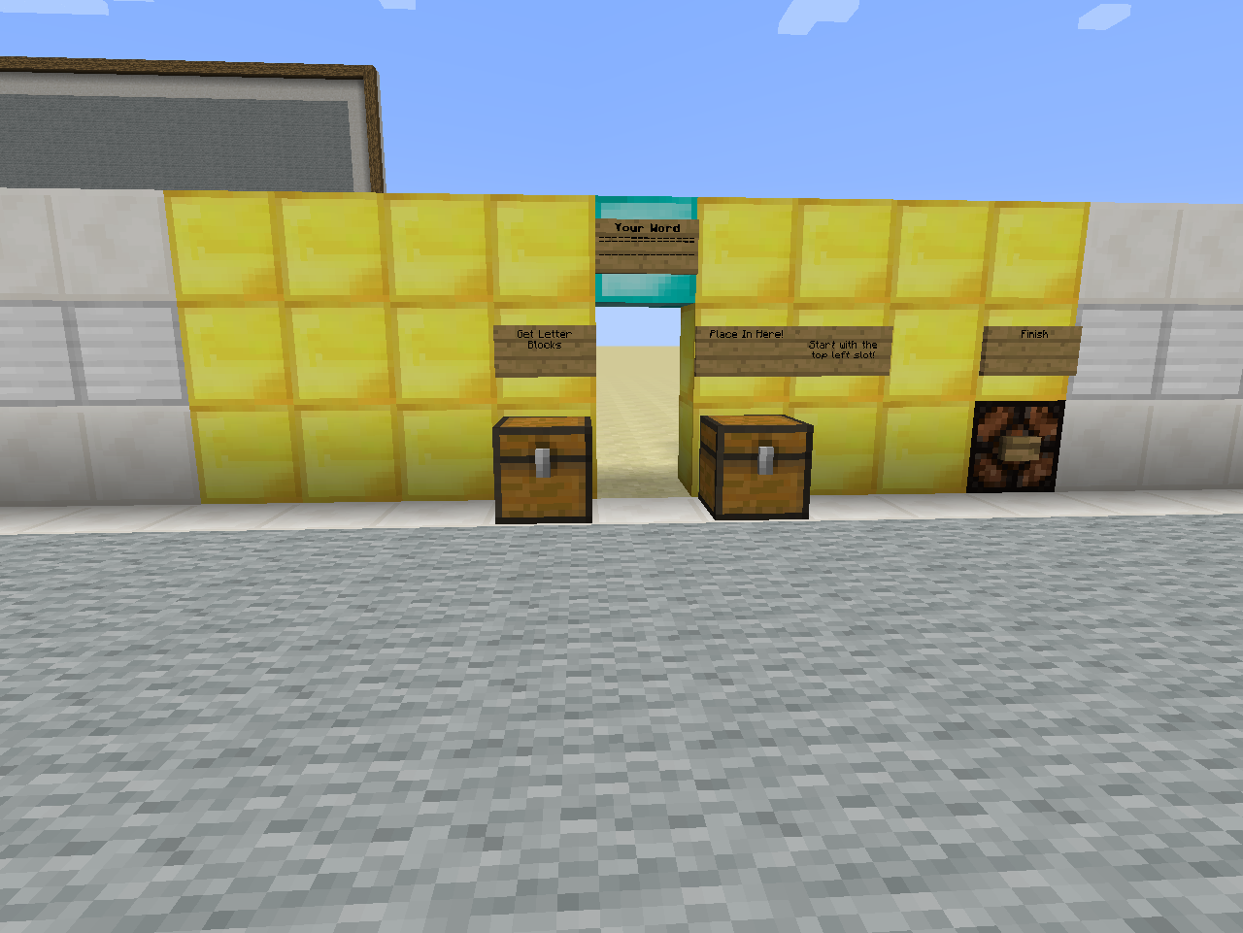

In deze ruimte kan men het woord samenstellen.

Men kiest de letter uit de linker koffer en plaatst ze in de juiste volgorde in de rechter koffer.

Opdracht 3

Maak de volgende opstelling.

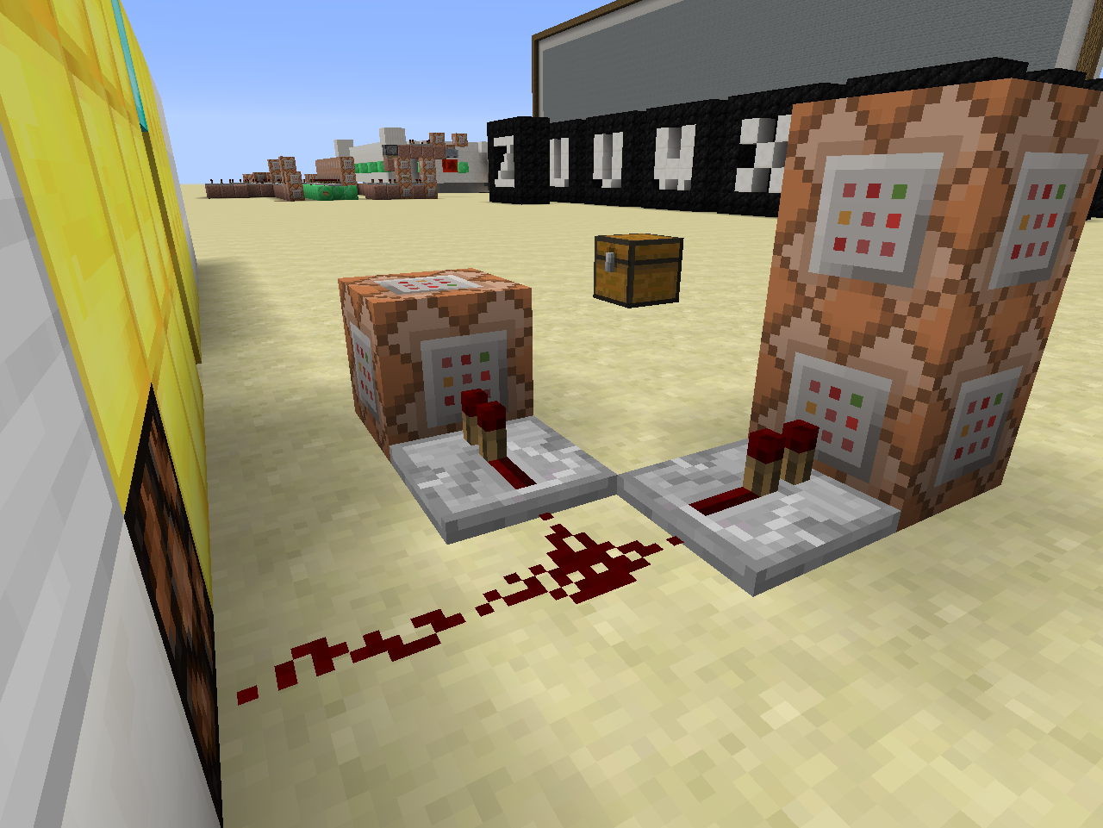

3

2

1

**C1:**

* Geef de **dichtstbijzijnde speler 8 levels** aan **xp**

/xp <getal> [speler]

/xp <getal>L [speler]

Getal: geeft het aantal xp punten aan die men aan een speler wil geven

Getal L: geeft het aantal xp level men aan een speler wil geven.

Speler: de speler aan wie men de xp wil geven. Kan ook een selector zijn

C2:

* **Teleporteer** **alle spelers** die in het **team Maker** zitten

|  |  |
| --- | --- |
| X | 1032 |
| Y | 6 |
| z | -203 |

Een groep teleportatie commando:

/tp <selector>[team=teamNaam] <x> <y> <z>

Selector: een shorthand voorzien door minecraft.

@p Dichtstbijzijnde speler

@r Willekeurige speler

@a Alle spelers

@e Alle entiteiten

teamNaam: de naam van het team waartoe de speler moet behoren.

C3

* Zet op het **scorebord** het doel **SlotAdvance** voor de **dichtstbijzijnde speler** op **17**

/scoreboard players set <speler> <doel> <score>

Speler: de naam van een speller of een van de selectors;

Doel: de naam van het doel

Score: wat de score is voor dat doel.

## De Speelruimte

Onze woordmaker wordt nu in de speel ruimte gedropt. En het raden kan beginnen.

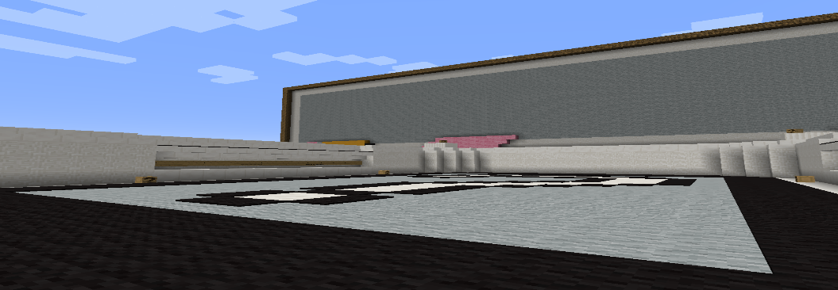

# Het pad van de gisser.

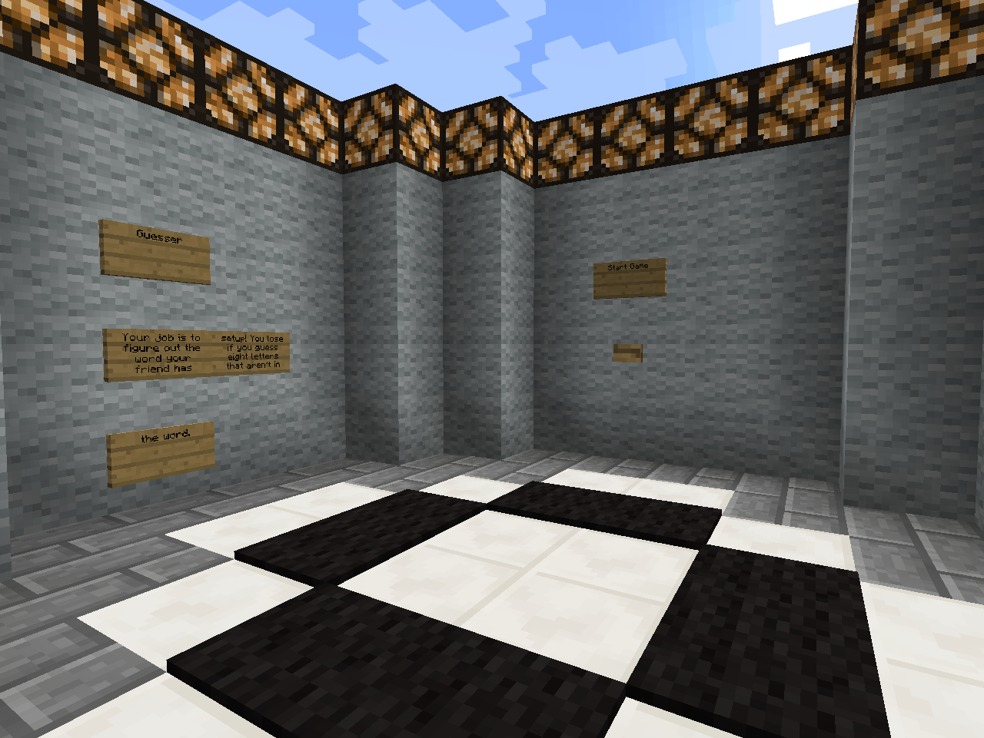

De rader moet nu wachten tot de woordmaker klaar is.

Hij kan rechtstreeks op de knop start game drukken en wachten op de andere speler.

Opdracht 4

Maak de volgende opstelling.

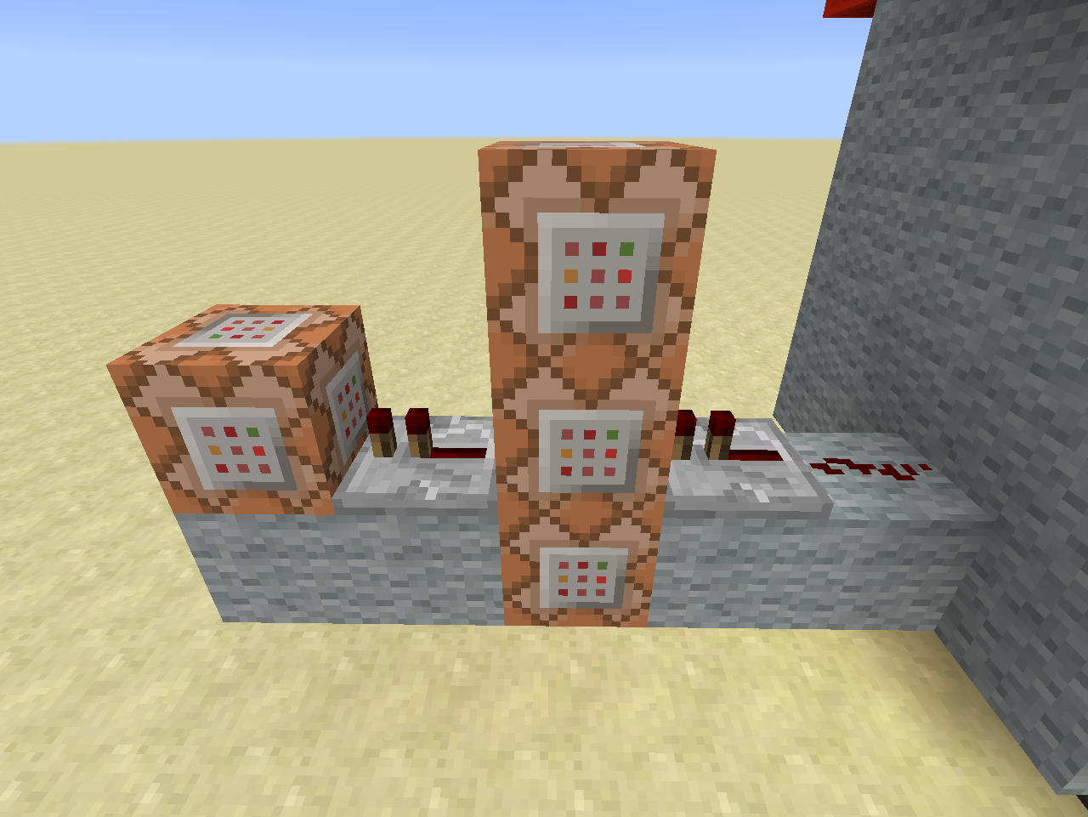

4

2

3

1

De drukknop op de muur zal via 1 redstone signaal naar een repeater gaan. En eerst het commando van de middelste blok uitvoeren.

Eenmaal dit commando is uitgevoerd zulle de blokken onder en boven en de volgende blok hun commando’s uitvoeren. We gebruiken een overgang ’s repeater om het commando van de laatste blok niet meerdere keren uit te voeren.

Legende

|  |  |  |  |  |
| --- | --- | --- | --- | --- |
|  |  | C3 |  |  |
| C4 | R2 | C1 | R1 | Rd1 |
| wol | wol | C2 | wol | Wol |

Rd1: redstone dust

R1 ,R2: repeaters:

1 Tick wachttijd

C1, C2, C3, C4: commando bokken

**C1:**

* Vertel het **scoreboard** dat **alle spelers** klaar zijn door het **doel** **Ready** met **één** te verhogen

/scoreboard players add <speler> <doel> <teller>

Speler: de naam van een speller of een van de selectors;

Doel: de naam van het doel

Teller: Met hoeveel moet de teller voor het doel optellen

**C2:**

* Vertel in het **chat venster** het bericht dat de **woordenrader** klaar is om te beginnen

/tellraw <Speler> <raw json bericht>

Speler: de speller waarvoor het bericht is of een selector

raw json bericht: een manier waarop men een bericht kan opstellen, en kleuren zie volgende link voor alle mogelijk opties: <http://minecraft.gamepedia.com/Commands#Raw_JSON_text>

/tellraw @a {"text":"","extra":[{"text":"[Hangman] ","color":"gold","bold":"true"},{"selector":"@p","color":"yellow"},{"text":" is ready to begin!","color":"dark_green"}]}

**[Hangman]** <speler> is ready to begin

**C3:**

* Vertel het **scorebord** om de dichtsbijzijnde speler toe te voegen aan het team **Guess**

/scoreboard teams join <team> [speler(s)...]

Team: Naam van het team

Speler(s): de speler of spelers die men wil toevoegen. Om alle speler te selecteren kan “*” gebruiken.

**C4:**

* **Verwijder** de **drukknop** door deze te **vervangen** met een **luchtblok**.

Locatie van de drukknop

|  |  |
| --- | --- |
| X | 1055 |
| Y | 5 |
| z | -63 |

/setblock <x> <y> <z> <blok> [data] [oudeBlokAfhandeling]

<x> <y> <z>: de locatie waar men een block wil plaatsen.

Blok: de minecraft blok id naam. Informatie over de blok id’s vindt men [hier](http://minecraft.gamepedia.com/Data_values#Block_IDs).

Optionele waarde tussen 0 en 15

oudeBlokAfhandeling: Wat te doen met de oude block. Vaste waarden binnen minecraft

Destroy: oude block wordt verwijderd net alsof het door een speler is verwijderd. Men hoort ook het blok breek geluid

Keep: enkel lucht blokken worden vervangen

Replace: de blok verdwijnt zonder een spoor na te laten.

Wol: wol blokken

## De Speelruimte

Als beide spelers klaar zijn wordt de rader in de speel ruimte gedropt.

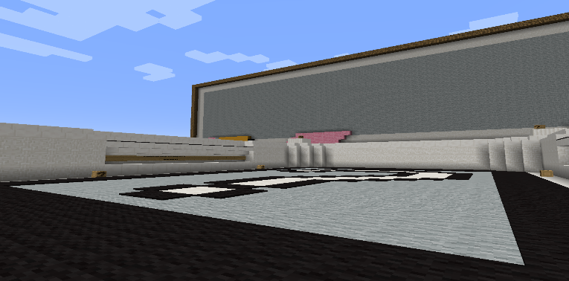

# Initialisatie van het spel

Nu beide spelers melden dat ze klaar zijn is het tijd om een nieuw spel te initialiseren. We teleporteren de gebruikers naar de volgende ruimtes en set/resetten wat blokken en doelen.

## Initialisatie circuit

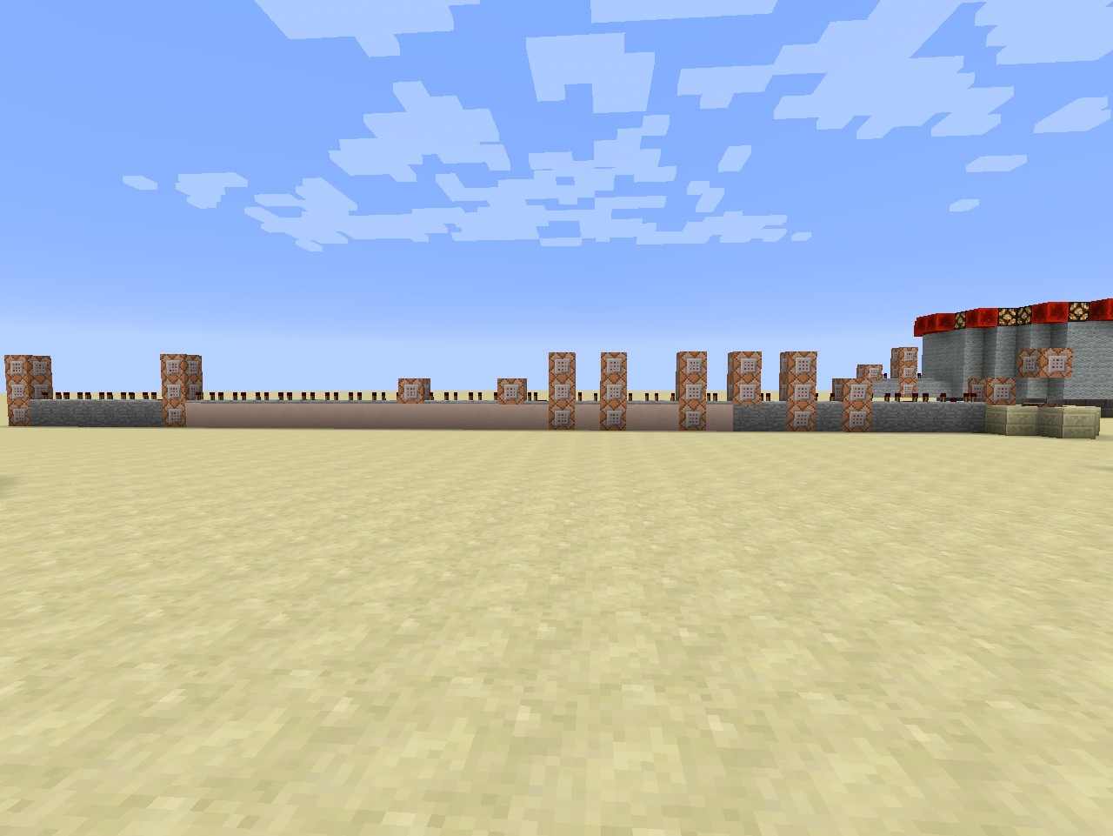

Opdracht 7

Opdracht 6

Opdracht 5

Het initialisatie circuit is een lange rij commando’s en repeaters.

We zullen dit dan ook in drie stukken kappen.

Opdracht 5: van rechts naar links loop vanaf de zandsteen tot aan de witteklei

Opdracht 6: zijn alle commando blokken op de witte klei

Opdracht 7: de commando blokken op de stenen.

### Eerste deel van het circuit

Opdracht 5

Vanaf hier krijgt men enkel nog de nodige informatie. De commando’s die al gebruikt zijn staan er niet meer als voorbeeld bij. Nieuwe commando’s worden eenmalig getoond met informatie.

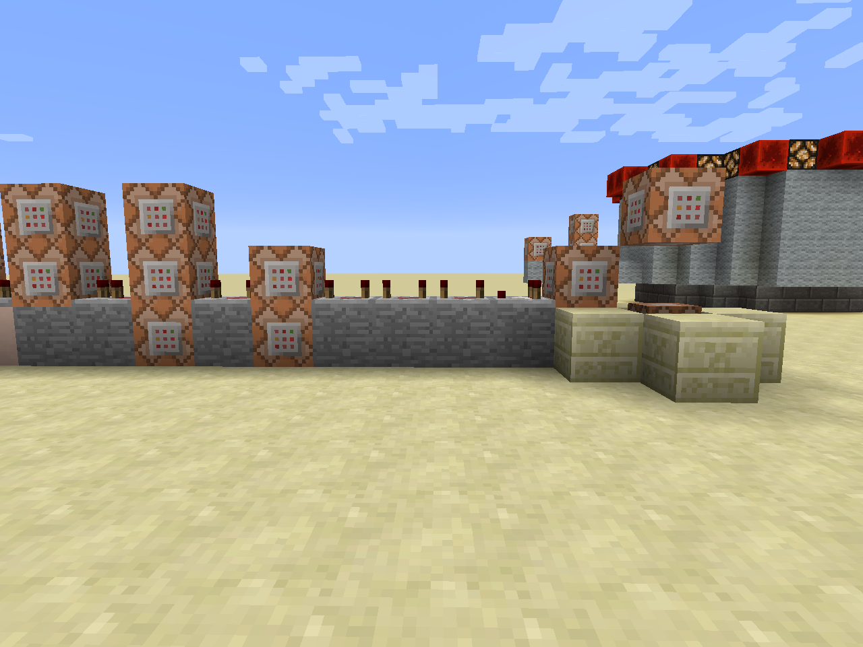

CC1

8

9

7

6

5

4

3

2

1

|  |  |  |  |  |  |  |  |  |  |  |
| --- | --- | --- | --- | --- | --- | --- | --- | --- | --- | --- |
| C9 |  | C7 |  | | | | | | | C1 |
| C8 | R6 | C5 | R4 | C3 | R3 | R2 | R1 | cmp1 | C2 |  |
| steen | steen | C6 | steen | C4 | Steen | Steen | Steen | Steen | steen | CC1 |
|  | | | | | | | | | | Rb1+ar |

Rb1 => dit is een blok redstone en is aanwezig

Ar => activator rail. Een mijnkar met commandoblok zal elke 4 game ticks activeren

**C1:**

* **Vul** een gebied van **1*1*3** met **lucht relatief ten opzichte van de commandoblok.**

/fill <x1> <y1> <z1> <x2> <y2> <z2> <blok>

<x1> <y1> <z1>, <x2> <y2> <z2> coördinaten van 2 tegenovergesteld hoeken

blok: de minecraft blok id/naam. Informatie over de blok id’s vindt men [hier](http://minecraft.gamepedia.com/Data_values#Block_IDs).

**CC1:**

* **Vul** een gebied van **1*1*3** met **redstone-blokken relatief ten opzichte van de commandoblok.**

/fill <x1> <y1> <z1> <x2> <y2> <z2> <blok>

<x1> <y1> <z1>, <x2> <y2> <z2> coördinaten van 2 tegenovergesteld hoeken

blok: de minecraft blok id naam. Informatie over de blok id’s vindt men [hier](http://minecraft.gamepedia.com/Data_values#Block_IDs).

**C2:**

* **Test** of **alle spelers** op de startknop hebben geklikt =>doel **Ready**.

/testfor <speler> [tag]

Tag iets van het type NBT Tag. In het geval van een doel heeft men de volgende 2 mogelijkheden.

Score_**doel** =2 =>de voorwaarde is ok indien het Doel 0,1 of 2 is. Of anders gezegd kleiner dan of gelijk aan 2

Score_**doel**_min=2 => het doel is minstens 2 of hoger

/testfor @a[score_Ready_min=2]

**C3:**

* Zet het doel “**End**” op **1** voor **alle spelers**

Hint : scoreboard players set

**C4:**

* Zet het doel “**Guess**” op **0** voor **alle spelers**.

**C5:**

* Vertel in het **chat venster** dat **alle spelers** klaar is en dat het spel zal beginnen eens de woordenmaker zijn woord heeft gemaakt.

/tellraw @a {"text":"","extra":[{"text":"[Hangman] ","color":"gold","bold":"true"},{"text":"Everybody is ready! The game will begin once the word maker finishes setting up the word!","color":"dark_green"}]}

**C6:**

* **Teleporteer** **alle spelers** van het **team Maker**

|  |  |
| --- | --- |
| X | 1101 |
| Y | 4 |
| z | -165 |

**C7:**

* **Teleporteer alle spelers** van het **team** **Guess**.

|  |  |
| --- | --- |
| X | 1032 |
| Y | 6 |
| z | -203 |

C8:

* Geen commando

**C9:**

* **Zet** voor **alle spelers** het **Ready** doel op **0**

### Tweede deel van het circuit

Opdracht 6

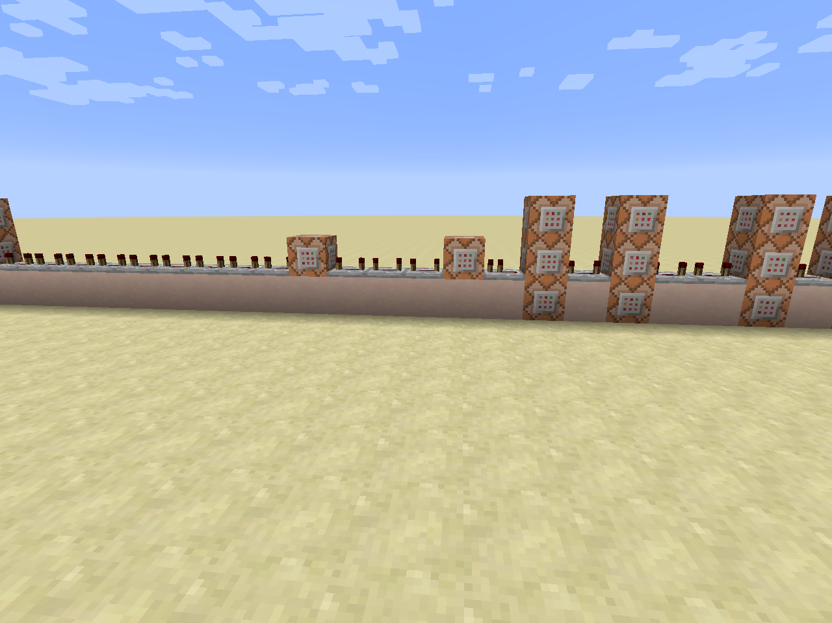

10

11

9

8

7

6

5

4

3

2

1

|  |  |  |  |  |  |  |  |  |  |  |  |  |  |  |  |  |  |  |  |
| --- | --- | --- | --- | --- | --- | --- | --- | --- | --- | --- | --- | --- | --- | --- | --- | --- | --- | --- | --- |
|  | | | | | | | | | | | | | C9 |  | C6 |  | | C3 |  |
| R15 | R14 | R13 | R12 | R11 | R10 | R9 | C11 | R8 | R7 | R6 | C10 | R5 | C7 | R4 | C4 | R3 | R2 | C1 | R1 |
|  | | | | | | | | | | | | | C8 |  | C5 |  | | C2 |  |

**C1:**

* Maak voor **alle spelers** hun **inventaris leeg**

/clear <speler>

Speler: naam van de speler of een selector

**C2:**

* **Verander** de **spelmodus** voor **alle spelers** van het **team Maker** naar **creatief**

/gamemode <mode> [speler]

Mode: de mogelijke speel modussen

1. Overleven
2. Creatief
3. Avontuur
4. Bijstander

Speler: de naam van de speller of een selector waarvoor men de spel modus wil veranderen

**C3:**

* **Verander** de **spelmodus** voor **alle spelers** van het **team Guess** naar **avontuur**

**C4:**

* Geen commando

**C5:**

* **Kloon** een gebied

|  |  |  |  |  |  |
| --- | --- | --- | --- | --- | --- |
| X1 | 1056 | X2 | 1056 | X | 1045 |
| Y1 | 3 | Y2 | 3 | Y | 4 |
| Z1 | -207 | Z2 | -195 | Z | -210 |

/clone <x1> <y1> <z1> <x2> <y2> <z2> <x> <y> <z>

<x1> <y1> <z1> <x2> <y2> <z2>: het gebied dat men wil klonen.

<x> <y> <z>: Startpositie waarde kloon moet komen.

**C6:**

* **Kloon** een gebied

|  |  |  |  |  |  |
| --- | --- | --- | --- | --- | --- |
| X1 | 1058 | X2 | 1058 | X | 1095 |
| Y1 | 3 | Y2 | 3 | Y | 4 |
| Z1 | -207 | Z2 | -195 | Z | -210 |

**C7:**

* Vertel in het **chat venster** voor **alle spelers** in het **team Maker** wat ze moeten doen.

/tellraw @a[team=Maker] {"text":"","extra":[{"text":"[Hangman] ","color":"gold","bold":"true"},{"text":"Take blocks from the chest on the left and order them to spell the word in the chest on the right! Enter it as if you were reading a book; start at the top-left and move to the right! You can enter up to 15 letters!","color":"dark_green"}]}

**C8:**

* **Kloon** een gebied

|  |  |  |  |  |  |
| --- | --- | --- | --- | --- | --- |
| X1 | 1066 | X2 | 1065 | X | 1055 |
| Y1 | 3 | Y2 | 3 | Y | 5 |
| Z1 | -86 | Z2 | -86 | Z | -92 |

**C9:**

* **Kloon** een gebied

|  |  |  |  |  |  |
| --- | --- | --- | --- | --- | --- |
| X1 | 1066 | X2 | 1065 | X | 1055 |
| Y1 | 3 | Y2 | 3 | Y | 5 |
| Z1 | -86 | Z2 | -86 | Z | -63 |

**C10:**

* **Zet** een **blok redstone** op de volgende positie

|  |  |
| --- | --- |
| X | 1096 |
| Y | 21 |
| z | -90 |

Hint setblock

**C11:**

* **Zet** een **blok lucht** op de volgende positie.

|  |  |
| --- | --- |
| X | 1096 |
| Y | 21 |
| z | -90 |

Hint setblock

### Derde deel van het circuit

Opdracht 7

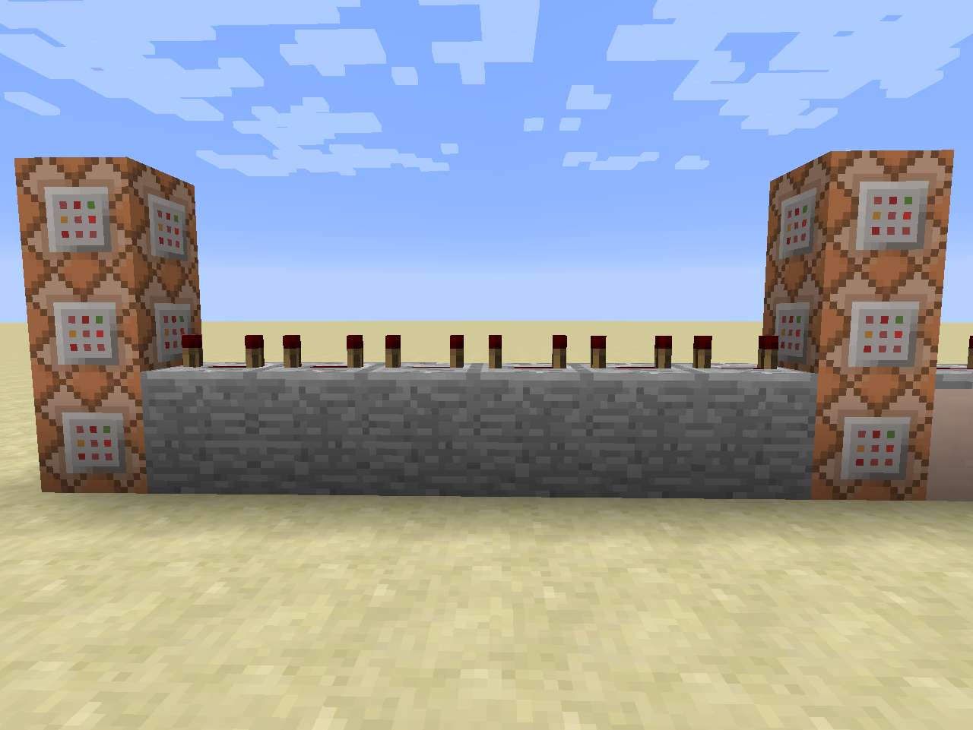

5

4

6

3

2

1

|  |  |  |  |  |  |  |
| --- | --- | --- | --- | --- | --- | --- |
| C6 |  | | | | | C2 |
| C4 | R5 | R4 | R3 | R2 | R1 | C1 |
| C5 |  |  |  |  |  | C3 |

**C1:**

* **Zet** een **hopper** op de volgende positie

|  |  |
| --- | --- |
| X | 1094 |
| Y | 13 |
| z | -89 |

Hint setblock

**C2:**

* **Zet** een **hopper** op de volgende positie

|  |  |
| --- | --- |
| X | 1094 |
| Y | 13 |
| z | -91 |

Hint setblock

**C3**:

* **Vul** een gebied met **hoppers** op de volgende positie

|  |  |  |  |
| --- | --- | --- | --- |
| X1 | 1092 | X2 | 1092 |
| Y1 | 3 | Y2 | 3 |
| Z1 | -89 | Z2 | -91 |

Hint fill

C4:

* **Zet** een **blok lucht** op de volgende positie

|  |  |
| --- | --- |
| X | 1094 |
| Y | 13 |
| z | -89 |

Hint setblock

C5:

* **Zet** een **blok lucht** op de volgende positie

|  |  |
| --- | --- |
| X | 1094 |
| Y | 13 |
| z | -91 |

Hint setblock

C6:

* **Vul** een gebied met **lucht** op de volgende positie

|  |  |  |  |
| --- | --- | --- | --- |
| X1 | 1092 | X2 | 1092 |
| Y1 | 3 | Y2 | 3 |
| Z1 | -89 | Z2 | -91 |

Hint fill

# De tikkende toren

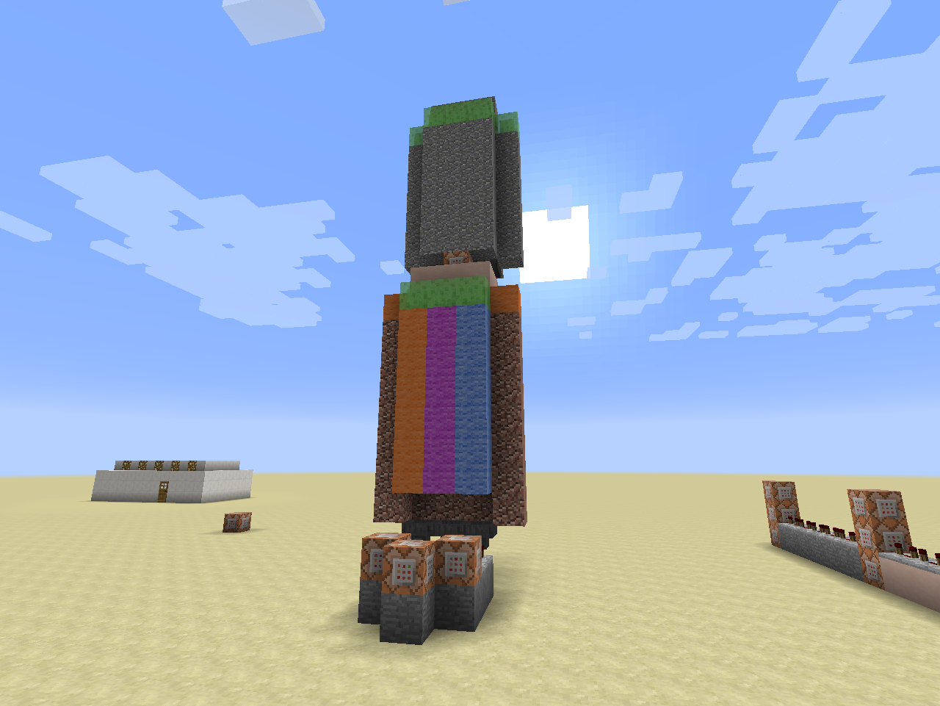 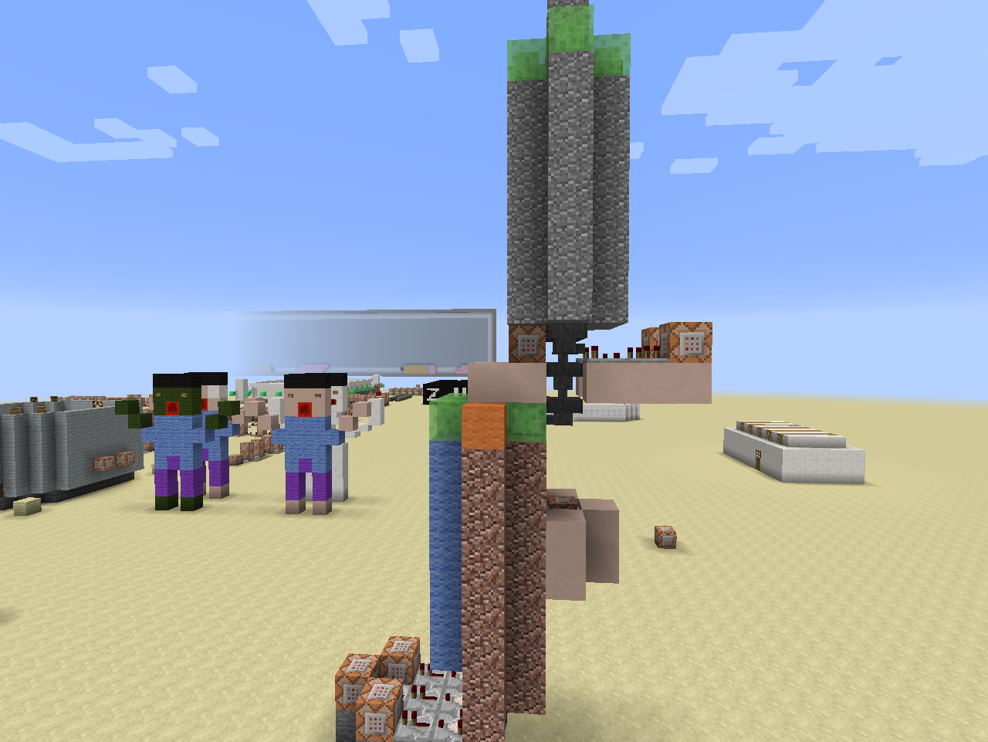

CC1

6

5

4

2

1

3

4

Opdracht 8

C1:

* **Kloon** een gebied

|  |  |  |  |  |  |
| --- | --- | --- | --- | --- | --- |
| X1 | 1071 | X2 | 1063 | X | 1050 |
| Y1 | 12 | Y2 | 3 | Y | 15 |
| Z1 | -109 | Z2 | -108 | Z | -240 |

C2:

* **Kloon** een gebied

|  |  |  |  |  |  |
| --- | --- | --- | --- | --- | --- |
| X1 | 1081 | X2 | 1073 | X | 1050 |
| Y1 | 12 | Y2 | 3 | Y | 15 |
| Z1 | -112 | Z2 | -111 | Z | -240 |

C3:

* **Kloon** een gebied

|  |  |  |  |  |  |
| --- | --- | --- | --- | --- | --- |
| X1 | 1071 | X2 | 1063 | X | 1050 |
| Y1 | 12 | Y2 | 3 | Y | 15 |
| Z1 | -112 | Z2 | -111 | Z | -240 |

C4:

* **Zet** een **blok lucht** op de volgende positie

|  |  |
| --- | --- |
| X | ~ |
| Y | ~-1 |
| z | ~ |

CC1:

* **Zet** een **redstone blok** op de volgende positie

|  |  |
| --- | --- |
| X | ~-1 |
| Y | ~4 |
| z | ~ |

C5:

* **Kloon** een gebied

|  |  |  |  |  |  |
| --- | --- | --- | --- | --- | --- |
| X1 | 1081 | X2 | 1073 | X | 1050 |
| Y1 | 12 | Y2 | 3 | Y | 15 |
| Z1 | -109 | Z2 | -108 | Z | -240 |

C6:

* **Kloon** een gebied

|  |  |  |  |  |  |
| --- | --- | --- | --- | --- | --- |
| X1 | 1081 | X2 | 1073 | X | 1050 |
| Y1 | 12 | Y2 | 3 | Y | 15 |
| Z1 | -109 | Z2 | -108 | Z | -240 |

# Het controlesysteem van de win voorwaarden.

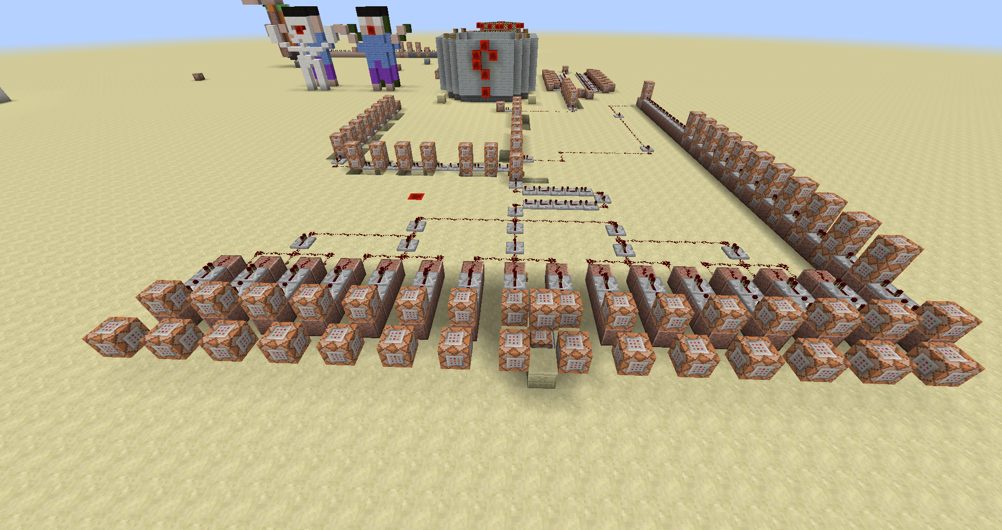

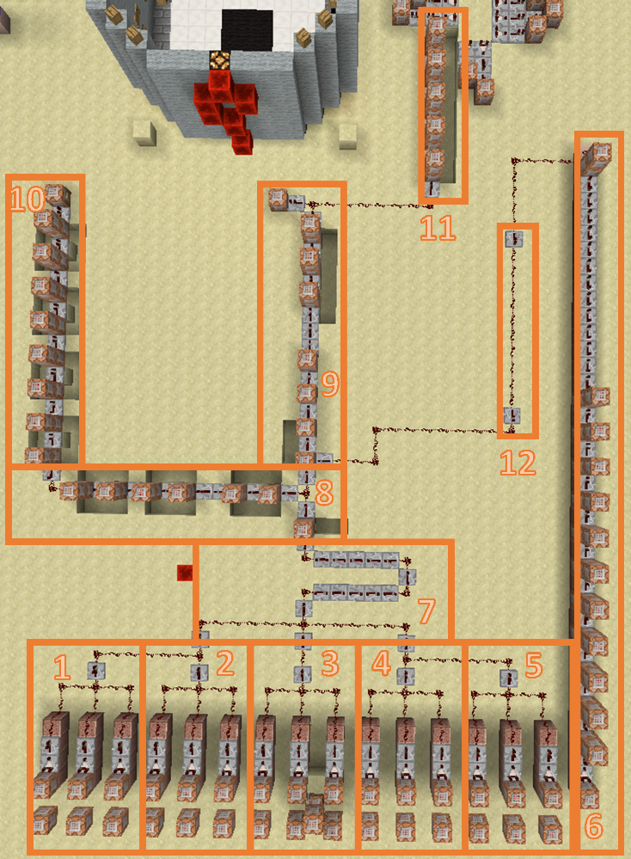We delen dit circuit op in 12 kleinere stukjes.

Groepen 1 tot en met 5 zijn herhalen van dezelfde code met veranderingen in de vergelijking. De achterste rij commandoblokken in deze 5 groepen bevat geen code.

Opdracht 9

## 1ste groep: commando blokken 1-3

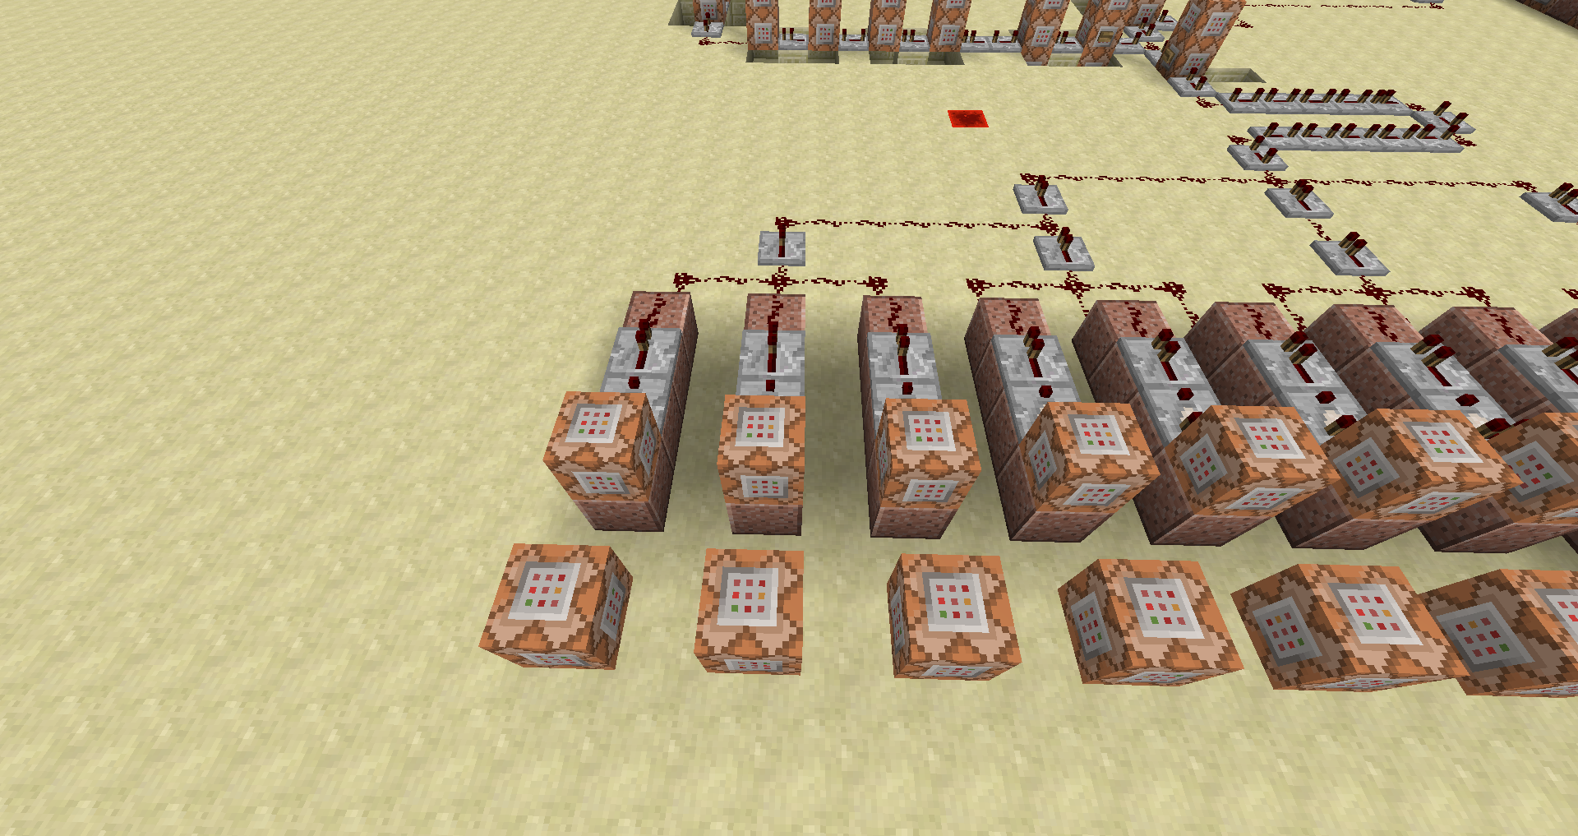 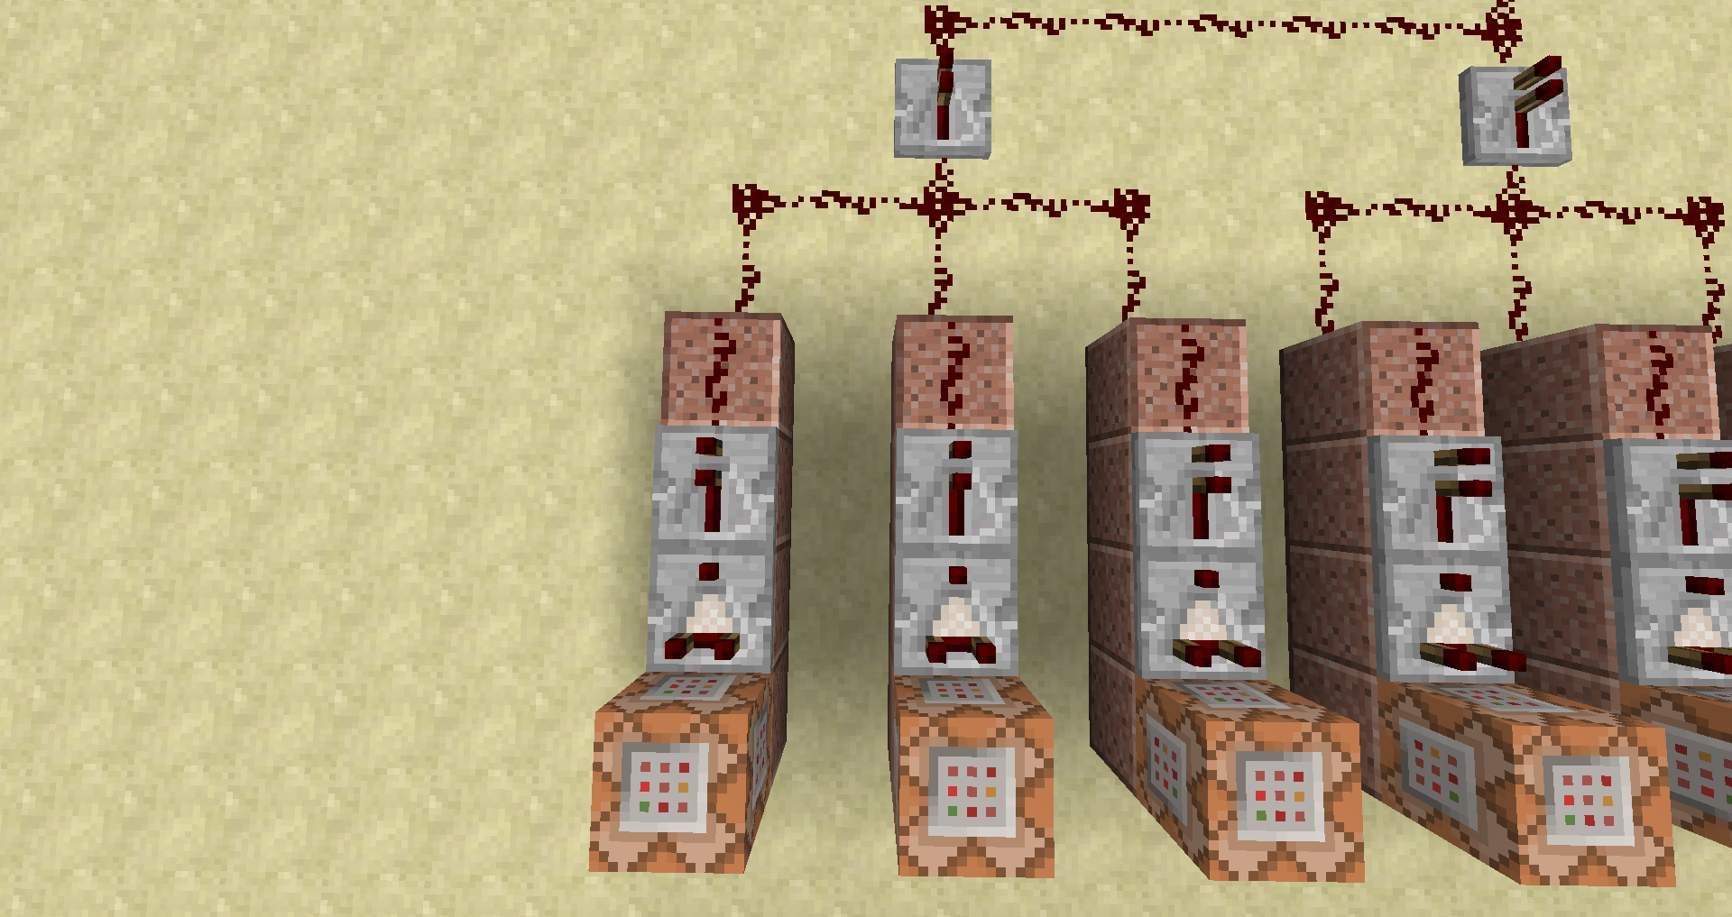

**1**

**2**

**3**

**3**

**2**

**1**

C1:

* **Test** de volgende **doelen**:

**score_Correct** gelijk aan 1

**score_Endcap** gelijk aan 1

**score_Mode** hoger dan of gelijk aan 1

**score_Fail** kleiner dan of gelijk aan 0

C2:

* **Test** de volgende **doelen**:

**score_Correct** gelijk aan 2

**score_Endcap** gelijk aan 2

**score_Mode** hoger dan of gelijk aan 1

**score_Fail** kleiner dan of gelijk aan 0

C3:

* **Test** de volgende **doelen**:

**score_Correct** gelijk aan 3

**score_Endcap** gelijk aan 3

**score_Mode** hoger dan of gelijk aan 1

**score_Fail** kleiner dan of gelijk aan 0

## 2de groep: commando blokken 4-6

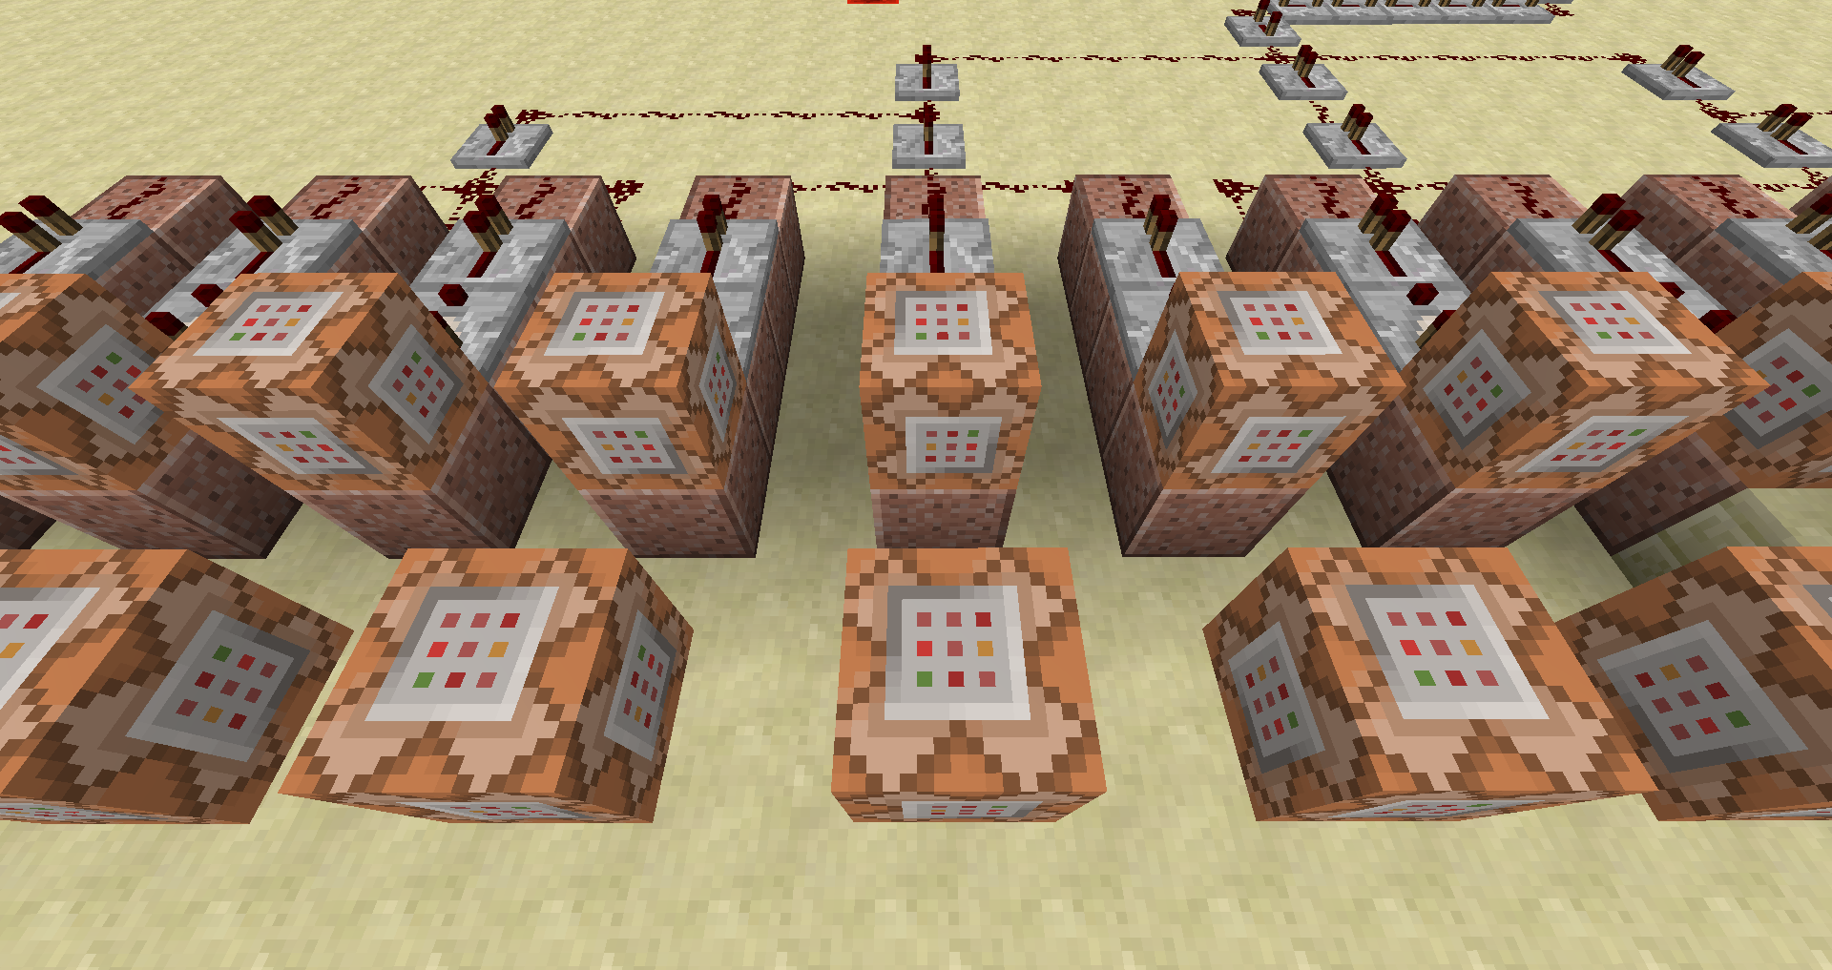 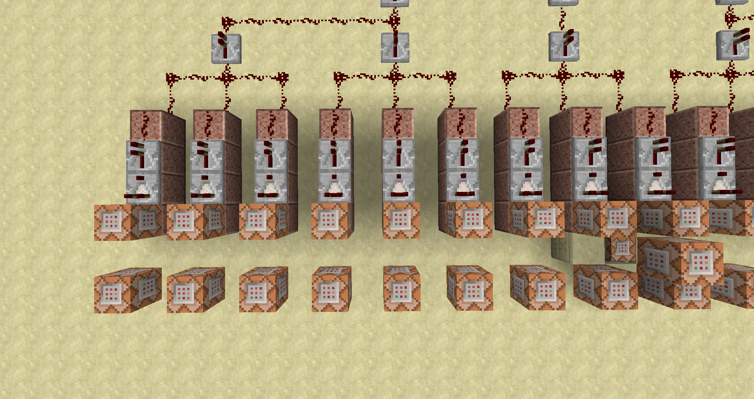

**7**

**6**

**5**

**4**

**6**

**5**

**4**

**3**

C4:

* **Test** de volgende **doelen**:

**score_Correct** gelijk aan 4

**score_Endcap** gelijk aan 4

**score_Mode** hoger dan of gelijk aan 1

**score_Fail** kleiner dan of gelijk aan 0

C5:

* **Test** de volgende **doelen**:

**score_Correct** gelijk aan 5

**score_Endcap** gelijk aan 5

**score_Mode** hoger dan of gelijk aan 1

**score_Fail** kleiner dan of gelijk aan 0

C6:

* **Test** de volgende **doelen**:

**score_Correct** gelijk aan 6

**score_Endcap** gelijk aan 6

**score_Mode** hoger dan of gelijk aan 1

**score_Fail** kleiner dan of gelijk aan 0

## 3de groep: commando blokken 7-11

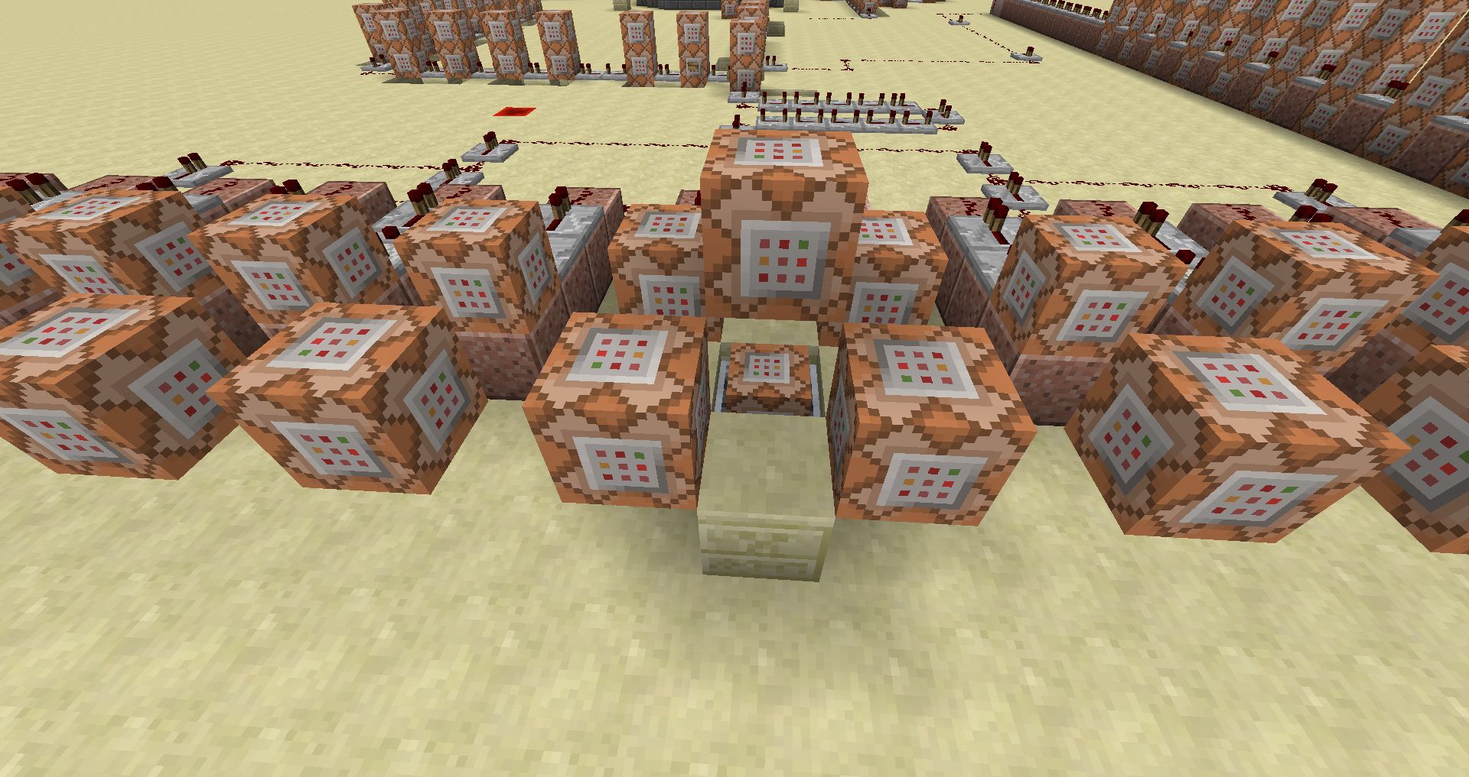 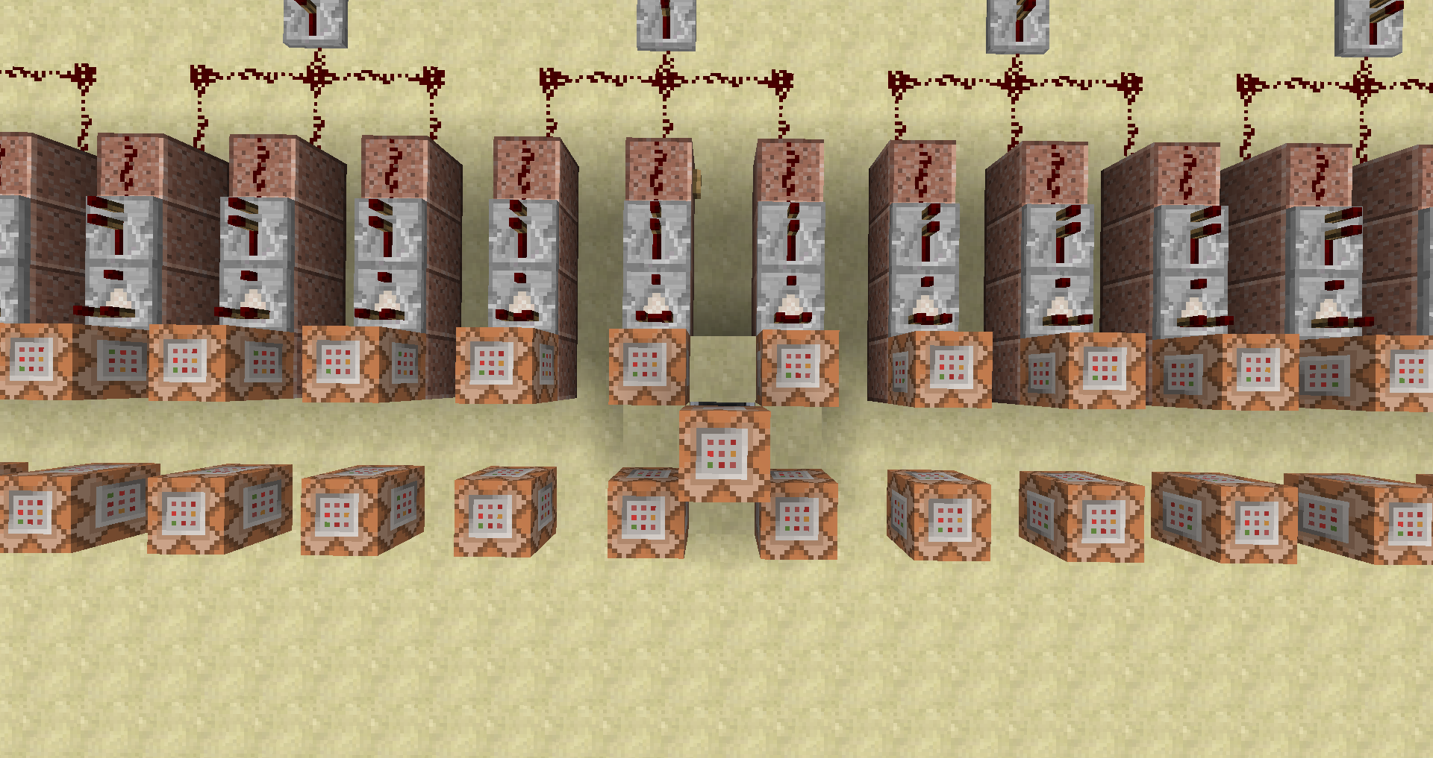

**CC1**

**10**

**9**

**87**

**7**

**10**

**9**

**8**

**7**

**6**

C7:

* **Test** de volgende **doelen**:

**score_Correct** gelijk aan 7

**score_Endcap** gelijk aan 7

**score_Mode** hoger dan of gelijk aan 1

**score_Fail** kleiner dan of gelijk aan 0

C8:

* **Test** de volgende **doelen**:

**score_Correct** gelijk aan 8

**score_Endcap** gelijk aan 8

**score_Mode** hoger dan of gelijk aan 1

**score_Fail** kleiner dan of gelijk aan 0

CC1:

* **Vul** een gebied met **redstone blokken** relatief van deze blok

|  |  |  |  |
| --- | --- | --- | --- |
| X1 | ~15 | X2 | ~-15 |
| Y1 | ~1 | Y2 | ~1 |
| Z1 | ~ | Z2 | ~ |

C9:

* **Vul** een gebied met **Lucht** relatief van deze blok

|  |  |  |  |
| --- | --- | --- | --- |
| X1 | ~15 | X2 | ~-15 |
| Y1 | ~-1 | Y2 | ~-1 |
| Z1 | ~ | Z2 | ~ |

C10:

* **Test** de volgende **doelen**:

**score_Correct** gelijk aan 9

**score_Endcap** gelijk aan 9

**score_Mode** hoger dan of gelijk aan 1

**score_Fail** kleiner dan of gelijk aan 0

## 4de groep: commando blokken 11-13

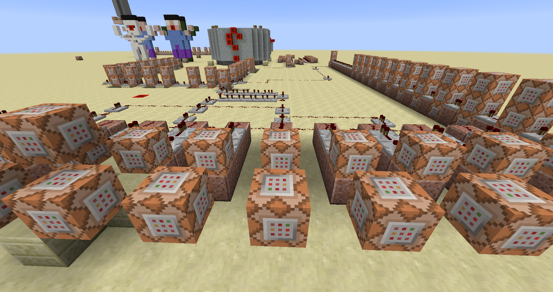 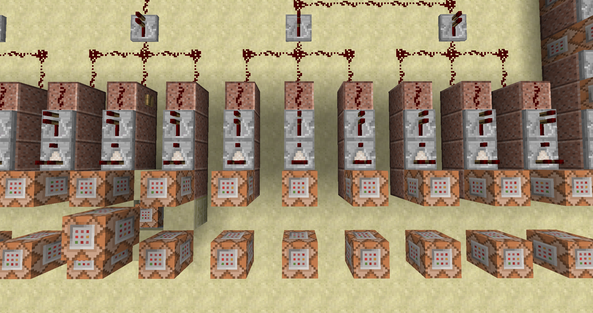

**13**

**12**

**11**

**14**

**13**

**12**

**11**

**10**

C11:

* **Test** de volgende **doelen**:

**score_Correct** gelijk aan 10

**score_Endcap** gelijk aan 10

**score_Mode** hoger dan of gelijk aan 1

**score_Fail** kleiner dan of gelijk aan 0

C12:

* **Test** de volgende **doelen**:

**score_Correct** gelijk aan 11

**score_Endcap** gelijk aan 11

**score_Mode** hoger dan of gelijk aan 1

**score_Fail** kleiner dan of gelijk aan 0

C13:

* **Test** de volgende **doelen**:

**score_Correct** gelijk aan 12

**score_Endcap** gelijk aan 12

**score_Mode** hoger dan of gelijk aan 1

**score_Fail** kleiner dan of gelijk aan 0

## 5de groep: commando blokken 14-16

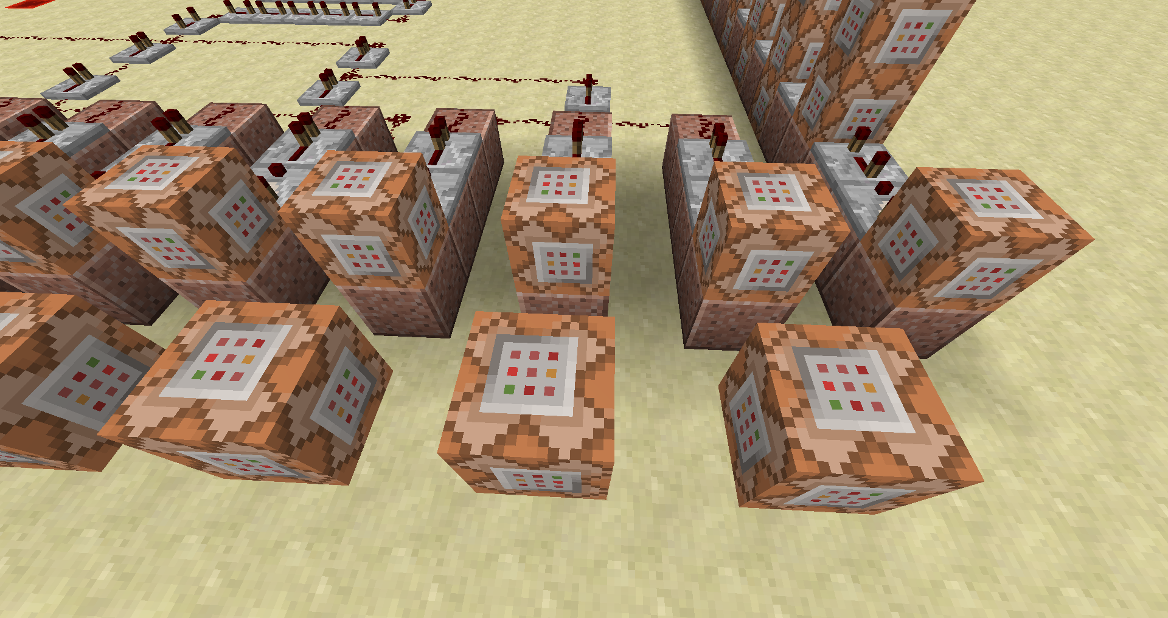 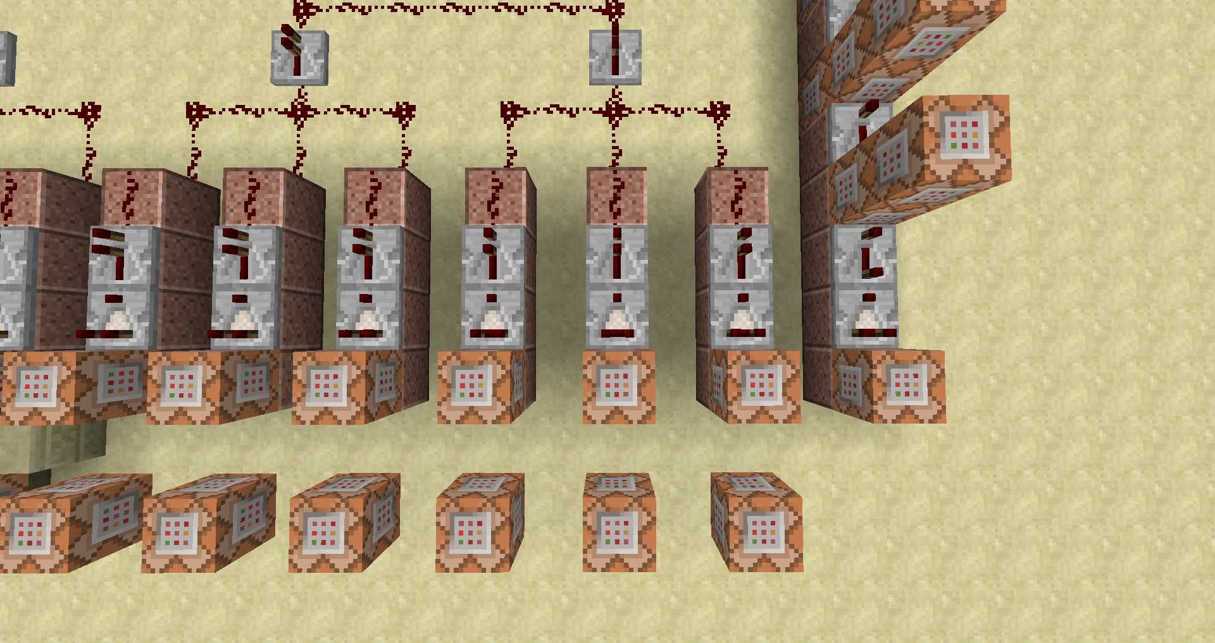

**16**

**15**

**14**

**16**

**15**

**14**

**13**

C14:

* **Test** de volgende **doelen**:

**score_Correct** gelijk aan 13

**score_Endcap** gelijk aan 13

**score_Mode** hoger dan of gelijk aan 1

**score_Fail** kleiner dan of gelijk aan 0

C15:

* **Test** de volgende **doelen**:

**score_Correct** gelijk aan 14

**score_Endcap** gelijk aan 14

**score_Mode** hoger dan of gelijk aan 1

**score_Fail** kleiner dan of gelijk aan 0

C16:

* **Test** de volgende **doelen**:

**score_Correct** gelijk aan 15

**score_Endcap** gelijk aan 15

**score_Mode** hoger dan of gelijk aan 1

**score_Fail** kleiner dan of gelijk aan 0

## 6de groep: commando blokken 17 -51

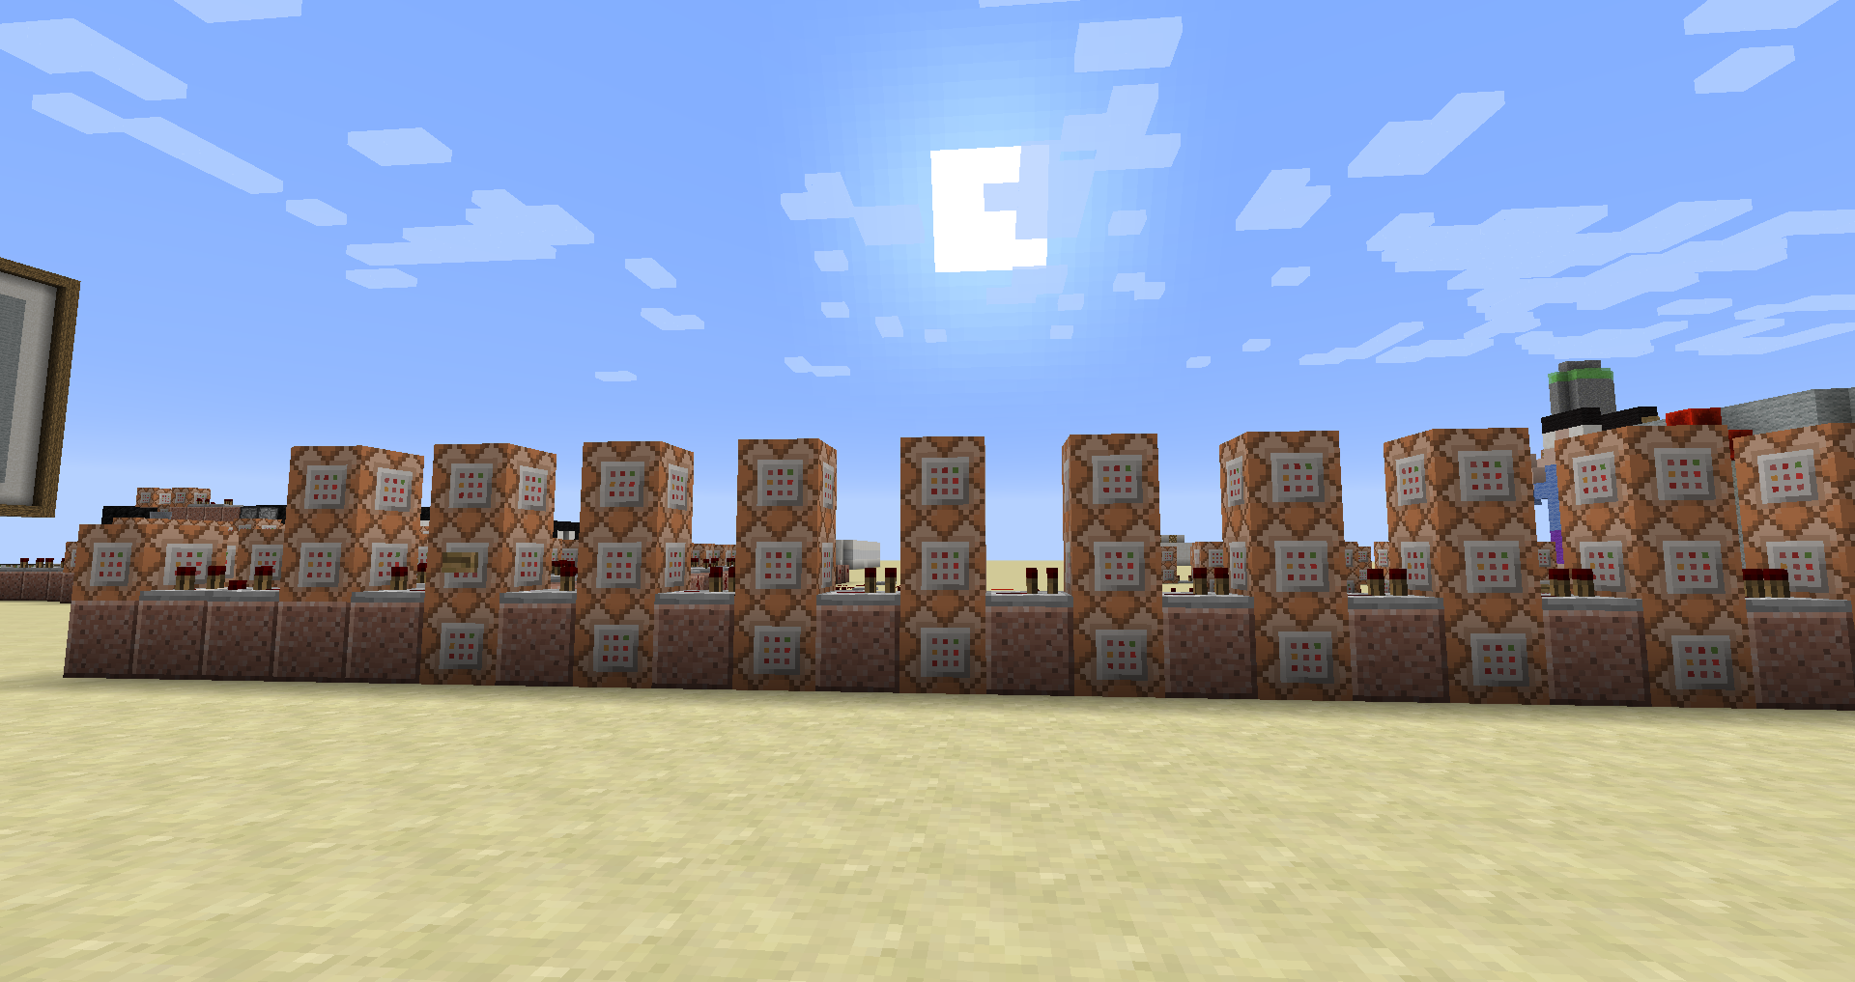

**43**

**42**

**41**

**40**

**39**

**38**

**37**

**36**

**35**

**34**

**33**

**32**

**31**

**30**

**29**

**28**

**27**

**26**

**25**

**24**

**23**

**20**

**22**

**21**

**18**

**19**

**17**

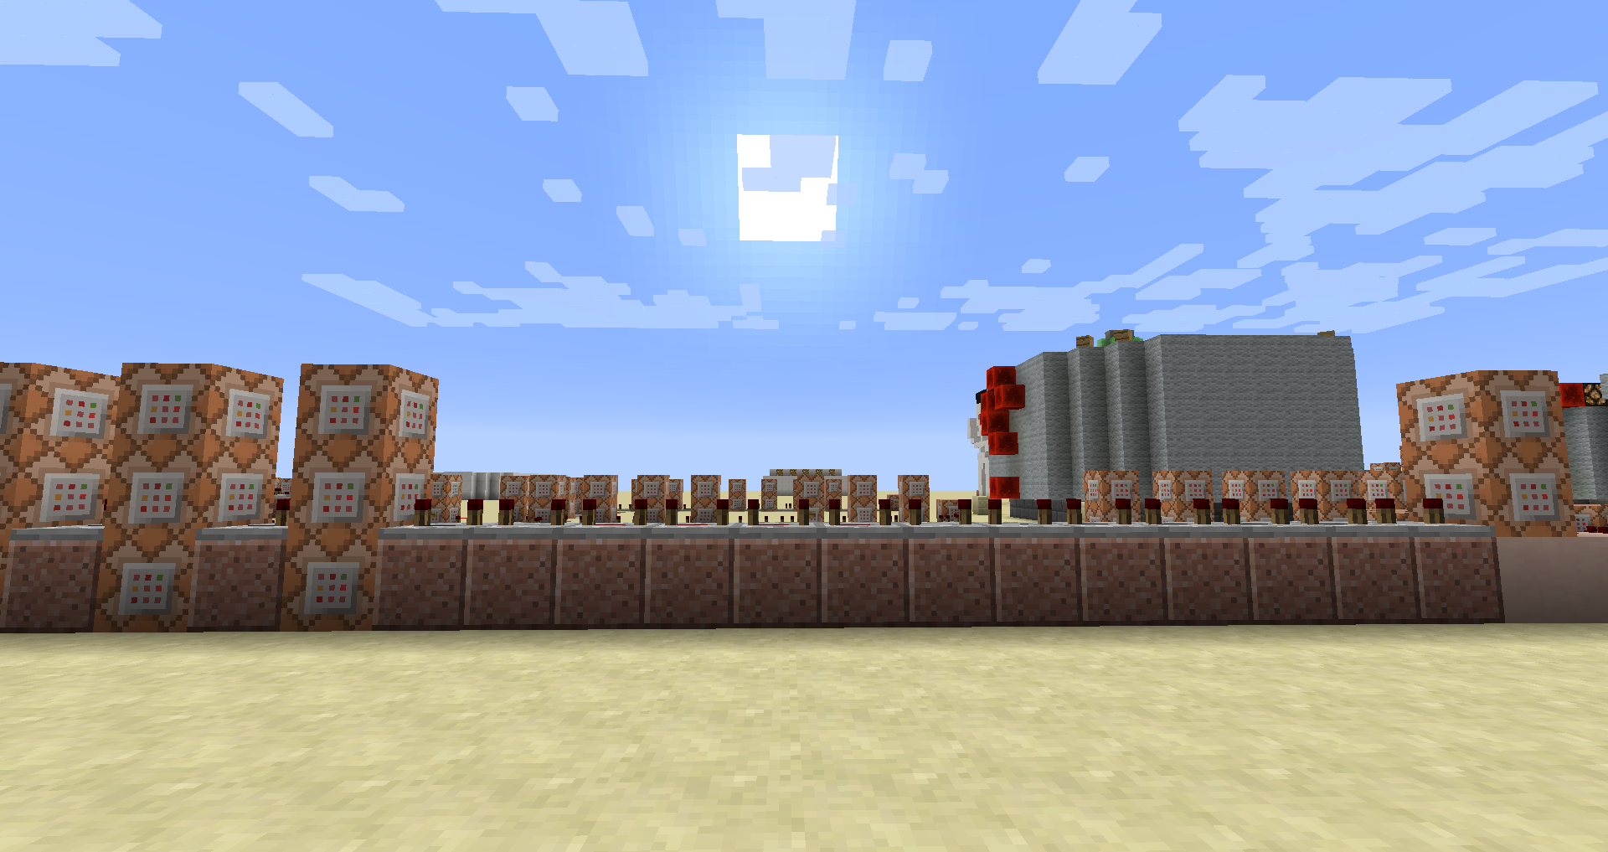

**50**

**51**

**49**

**48**

**47**

**44**

**46**

**45**

C17:

* **Test** de volgende **doelen**:

**score_Incorrect** hoger dan of gelijk aan 8

C18:

* Zet het doel **Incorrect** op 0 voor **alle spelers**

C19:

* Zet het doel **Mode** op 1 voor **alle spelers**

C20:

* **Speel een geluid** voor **alle spelers**

/playsound <geluid> <bron> <speler> [<X Y Z>] [<volume>] [<pitch>] [<minimumvolume>]

Geluid: welk muziekje, lawaai je wilt afspele. Dit moet beschreven staan in sounds.json => resourcepacks kunnen hun eigen geluiden toevoegen. Zie appendix C

Bron: welk geluidskanaal gebruikt zal worden. Indien niet opgegeven is dit master.

Mogelijke kanalen: master, music, record, weather, block, hostile, neutral, player, ambient, voice.

Speler: de naam van de speler of een selector.

[<X Y Z>]: optioneel kan men ook een positie weergeven vanwaar het geluid moet gespeeld worden

[<volume>]: tussen 0.0 en 1.0 is het volume vanaf 1.0 is het de straal waarin men het geluid kan horen.

[<pitch>]: Bepaal de toonhoogte van het geluid. Moet een waarde tussen 0.0 en 2.0 zijn. Waarden lager dan 0.5 zijn gelijk aan 0.5. Waarden lager dan 1.0 verlagen de pitch en verlagen de duurtijd van het geluid. Waarden hoger dan 1.0 verhogen de pitch en de duurtijd van het geluid. Indien niet opgegeven wordt is het de standaard waarde van 1.0

[<minimumvolume>]: bepaal het geluidsniveau van speler(s) buiten de geconfigureerd volume straal

Geluid: **note.bass**

C21:

* Vertel in het **chat venster** voor **alle spelers** dat de gisser geen beurten meer heeft en dat het woord wordt weergegeven.

/tellraw @a {"text":"","extra":[{"text":"[Hangman] ","color":"gold","bold":"true"},{"text":"The guesser is out of guesses! The word is now displayed on the board!","color":"dark_red"}]}

C22:

* Zet het doel **Fail** op 1 voor **alle spelers**

C23:

* Zet het doel **C** op 1 voor **alle spelers**

C24:

* Zet het doel **A** op 1 voor **alle spelers**

C25:

* Zet het doel **B** op 1 voor **alle spelers**

C26:

* Zet het doel **G** op 1 voor **alle spelers**

C27:

* Zet het doel **E** op 1 voor **alle spelers**

C28:

* Zet het doel **F** op 1 voor **alle spelers**

C29:

* Zet het doel **H** op 1 voor **alle spelers**

C30:

* Zet het doel **D** op 1 voor **alle spelers**

C31:

* Zet het doel **I** op 1 voor **alle spelers**

C32:

* Zet het doel **L** op 1 voor **alle spelers**

C33:

* Zet het doel **J** op 1 voor **alle spelers**

C34:

* Zet het doel **K** op 1 voor **alle spelers**

C35:

* Zet het doel **N** op 1 voor **alle spelers**

C36:

* Zet het doel **M** op 1 voor **alle spelers**

C37:

* Zet het doel **O** op 1 voor **alle spelers**

C38:

* Zet het doel **Q** op 1 voor **alle spelers**

C39:

* Zet het doel **P** op 1 voor **alle spelers**

C40:

* Zet het doel **R** op 1 voor **alle spelers**

C41:

* Zet het doel **U** op 1 voor **alle spelers**

C42:

* Zet het doel **S** op 1 voor **alle spelers**

C43:

* Zet het doel **T** op 1 voor **alle spelers**

C44:

* Zet het doel **W** op 1 voor **alle spelers**

C45:

* Zet het doel **X** op 1 voor **alle spelers**

C46:

* Zet het doel **M** op 1 voor **alle spelers**

C47:

* Zet het doel **Incorrect** op 0 voor **alle spelers**

C48:

* Zet het doel **Z** op 1 voor **alle spelers**

C49:

* Zet het doel **Y** op 1 voor **alle spelers**

Repeaters: Zet alle repeaters tussen commandbol 48 en 49 of 4 tik vertraging.

C50:

* **Vul** een gebied met **lucht** op de volgende positie

|  |  |  |  |
| --- | --- | --- | --- |
| X1 | 1044 | X2 | 1029 |
| Y1 | 31 | Y2 | 44 |
| Z1 | -236 | Z2 | -236 |

C51:

* Zet het doel **End** op 1 voor **alle spelers**

## 7de groep: Repeaters

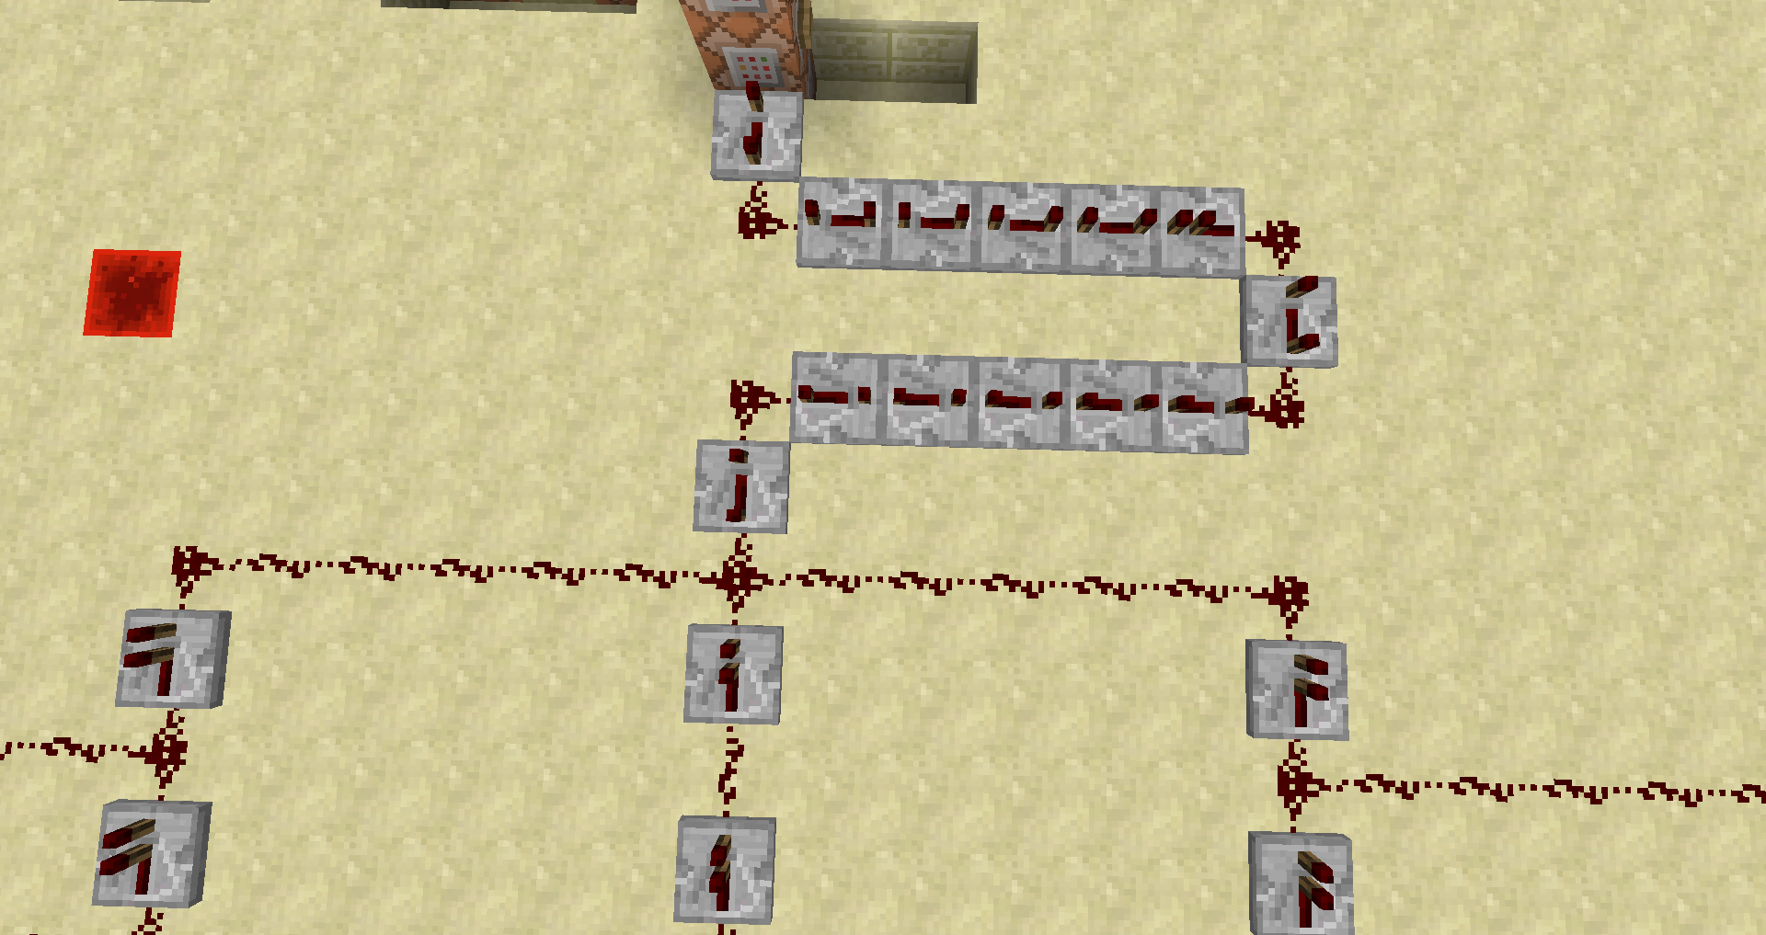

Geef al deze repeaters een 4 ticks vertraging.

## 8ste groep: commandoblokken 52 – 68

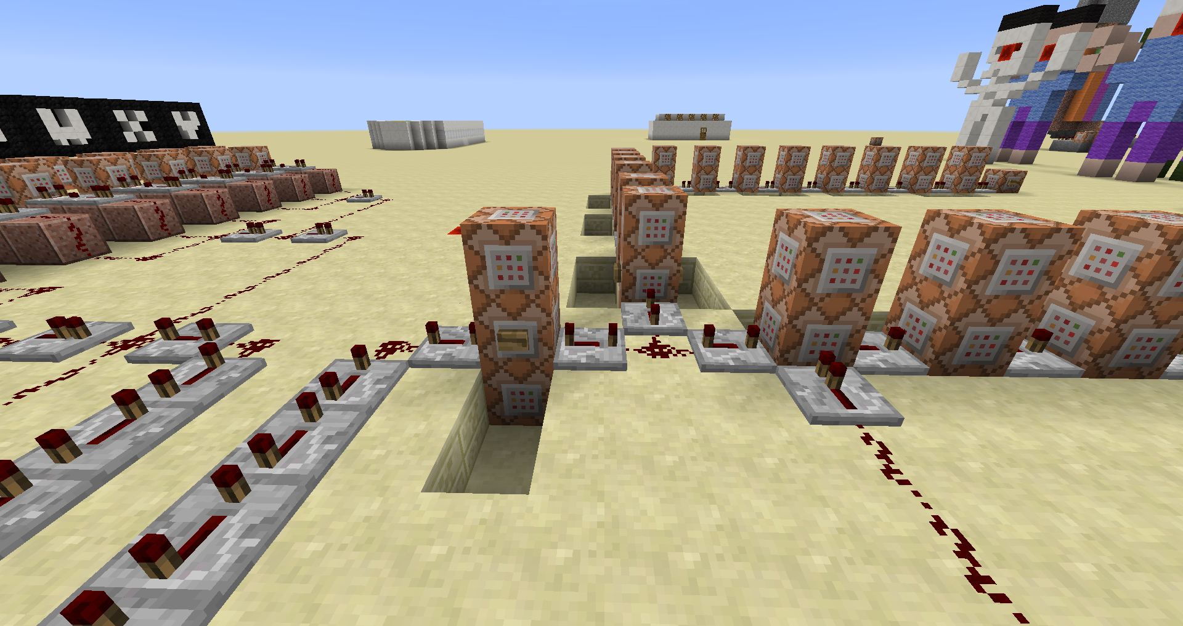 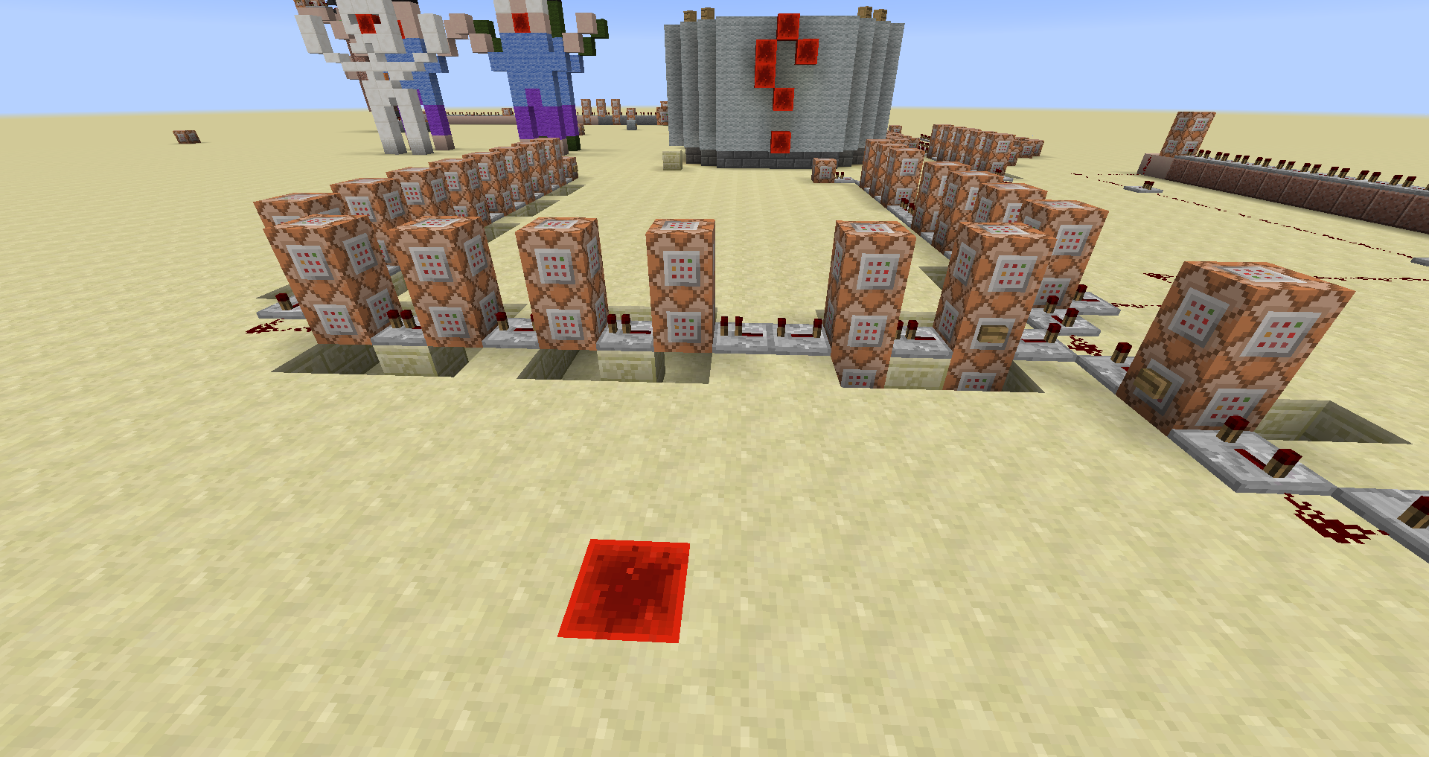

**68**

**67**

**66**

**65**

**64**

**63**

**62**

**61**

**60**

**59**

**58**

**55**

**56**

**57**

**53**

**52**

**56**

**55**

**54**

**52**

C52:

* **Speel een geluid** voor **alle spelers**

**note.pling**

C53:

* **Vertel** aan **alle spelers** dat de **gisser** het woord heeft geraden.

/tellraw @a {"text":"","extra":[{"text":"[Hangman] ","color":"gold","bold":"true"},{"selector":"@a[team=Guess]","color":"yellow"},{"text":" has figured out the word! The guesser wins!","color":"dark_green"}]}

C54:

* Zet het doel **Incorrect** op 0 voor **alle spelers**

C55:

* **Roep** een **vuurwerkpijl** **op**

/summon FireworksRocketEntity 1057 3 -107 {LifeTime:20,FireworksItem:{id:401,Count:1,tag:{Fireworks:{Explosions:[{Type:4,Flicker:1,Trail:1,Colors:[1900324],FadeColors:[16777215]},{Type:4,Flicker:1,Trail:1,Colors:[8781729],FadeColors:[16777215]},{Type:4,Flicker:1,Trail:1,Colors:[1743104],FadeColors:[16777215]},{Type:4,Flicker:1,Trail:1,Colors:[6639876],FadeColors:[16777215]}]}}}}

C56:

* **Roep** een **vuurwerkpijl** **op**

/summon FireworksRocketEntity 1057 3 -119 {LifeTime:20,FireworksItem:{id:401,Count:1,tag:{Fireworks:{Explosions:[{Type:4,Flicker:1,Trail:1,Colors:[1900324],FadeColors:[16777215]},{Type:4,Flicker:1,Trail:1,Colors:[8781729],FadeColors:[16777215]},{Type:4,Flicker:1,Trail:1,Colors:[1743104],FadeColors:[16777215]},{Type:4,Flicker:1,Trail:1,Colors:[6639876],FadeColors:[16777215]}]}}}}

C57:

* **Maak de Inventaris leeg** voor **alle spelers**

C58:

* **Roep** een **vuurwerkpijl** **op**

/summon FireworksRocketEntity 1045 3 -107 {LifeTime:20,FireworksItem:{id:401,Count:1,tag:{Fireworks:{Explosions:[{Type:4,Flicker:1,Trail:1,Colors:[1900324],FadeColors:[16777215]},{Type:4,Flicker:1,Trail:1,Colors:[8781729],FadeColors:[16777215]},{Type:4,Flicker:1,Trail:1,Colors:[1743104],FadeColors:[16777215]},{Type:4,Flicker:1,Trail:1,Colors:[6639876],FadeColors:[16777215]}]}}}}

C59:

* **Roep** een **vuurwerkpijl** **op**

/summon FireworksRocketEntity 1045 3 -119 {LifeTime:20,FireworksItem:{id:401,Count:1,tag:{Fireworks:{Explosions:[{Type:4,Flicker:1,Trail:1,Colors:[1900324],FadeColors:[16777215]},{Type:4,Flicker:1,Trail:1,Colors:[8781729],FadeColors:[16777215]},{Type:4,Flicker:1,Trail:1,Colors:[1743104],FadeColors:[16777215]},{Type:4,Flicker:1,Trail:1,Colors:[6639876],FadeColors:[16777215]}]}}}}

C60:

* **Verander** de **game modus** naar **avontuur**

C61:

* **Roep** een **vuurwerkpijl** **op**

/summon FireworksRocketEntity 1057 3 -107 {LifeTime:20,FireworksItem:{id:401,Count:1,tag:{Fireworks:{Explosions:[{Type:4,Flicker:1,Trail:1,Colors:[1900324],FadeColors:[16777215]},{Type:4,Flicker:1,Trail:1,Colors:[8781729],FadeColors:[16777215]},{Type:4,Flicker:1,Trail:1,Colors:[1743104],FadeColors:[16777215]},{Type:4,Flicker:1,Trail:1,Colors:[6639876],FadeColors:[16777215]}]}}}}

C62:

leeg

C63:

* **Roep** een **vuurwerkpijl** **op**

/summon FireworksRocketEntity 1045 3 -107 {LifeTime:20,FireworksItem:{id:401,Count:1,tag:{Fireworks:{Explosions:[{Type:4,Flicker:1,Trail:1,Colors:[1900324],FadeColors:[16777215]},{Type:4,Flicker:1,Trail:1,Colors:[8781729],FadeColors:[16777215]},{Type:4,Flicker:1,Trail:1,Colors:[1743104],FadeColors:[16777215]},{Type:4,Flicker:1,Trail:1,Colors:[6639876],FadeColors:[16777215]}]}}}}

C64:

* **Roep** een **vuurwerkpijl** **op**

/summon FireworksRocketEntity 1045 3 -119 {LifeTime:20,FireworksItem:{id:401,Count:1,tag:{Fireworks:{Explosions:[{Type:4,Flicker:1,Trail:1,Colors:[1900324],FadeColors:[16777215]},{Type:4,Flicker:1,Trail:1,Colors:[8781729],FadeColors:[16777215]},{Type:4,Flicker:1,Trail:1,Colors:[1743104],FadeColors:[16777215]},{Type:4,Flicker:1,Trail:1,Colors:[6639876],FadeColors:[16777215]}]}}}}

C65:

* **Roep** een **vuurwerkpijl** **op**

/summon FireworksRocketEntity 1057 3 -107 {LifeTime:20,FireworksItem:{id:401,Count:1,tag:{Fireworks:{Explosions:[{Type:4,Flicker:1,Trail:1,Colors:[1900324],FadeColors:[16777215]},{Type:4,Flicker:1,Trail:1,Colors:[8781729],FadeColors:[16777215]},{Type:4,Flicker:1,Trail:1,Colors:[1743104],FadeColors:[16777215]},{Type:4,Flicker:1,Trail:1,Colors:[6639876],FadeColors:[16777215]}]}}}}

C66:

* **Roep** een **vuurwerkpijl** **op**

/summon FireworksRocketEntity 1057 3 -119 {LifeTime:20,FireworksItem:{id:401,Count:1,tag:{Fireworks:{Explosions:[{Type:4,Flicker:1,Trail:1,Colors:[1900324],FadeColors:[16777215]},{Type:4,Flicker:1,Trail:1,Colors:[8781729],FadeColors:[16777215]},{Type:4,Flicker:1,Trail:1,Colors:[1743104],FadeColors:[16777215]},{Type:4,Flicker:1,Trail:1,Colors:[6639876],FadeColors:[16777215]}]}}}}

C67:

* **Roep** een **vuurwerkpijl** **op**

/summon FireworksRocketEntity 1045 3 -107 {LifeTime:20,FireworksItem:{id:401,Count:1,tag:{Fireworks:{Explosions:[{Type:4,Flicker:1,Trail:1,Colors:[1900324],FadeColors:[16777215]},{Type:4,Flicker:1,Trail:1,Colors:[8781729],FadeColors:[16777215]},{Type:4,Flicker:1,Trail:1,Colors:[1743104],FadeColors:[16777215]},{Type:4,Flicker:1,Trail:1,Colors:[6639876],FadeColors:[16777215]}]}}}}

C68:

* **Roep** een **vuurwerkpijl** **op**

/summon FireworksRocketEntity 1045 3 -119 {LifeTime:20,FireworksItem:{id:401,Count:1,tag:{Fireworks:{Explosions:[{Type:4,Flicker:1,Trail:1,Colors:[1900324],FadeColors:[16777215]},{Type:4,Flicker:1,Trail:1,Colors:[8781729],FadeColors:[16777215]},{Type:4,Flicker:1,Trail:1,Colors:[1743104],FadeColors:[16777215]},{Type:4,Flicker:1,Trail:1,Colors:[6639876],FadeColors:[16777215]}]}}}}

## 9de groep: commando blokken 69-88

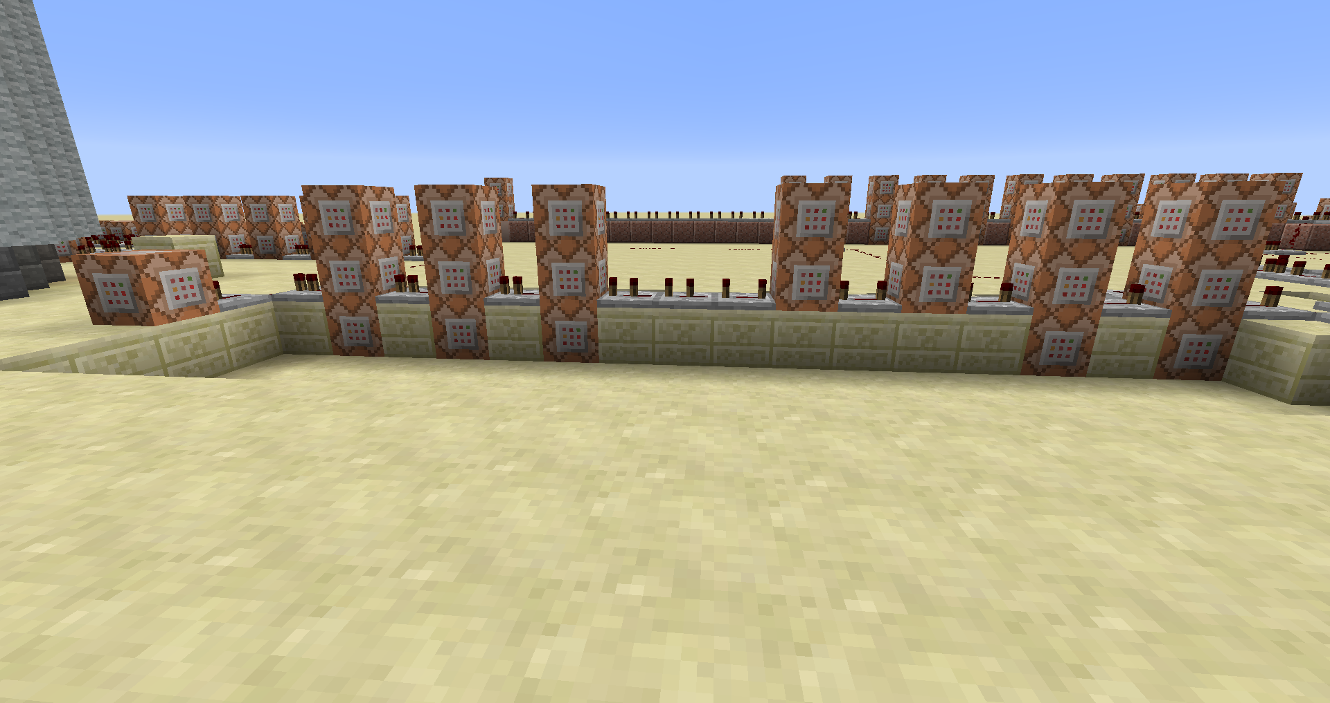

**71**

**70**

**69**

**74**

**73**

**72**

**76**

**75**

**78**

**77**

**81**

**80**

**79**

**84**

**83**

**82**

**87**

**86**

**85**

**88**

C69:

* Maak voor **alle spelers** hun **inventaris leeg**

C70:

* **Teleporteer** **alle spelers** naar volgende locatie

|  |  |
| --- | --- |
| X | 1051 |
| Y | 6 |
| Z | -113 |

C71:

* **Verander** de **spelmodus** voor **alle spelers** naar **avontuur**

C72:

* **Zet** **op het scherm** voor **alle speler** in de **subtitel** een **dankbetuiging aan de originele map maker**.

/title @a subtitle {text:"Developed by NeoMc",color:"gold"}

C73:

* **Zet** **op het** **scherm** voor **alle spelers** de **naam van het spel**

/title @a title {text:"Hangman","color":gold}

C74:

* Zet het doel **Correct** op 0 voor **alle spelers**

C75:

* Zet het doel **Mode** op 0 voor **alle spelers**

C76:

* Zet het doel **End** op 0 voor **alle spelers**

C77:

* **Kloon** een gebied

|  |  |  |  |  |  |
| --- | --- | --- | --- | --- | --- |
| X1 | 1100 | X2 | 1100 | X | 1102 |
| Y1 | 3 | Y2 | 3 | Y | 3 |
| Z1 | -175 | Z2 | -175 | Z | -168 |

C78:

* Zet het doel **SlotAdvance** op 0 voor **alle spelers**

C79:

* **Wis** de **titel**

/title @a title {text:""}

C80:

* **Verander** de **subtitel**

/title @a subtitle {text:"Thanks for playing!",color:"green"}

C81:

* **Vul** een gebied met **lucht** op de volgende positie

|  |  |  |  |
| --- | --- | --- | --- |
| X1 | 1044 | X2 | 1029 |
| Y1 | 31 | Y2 | 44 |
| Z1 | -236 | Z2 | -236 |

C82:

* Zet het doel **Endcap** op 0 voor **alle spelers**

C83:

* Zet het doel **End** op 0 voor **alle spelers**

C84:

* Maak voor **alle spelers** hun **inventaris leeg**

C85:

* Zet het doel **Mode** op 0 voor **alle spelers**

C86:

* Zet het doel **Incorrect** op 0 voor **alle spelers**

C87:

* Zet het doel **Fail** op 0 voor **alle spelers**

C88:

* **Neem** **1000000 level** aan **xp** weg van **alle spelers**

## 10de groep: commando blokken 89-105

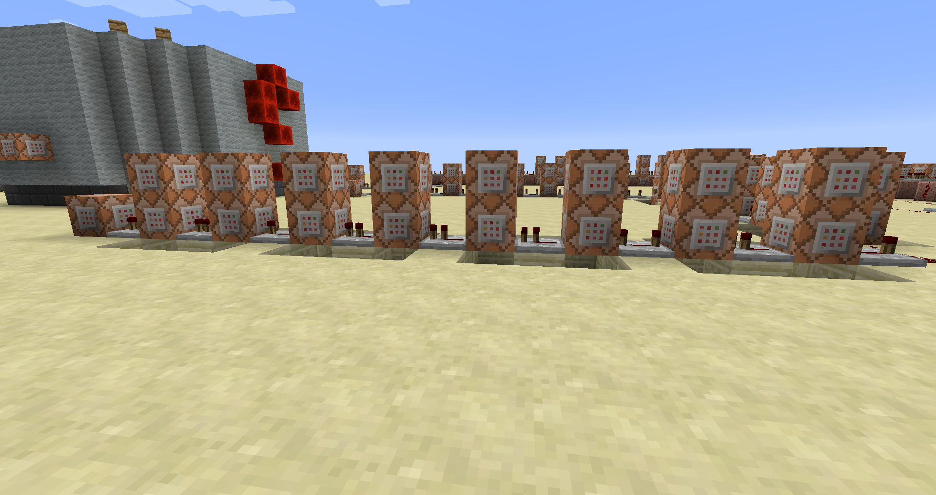

**100**

**105**

**104**

**103**

**102**

**101**

**99**

**98**

**97**

**96**

**95**

**94**

**93**

**92**

**91**

**90**

**89**

C89:

* **Roep** een **vuurwerkpijl** **op**

/summon FireworksRocketEntity 1057 3 -107 {LifeTime:20,FireworksItem:{id:401,Count:1,tag:{Fireworks:{Explosions:[{Type:4,Flicker:1,Trail:1,Colors:[1900324],FadeColors:[16777215]},{Type:4,Flicker:1,Trail:1,Colors:[8781729],FadeColors:[16777215]},{Type:4,Flicker:1,Trail:1,Colors:[1743104],FadeColors:[16777215]},{Type:4,Flicker:1,Trail:1,Colors:[6639876],FadeColors:[16777215]}]}}}}

C90:

* **Roep** een **vuurwerkpijl** **op**

/summon FireworksRocketEntity 1057 3 -119 {LifeTime:20,FireworksItem:{id:401,Count:1,tag:{Fireworks:{Explosions:[{Type:4,Flicker:1,Trail:1,Colors:[1900324],FadeColors:[16777215]},{Type:4,Flicker:1,Trail:1,Colors:[8781729],FadeColors:[16777215]},{Type:4,Flicker:1,Trail:1,Colors:[1743104],FadeColors:[16777215]},{Type:4,Flicker:1,Trail:1,Colors:[6639876],FadeColors:[16777215]}]}}}}

C91:

* **Roep** een **vuurwerkpijl** **op**

/summon FireworksRocketEntity 1045 3 -107 {LifeTime:20,FireworksItem:{id:401,Count:1,tag:{Fireworks:{Explosions:[{Type:4,Flicker:1,Trail:1,Colors:[1900324],FadeColors:[16777215]},{Type:4,Flicker:1,Trail:1,Colors:[8781729],FadeColors:[16777215]},{Type:4,Flicker:1,Trail:1,Colors:[1743104],FadeColors:[16777215]},{Type:4,Flicker:1,Trail:1,Colors:[6639876],FadeColors:[16777215]}]}}}}

C92:

* **Roep** een **vuurwerkpijl** **op**

/summon FireworksRocketEntity 1045 3 -119 {LifeTime:20,FireworksItem:{id:401,Count:1,tag:{Fireworks:{Explosions:[{Type:4,Flicker:1,Trail:1,Colors:[1900324],FadeColors:[16777215]},{Type:4,Flicker:1,Trail:1,Colors:[8781729],FadeColors:[16777215]},{Type:4,Flicker:1,Trail:1,Colors:[1743104],FadeColors:[16777215]},{Type:4,Flicker:1,Trail:1,Colors:[6639876],FadeColors:[16777215]}]}}}}

C93:

* **Roep** een **vuurwerkpijl** **op**

/summon FireworksRocketEntity 1057 3 -107 {LifeTime:20,FireworksItem:{id:401,Count:1,tag:{Fireworks:{Explosions:[{Type:4,Flicker:1,Trail:1,Colors:[1900324],FadeColors:[16777215]},{Type:4,Flicker:1,Trail:1,Colors:[8781729],FadeColors:[16777215]},{Type:4,Flicker:1,Trail:1,Colors:[1743104],FadeColors:[16777215]},{Type:4,Flicker:1,Trail:1,Colors:[6639876],FadeColors:[16777215]}]}}}}

C94:

* **Roep** een **vuurwerkpijl** **op**

/summon FireworksRocketEntity 1057 3 -119 {LifeTime:20,FireworksItem:{id:401,Count:1,tag:{Fireworks:{Explosions:[{Type:4,Flicker:1,Trail:1,Colors:[1900324],FadeColors:[16777215]},{Type:4,Flicker:1,Trail:1,Colors:[8781729],FadeColors:[16777215]},{Type:4,Flicker:1,Trail:1,Colors:[1743104],FadeColors:[16777215]},{Type:4,Flicker:1,Trail:1,Colors:[6639876],FadeColors:[16777215]}]}}}}

C95:

* **Roep** een **vuurwerkpijl** **op**

/summon FireworksRocketEntity 1045 3 -107 {LifeTime:20,FireworksItem:{id:401,Count:1,tag:{Fireworks:{Explosions:[{Type:4,Flicker:1,Trail:1,Colors:[1900324],FadeColors:[16777215]},{Type:4,Flicker:1,Trail:1,Colors:[8781729],FadeColors:[16777215]},{Type:4,Flicker:1,Trail:1,Colors:[1743104],FadeColors:[16777215]},{Type:4,Flicker:1,Trail:1,Colors:[6639876],FadeColors:[16777215]}]}}}}

C96:

* **Roep** een **vuurwerkpijl** **op**

/summon FireworksRocketEntity 1045 3 -119 {LifeTime:20,FireworksItem:{id:401,Count:1,tag:{Fireworks:{Explosions:[{Type:4,Flicker:1,Trail:1,Colors:[1900324],FadeColors:[16777215]},{Type:4,Flicker:1,Trail:1,Colors:[8781729],FadeColors:[16777215]},{Type:4,Flicker:1,Trail:1,Colors:[1743104],FadeColors:[16777215]},{Type:4,Flicker:1,Trail:1,Colors:[6639876],FadeColors:[16777215]}]}}}}

C97:

* **Roep** een **vuurwerkpijl** **op**

/summon FireworksRocketEntity 1057 3 -107 {LifeTime:20,FireworksItem:{id:401,Count:1,tag:{Fireworks:{Explosions:[{Type:4,Flicker:1,Trail:1,Colors:[1900324],FadeColors:[16777215]},{Type:4,Flicker:1,Trail:1,Colors:[8781729],FadeColors:[16777215]},{Type:4,Flicker:1,Trail:1,Colors:[1743104],FadeColors:[16777215]},{Type:4,Flicker:1,Trail:1,Colors:[6639876],FadeColors:[16777215]}]}}}}

C98:

* **Roep** een **vuurwerkpijl** **op**

/summon FireworksRocketEntity 1057 3 -119 {LifeTime:20,FireworksItem:{id:401,Count:1,tag:{Fireworks:{Explosions:[{Type:4,Flicker:1,Trail:1,Colors:[1900324],FadeColors:[16777215]},{Type:4,Flicker:1,Trail:1,Colors:[8781729],FadeColors:[16777215]},{Type:4,Flicker:1,Trail:1,Colors:[1743104],FadeColors:[16777215]},{Type:4,Flicker:1,Trail:1,Colors:[6639876],FadeColors:[16777215]}]}}}}

C99:

* **Roep** een **vuurwerkpijl** **op**

/summon FireworksRocketEntity 1045 3 -107 {LifeTime:20,FireworksItem:{id:401,Count:1,tag:{Fireworks:{Explosions:[{Type:4,Flicker:1,Trail:1,Colors:[1900324],FadeColors:[16777215]},{Type:4,Flicker:1,Trail:1,Colors:[8781729],FadeColors:[16777215]},{Type:4,Flicker:1,Trail:1,Colors:[1743104],FadeColors:[16777215]},{Type:4,Flicker:1,Trail:1,Colors:[6639876],FadeColors:[16777215]}]}}}}

C100:

* **Roep** een **vuurwerkpijl** **op**

/summon FireworksRocketEntity 1045 3 -119 {LifeTime:20,FireworksItem:{id:401,Count:1,tag:{Fireworks:{Explosions:[{Type:4,Flicker:1,Trail:1,Colors:[1900324],FadeColors:[16777215]},{Type:4,Flicker:1,Trail:1,Colors:[8781729],FadeColors:[16777215]},{Type:4,Flicker:1,Trail:1,Colors:[1743104],FadeColors:[16777215]},{Type:4,Flicker:1,Trail:1,Colors:[6639876],FadeColors:[16777215]}]}}}}

C101:

* **Roep** een **vuurwerkpijl** **op**

/summon FireworksRocketEntity 1057 3 -107 {LifeTime:20,FireworksItem:{id:401,Count:1,tag:{Fireworks:{Explosions:[{Type:4,Flicker:1,Trail:1,Colors:[1900324],FadeColors:[16777215]},{Type:4,Flicker:1,Trail:1,Colors:[8781729],FadeColors:[16777215]},{Type:4,Flicker:1,Trail:1,Colors:[1743104],FadeColors:[16777215]},{Type:4,Flicker:1,Trail:1,Colors:[6639876],FadeColors:[16777215]}]}}}}

C102:

* **Roep** een **vuurwerkpijl** **op**

/summon FireworksRocketEntity 1057 3 -119 {LifeTime:20,FireworksItem:{id:401,Count:1,tag:{Fireworks:{Explosions:[{Type:4,Flicker:1,Trail:1,Colors:[1900324],FadeColors:[16777215]},{Type:4,Flicker:1,Trail:1,Colors:[8781729],FadeColors:[16777215]},{Type:4,Flicker:1,Trail:1,Colors:[1743104],FadeColors:[16777215]},{Type:4,Flicker:1,Trail:1,Colors:[6639876],FadeColors:[16777215]}]}}}}

C103:

* **Roep** een **vuurwerkpijl** **op**

/summon FireworksRocketEntity 1045 3 -107 {LifeTime:20,FireworksItem:{id:401,Count:1,tag:{Fireworks:{Explosions:[{Type:4,Flicker:1,Trail:1,Colors:[1900324],FadeColors:[16777215]},{Type:4,Flicker:1,Trail:1,Colors:[8781729],FadeColors:[16777215]},{Type:4,Flicker:1,Trail:1,Colors:[1743104],FadeColors:[16777215]},{Type:4,Flicker:1,Trail:1,Colors:[6639876],FadeColors:[16777215]}]}}}}

C104:

* **Roep** een **vuurwerkpijl** **op**

/summon FireworksRocketEntity 1045 3 -119 {LifeTime:20,FireworksItem:{id:401,Count:1,tag:{Fireworks:{Explosions:[{Type:4,Flicker:1,Trail:1,Colors:[1900324],FadeColors:[16777215]},{Type:4,Flicker:1,Trail:1,Colors:[8781729],FadeColors:[16777215]},{Type:4,Flicker:1,Trail:1,Colors:[1743104],FadeColors:[16777215]},{Type:4,Flicker:1,Trail:1,Colors:[6639876],FadeColors:[16777215]}]}}}}

C105:

* **Speel een geluid** voor **alle spelers**

**random.levelup**

## 11de groep: Commando block 106-120

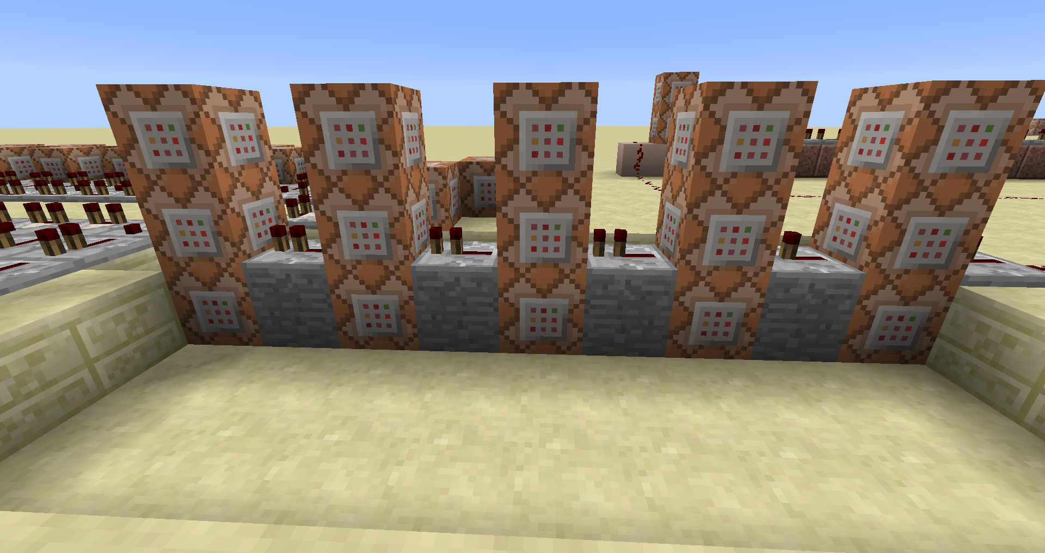

**120**

**119**

**118**

**117**

**116**

**115**

**114**

**113**

**112**

**111**

**110**

**109**

**108**

**107**

**106**

Voor commando blokken 106 tot 120 **update de entity data** **CustomName** naar een **underscore**

C106

/entitydata @e[type=Pig] {CustomName:_}

C107

/entitydata @e[type=Cow] {CustomName:_}

C108

/entitydata @e[type=Chicken] {CustomName:_}

C109

/entitydata @e[type=Zombie] {CustomName:_}

C110

/entitydata @e[type=Sheep] {CustomName:_}

C111

/entitydata @e[type=Skeleton] {CustomName:_}

C112

/entitydata @e[type=Spider] {CustomName:_}

C113

/entitydata @e[type=PigZombie] {CustomName:_}

C114

/entitydata @e[type=CaveSpider] {CustomName:_}

C115

/entitydata @e[type=Villager] {CustomName:_}

C116

/entitydata @e[type=Slime] {CustomName:_}

C117

/entitydata @e[type=EntityHorse] {CustomName:_}

C118

/entitydata @e[type=MushroomCow] {CustomName:_}

C119

/entitydata @e[type=Ozelot] {CustomName:_}

C120

/entitydata @e[type=Rabbit] {CustomName:_}

# Appendix A: Tell Raw/Tittle/Subtittle/Sign/Book het json formaat

Bij elke van deze items kunnen we gestileerde tekst gebruiken. We doen dit aan de hand een json string.

Er bestaan een paar tools om u hierbij te helpen =><https://www.minecraftjson.com/>

We gaan de opbouw van het json formaat doen aan de hand van tellraw. (U kan hiermee experimenteren in de tutorial map)

Gewoon tekst weergeven met het json formaat

{“text”:”Wat tekst”}

/tellraw @a [{“text”:”Wat tekst”}]

We kunnen dit ook opsplitsen als het volgt en toch nog altijd dezelfde output zien.

{“text”:”Wat”},{“text”:”tekst”}

/tellraw @a [{“text”:”Wat”},{“text”:”tekst”}]

Als we gebruik willen maken van de selectors

{“text”:”Wat”},{“text”:”tekst”},{“text”:”voor”},{“selector”:”@p”}

/tellraw @a [{“text”:”Wat”},{“text”:”tekst”},{“text”:”voor”},{“selector”:”@p”}]

Elk van deze tekst objecten kunnen we voorzien van extra informatie

Zo kunnen we van elk woord het kleur veranderen, of onderlijnen, doorstrepen, een link van maken enzovoor

## Kleur

{“text”:”Wat”,”color”:”<kleur>”}

|  |  |  |  |  |  |  |  |
| --- | --- | --- | --- | --- | --- | --- | --- |
| Black |  | Dark_red |  | Dark_gray |  | Red |  |
| Dark_blue |  | Dark_purple |  | Blue |  | Light_purple |  |
| Dark_green |  | Gold |  | Green |  | Yellow |  |
| Dark_aqua |  | Gray |  | Aqua |  | White |  |

## Vette tekst

{“text”:”Wat”,”bold”:true}

## Schuine tekst

{“text”:”Wat”,”italic”:true}

## Onderstrepen van tekst

{“text”:”Wat”,”underlined”:true}

## Doorstrepen van tekst

{“text”:”Wat”,”strikethrough”:true}

## Obfuscatie

{“text”:”Wat”,”obfuscated”:true}



# Appendix B Block ID’s

|  |  |  |  |  |
| --- | --- | --- | --- | --- |
| **Icon** | **Dec** | **Hex** | **Name** | **Block** |
|  | 0 | 0 | minecraft:air | [Air](http://minecraft.gamepedia.com/Air) |
| [Stone.png](http://minecraft.gamepedia.com/File:Stone.png?version=ce443d030d48ac4d005319a6d1fa0b26) | 1 | 1 | minecraft:stone | [Stone](http://minecraft.gamepedia.com/Stone) [S](http://minecraft.gamepedia.com/Data_values#Stone)[B](http://minecraft.gamepedia.com/Data_values#Stone) |
| [Grass.png](http://minecraft.gamepedia.com/File:Grass.png?version=2da7ad9a533cf9618b8b05f3da105883) | 2 | 2 | minecraft:grass | [Grass Block](http://minecraft.gamepedia.com/Grass_Block) |
| [Dirt.png](http://minecraft.gamepedia.com/File:Dirt.png?version=e2eb9ee18e3b17138728163e70c01026) | 3 | 3 | minecraft:dirt | [Dirt](http://minecraft.gamepedia.com/Dirt) [S](http://minecraft.gamepedia.com/Data_values#Dirt)[B](http://minecraft.gamepedia.com/Data_values#Dirt) |
| [Cobblestone.png](http://minecraft.gamepedia.com/File:Cobblestone.png?version=c6c72b002cfc5a6a1419ba3edc674efa) | 4 | 4 | minecraft:cobblestone | [Cobblestone](http://minecraft.gamepedia.com/Cobblestone) |
| [Oak Wood Planks.png](http://minecraft.gamepedia.com/File:Oak_Wood_Planks.png) | 5 | 5 | minecraft:planks | [Wood Planks](http://minecraft.gamepedia.com/Wood_Planks) [S](http://minecraft.gamepedia.com/Data_values#Wood_Planks)[B](http://minecraft.gamepedia.com/Data_values#Wood_Planks) |
| [Sapling.png](http://minecraft.gamepedia.com/File:Sapling.png?version=4e8c164dd06d319b7e8f2a837360ea48) | 6 | 6 | minecraft:sapling | [Sapling](http://minecraft.gamepedia.com/Sapling) [S](http://minecraft.gamepedia.com/Data_values#Sapling)[B](http://minecraft.gamepedia.com/Data_values#Sapling) |
| [Bedrock.png](http://minecraft.gamepedia.com/File:Bedrock.png?version=4bae3c0bdf3aa9c7aff637dfd23d79c6) | 7 | 7 | minecraft:bedrock | [Bedrock](http://minecraft.gamepedia.com/Bedrock) |
| [Water.png](http://minecraft.gamepedia.com/File:Water.png?version=70b235a56d466de7b5ebe95950b7d459) | 8 | 8 | minecraft:flowing_water | [Water](http://minecraft.gamepedia.com/Water) [S](http://minecraft.gamepedia.com/Data_values#Water_and_Lava) |
| [Water.png](http://minecraft.gamepedia.com/File:Water.png?version=70b235a56d466de7b5ebe95950b7d459) | 9 | 9 | minecraft:water | Stationary [Water](http://minecraft.gamepedia.com/Water) [S](http://minecraft.gamepedia.com/Data_values#Water_and_Lava) |
| [Lava.png](http://minecraft.gamepedia.com/File:Lava.png?version=7bc6fbbbb4ec589581da6ee1b9f6c919) | 10 | A | minecraft:flowing_lava | [Lava](http://minecraft.gamepedia.com/Lava) [S](http://minecraft.gamepedia.com/Data_values#Water_and_Lava) |
| [Lava.png](http://minecraft.gamepedia.com/File:Lava.png?version=7bc6fbbbb4ec589581da6ee1b9f6c919) | 11 | B | minecraft:lava | Stationary [Lava](http://minecraft.gamepedia.com/Lava) [S](http://minecraft.gamepedia.com/Data_values#Water_and_Lava) |
| [Sand.png](http://minecraft.gamepedia.com/File:Sand.png?version=7a789946f631561e6f7e6d4cdbbad119) | 12 | C | minecraft:sand | [Sand](http://minecraft.gamepedia.com/Sand) [S](http://minecraft.gamepedia.com/Data_values#Sand)[B](http://minecraft.gamepedia.com/Data_values#Sand) |
| [Gravel.png](http://minecraft.gamepedia.com/File:Gravel.png?version=bad45746dc13d583e17a1d99af51f6f0) | 13 | D | minecraft:gravel | [Gravel](http://minecraft.gamepedia.com/Gravel) |
| [Gold Ore.png](http://minecraft.gamepedia.com/File:Gold_Ore.png) | 14 | E | minecraft:gold_ore | [Gold Ore](http://minecraft.gamepedia.com/Gold_Ore) |
| [Iron Ore.png](http://minecraft.gamepedia.com/File:Iron_Ore.png) | 15 | F | minecraft:iron_ore | [Iron Ore](http://minecraft.gamepedia.com/Iron_Ore) |

|  |  |  |  |  |
| --- | --- | --- | --- | --- |
| **Icon** | **Dec** | **Hex** | **Name** | **Block** |
| [Coal Ore.png](http://minecraft.gamepedia.com/File:Coal_Ore.png) | 16 | 10 | minecraft:coal_ore | [Coal Ore](http://minecraft.gamepedia.com/Coal_Ore) |
| [Wood.png](http://minecraft.gamepedia.com/File:Wood.png?version=739a29bef78db40441ac780e7cce80be) | 17 | 11 | minecraft:log | [Wood](http://minecraft.gamepedia.com/Wood) [S](http://minecraft.gamepedia.com/Data_values#Wood)[B](http://minecraft.gamepedia.com/Data_values#Wood) |
| [Leaves.png](http://minecraft.gamepedia.com/File:Leaves.png?version=41353569aee2208f5d5fe7cd11f1f5b5) | 18 | 12 | minecraft:leaves | [Leaves](http://minecraft.gamepedia.com/Leaves) [S](http://minecraft.gamepedia.com/Data_values#Leaves)[B](http://minecraft.gamepedia.com/Data_values#Leaves) |
| [Sponge.png](http://minecraft.gamepedia.com/File:Sponge.png?version=7f0dec9fe59978de1c446eb1d25009fc) | 19 | 13 | minecraft:sponge | [Sponge](http://minecraft.gamepedia.com/Sponge) [S](http://minecraft.gamepedia.com/Data_values#Sponge)[B](http://minecraft.gamepedia.com/Data_values#Sponge) |
| [Glass.png](http://minecraft.gamepedia.com/File:Glass.png?version=ce909cadc8168daf1ac0f6ee6d4137fd) | 20 | 14 | minecraft:glass | [Glass](http://minecraft.gamepedia.com/Glass) |
| [Lapis Lazuli Ore.png](http://minecraft.gamepedia.com/File:Lapis_Lazuli_Ore.png) | 21 | 15 | minecraft:lapis_ore | [Lapis Lazuli Ore](http://minecraft.gamepedia.com/Lapis_Lazuli_Ore) |
| [Lapis Lazuli Block.png](http://minecraft.gamepedia.com/File:Lapis_Lazuli_Block.png) | 22 | 16 | minecraft:lapis_block | [Lapis Lazuli Block](http://minecraft.gamepedia.com/Lapis_Lazuli_Block) |
| [Dispenser.png](http://minecraft.gamepedia.com/File:Dispenser.png?version=d0a0515f53396dd9dd6d083ab2ca7f5c) | 23 | 17 | minecraft:dispenser | [Dispenser](http://minecraft.gamepedia.com/Dispenser) [S](http://minecraft.gamepedia.com/Data_values#Dispenser_and_Dropper)[E](http://minecraft.gamepedia.com/Block_entity) |
| [Sandstone.png](http://minecraft.gamepedia.com/File:Sandstone.png?version=88e0167ffc14c16cbf136b6f5901b3f1) | 24 | 18 | minecraft:sandstone | [Sandstone](http://minecraft.gamepedia.com/Sandstone) [S](http://minecraft.gamepedia.com/Data_values#Sandstone)[B](http://minecraft.gamepedia.com/Data_values#Sandstone) |
| [Note Block.png](http://minecraft.gamepedia.com/File:Note_Block.png) | 25 | 19 | minecraft:noteblock | [Note Block](http://minecraft.gamepedia.com/Note_Block) [E](http://minecraft.gamepedia.com/Block_entity) |
| [Bed.png](http://minecraft.gamepedia.com/File:Bed.png?version=aeb4592001e81973ba96d56d4f144289) | 26 | 1A | minecraft:bed | [Bed](http://minecraft.gamepedia.com/Bed) [I](http://minecraft.gamepedia.com/Data_values#Item_IDs)[S](http://minecraft.gamepedia.com/Data_values#Bed) |
| [Powered Rail Off.png](http://minecraft.gamepedia.com/File:Powered_Rail_Off.png) | 27 | 1B | minecraft:golden_rail | [Powered Rail](http://minecraft.gamepedia.com/Powered_Rail) [S](http://minecraft.gamepedia.com/Data_values#Rails) |
| [Detector Rail.png](http://minecraft.gamepedia.com/File:Detector_Rail.png) | 28 | 1C | minecraft:detector_rail | [Detector Rail](http://minecraft.gamepedia.com/Detector_Rail) [S](http://minecraft.gamepedia.com/Data_values#Rails) |
| [Sticky Piston.png](http://minecraft.gamepedia.com/File:Sticky_Piston.png) | 29 | 1D | minecraft:sticky_piston | [Sticky Piston](http://minecraft.gamepedia.com/Piston) [S](http://minecraft.gamepedia.com/Data_values#Piston) |
| [WebBlock.png](http://minecraft.gamepedia.com/File:WebBlock.png?version=df2cb00d78f6588fa87516c69d4f8fe1) | 30 | 1E | minecraft:web | [Cobweb](http://minecraft.gamepedia.com/Cobweb) |
| [Tall Grass.png](http://minecraft.gamepedia.com/File:Tall_Grass.png) | 31 | 1F | minecraft:tallgrass | [Grass](http://minecraft.gamepedia.com/Grass) [S](http://minecraft.gamepedia.com/Data_values#Grass)[B](http://minecraft.gamepedia.com/Data_values#Grass) |

|  |  |  |  |  |
| --- | --- | --- | --- | --- |
| **Icon** | **Dec** | **Hex** | **Name** | **Block** |
| [Dead Bush.png](http://minecraft.gamepedia.com/File:Dead_Bush.png) | 32 | 20 | minecraft:deadbush | [Dead Bush](http://minecraft.gamepedia.com/Dead_Bush) |
| [Piston.png](http://minecraft.gamepedia.com/File:Piston.png?version=3945d55b941e1ce407eaa9d2873fdfb8) | 33 | 21 | minecraft:piston | [Piston](http://minecraft.gamepedia.com/Piston) [S](http://minecraft.gamepedia.com/Data_values#Piston) |
| [Block 34.png](http://minecraft.gamepedia.com/File:Block_34.png) | 34 | 22 | minecraft:piston_head | [Piston Head](http://minecraft.gamepedia.com/Piston#Piston_head) [S](http://minecraft.gamepedia.com/Data_values#Piston_Head) |
| [White Wool.png](http://minecraft.gamepedia.com/File:White_Wool.png) | 35 | 23 | minecraft:wool | [Wool](http://minecraft.gamepedia.com/Wool) [S](http://minecraft.gamepedia.com/Data_values#Wool.2C_Stained_Clay.2C_Stained_Glass_and_Carpet)[B](http://minecraft.gamepedia.com/Data_values#Wool.2C_Stained_Clay.2C_Stained_Glass_and_Carpet) |
|  | 36 | 24 | minecraft:piston_extension | [Block moved by Piston](http://minecraft.gamepedia.com/Piston#Piston_extension) [E](http://minecraft.gamepedia.com/Block_entity) |
| [Dandelion.png](http://minecraft.gamepedia.com/File:Dandelion.png?version=a0d571b8ee553ff405b6674b2b5886e6) | 37 | 25 | minecraft:yellow_flower | [Dandelion](http://minecraft.gamepedia.com/Flowers) |
| [Poppy.png](http://minecraft.gamepedia.com/File:Poppy.png?version=5c20de358459c6fa910b575b9712c000) | 38 | 26 | minecraft:red_flower | [Poppy](http://minecraft.gamepedia.com/Flowers) [S](http://minecraft.gamepedia.com/Data_values#Poppy)[B](http://minecraft.gamepedia.com/Data_values#Poppy) |
| [Brown Mushroom.png](http://minecraft.gamepedia.com/File:Brown_Mushroom.png) | 39 | 27 | minecraft:brown_mushroom | [Brown Mushroom](http://minecraft.gamepedia.com/Mushroom) |
| [Red Mushroom.png](http://minecraft.gamepedia.com/File:Red_Mushroom.png) | 40 | 28 | minecraft:red_mushroom | [Red Mushroom](http://minecraft.gamepedia.com/Mushroom) |
| [Block of Gold.png](http://minecraft.gamepedia.com/File:Block_of_Gold.png) | 41 | 29 | minecraft:gold_block | [Block of Gold](http://minecraft.gamepedia.com/Block_of_Gold) |
| [Block of Iron.png](http://minecraft.gamepedia.com/File:Block_of_Iron.png) | 42 | 2A | minecraft:iron_block | [Block of Iron](http://minecraft.gamepedia.com/Block_of_Iron) |
| [Double Stone Slab.png](http://minecraft.gamepedia.com/File:Double_Stone_Slab.png) | 43 | 2B | minecraft:double_stone_slab | [Double Stone Slab](http://minecraft.gamepedia.com/Slab) [S](http://minecraft.gamepedia.com/Data_values#Slabs)[B](http://minecraft.gamepedia.com/Data_values#Slabs) |
| [Stone Slab.png](http://minecraft.gamepedia.com/File:Stone_Slab.png) | 44 | 2C | minecraft:stone_slab | [Stone Slab](http://minecraft.gamepedia.com/Slab) [S](http://minecraft.gamepedia.com/Data_values#Slabs)[B](http://minecraft.gamepedia.com/Data_values#Slabs) |
| [Bricks.png](http://minecraft.gamepedia.com/File:Bricks.png?version=d55723069ef7cdf17a429e917ce6a3dd) | 45 | 2D | minecraft:brick_block | [Bricks](http://minecraft.gamepedia.com/Bricks) |
| [TNT.png](http://minecraft.gamepedia.com/File:TNT.png?version=e41b1b491722196c093e1dbc3c0d4cd9) | 46 | 2E | minecraft:tnt | [TNT](http://minecraft.gamepedia.com/TNT) |
| [Bookshelf.png](http://minecraft.gamepedia.com/File:Bookshelf.png?version=828dedc8c8cb3ee17cc49b072c2c5608) | 47 | 2F | minecraft:bookshelf | [Bookshelf](http://minecraft.gamepedia.com/Bookshelf) |

|  |  |  |  |  |
| --- | --- | --- | --- | --- |
| **Icon** | **Dec** | **Hex** | **Name** | **Block** |
| [Moss Stone.png](http://minecraft.gamepedia.com/File:Moss_Stone.png) | 48 | 30 | minecraft:mossy_cobblestone | [Moss Stone](http://minecraft.gamepedia.com/Moss_Stone) |
| [Obsidian.png](http://minecraft.gamepedia.com/File:Obsidian.png?version=78dbd27b8f422c50044696f180a32e0c) | 49 | 31 | minecraft:obsidian | [Obsidian](http://minecraft.gamepedia.com/Obsidian) |
| [Torch.png](http://minecraft.gamepedia.com/File:Torch.png?version=e88d21fd6067eff618ded9f9eb031996) | 50 | 32 | minecraft:torch | [Torch](http://minecraft.gamepedia.com/Torch) [S](http://minecraft.gamepedia.com/Data_values#Torches_and_Redstone_Torches) |
| [Fire.png](http://minecraft.gamepedia.com/File:Fire.png?version=ef1ce2bc9f9f4c589415a7f6dc78263f) | 51 | 33 | minecraft:fire | [Fire](http://minecraft.gamepedia.com/Fire) [S](http://minecraft.gamepedia.com/Data_values#Fire) |
| [Monster Spawner.png](http://minecraft.gamepedia.com/File:Monster_Spawner.png) | 52 | 34 | minecraft:mob_spawner | [Monster Spawner](http://minecraft.gamepedia.com/Monster_Spawner) [E](http://minecraft.gamepedia.com/Block_entity) |
| [Oak Wood Stairs.png](http://minecraft.gamepedia.com/File:Oak_Wood_Stairs.png) | 53 | 35 | minecraft:oak_stairs | [Oak Wood Stairs](http://minecraft.gamepedia.com/Stairs) [S](http://minecraft.gamepedia.com/Data_values#Stairs) |
| [Chest.png](http://minecraft.gamepedia.com/File:Chest.png?version=330078b94bfa7fb9ba52911172f6df58) | 54 | 36 | minecraft:chest | [Chest](http://minecraft.gamepedia.com/Chest) [S](http://minecraft.gamepedia.com/Data_values#Ladders.2C_Wall_Signs.2C_Furnaces.2C_Chests.2C_and_Wall_Banners)[E](http://minecraft.gamepedia.com/Block_entity) |
| [Redstone (Wire,Inventory).png](http://minecraft.gamepedia.com/File:Redstone_(Wire,Inventory).png) | 55 | 37 | minecraft:redstone_wire | [Redstone Wire](http://minecraft.gamepedia.com/Redstone) [I](http://minecraft.gamepedia.com/Data_values#Item_IDs)[S](http://minecraft.gamepedia.com/Data_values#Redstone_Wire) |
| [Diamond Ore.png](http://minecraft.gamepedia.com/File:Diamond_Ore.png) | 56 | 38 | minecraft:diamond_ore | [Diamond Ore](http://minecraft.gamepedia.com/Diamond_Ore) |
| [Block of Diamond.png](http://minecraft.gamepedia.com/File:Block_of_Diamond.png) | 57 | 39 | minecraft:diamond_block | [Block of Diamond](http://minecraft.gamepedia.com/Block_of_Diamond) |
| [Crafting Table.png](http://minecraft.gamepedia.com/File:Crafting_Table.png) | 58 | 3A | minecraft:crafting_table | [Crafting Table](http://minecraft.gamepedia.com/Crafting_Table) |
| [Crops.png](http://minecraft.gamepedia.com/File:Crops.png?version=be4df1c09081dc572cdf7586f4e7a22b) | 59 | 3B | minecraft:wheat | [Wheat](http://minecraft.gamepedia.com/Seeds) [I](http://minecraft.gamepedia.com/Data_values#Item_IDs)[S](http://minecraft.gamepedia.com/Data_values#Crops) |
| [Farmland.png](http://minecraft.gamepedia.com/File:Farmland.png?version=6236a39ae53e27e9d82261dfd9437ef1) | 60 | 3C | minecraft:farmland | [Farmland](http://minecraft.gamepedia.com/Farmland) [S](http://minecraft.gamepedia.com/Data_values#Farmland) |
| [Furnace.png](http://minecraft.gamepedia.com/File:Furnace.png?version=61adb9d83b71b232d0150f16050ed52a) | 61 | 3D | minecraft:furnace | [Furnace](http://minecraft.gamepedia.com/Furnace) [S](http://minecraft.gamepedia.com/Data_values#Ladders.2C_Wall_Signs.2C_Furnaces.2C_Chests.2C_and_Wall_Banners)[E](http://minecraft.gamepedia.com/Block_entity) |
| [Furnace (Active).png](http://minecraft.gamepedia.com/File:Furnace_(Active).png) | 62 | 3E | minecraft:lit_furnace | [Burning Furnace](http://minecraft.gamepedia.com/Furnace) [S](http://minecraft.gamepedia.com/Data_values#Ladders.2C_Wall_Signs.2C_Furnaces.2C_Chests.2C_and_Wall_Banners)[E](http://minecraft.gamepedia.com/Block_entity) |
| [Sign.png](http://minecraft.gamepedia.com/File:Sign.png?version=c195293b6e37b7366a6dfca18ed028cd) | 63 | 3F | minecraft:standing_sign | Standing [Sign](http://minecraft.gamepedia.com/Sign) [I](http://minecraft.gamepedia.com/Data_values#Item_IDs)[S](http://minecraft.gamepedia.com/Data_values#Sign_Posts_and_Standing_Banners)[E](http://minecraft.gamepedia.com/Block_entity) |

|  |  |  |  |  |
| --- | --- | --- | --- | --- |
| **Icon** | **Dec** | **Hex** | **Name** | **Block** |
| [Wooden Door.png](http://minecraft.gamepedia.com/File:Wooden_Door.png) | 64 | 40 | minecraft:wooden_door | [Oak Door](http://minecraft.gamepedia.com/Door) [I](http://minecraft.gamepedia.com/Data_values#Item_IDs)[S](http://minecraft.gamepedia.com/Data_values#Door) |
| [Ladder.png](http://minecraft.gamepedia.com/File:Ladder.png?version=e2df7d9b0fb89cadf927135e754c9228) | 65 | 41 | minecraft:ladder | [Ladder](http://minecraft.gamepedia.com/Ladder) [S](http://minecraft.gamepedia.com/Data_values#Ladders.2C_Wall_Signs.2C_Furnaces.2C_and_Chests) |
| [Rail.png](http://minecraft.gamepedia.com/File:Rail.png?version=1e91e8cecbc70d53eabd067540848e5c) | 66 | 42 | minecraft:rail | [Rail](http://minecraft.gamepedia.com/Rail) [S](http://minecraft.gamepedia.com/Data_values#Rails) |
| [Cobblestone Stairs.png](http://minecraft.gamepedia.com/File:Cobblestone_Stairs.png) | 67 | 43 | minecraft:stone_stairs | [Cobblestone Stairs](http://minecraft.gamepedia.com/Stairs) [S](http://minecraft.gamepedia.com/Data_values#Stairs) |
| [Wall Sign.png](http://minecraft.gamepedia.com/File:Wall_Sign.png) | 68 | 44 | minecraft:wall_sign | Wall [Sign](http://minecraft.gamepedia.com/Sign) [I](http://minecraft.gamepedia.com/Data_values#Item_IDs)[S](http://minecraft.gamepedia.com/Data_values#Ladders.2C_Wall_Signs.2C_Furnaces.2C_Chests.2C_and_Wall_Banners)[E](http://minecraft.gamepedia.com/Block_entity) |
| [Lever.png](http://minecraft.gamepedia.com/File:Lever.png?version=6a7691faf76129346750c96f1b0d9a97) | 69 | 45 | minecraft:lever | [Lever](http://minecraft.gamepedia.com/Lever) [S](http://minecraft.gamepedia.com/Data_values#Levers) |
| [Stone Pressure Plate.png](http://minecraft.gamepedia.com/File:Stone_Pressure_Plate.png) | 70 | 46 | minecraft:stone_pressure_plate | [Stone Pressure Plate](http://minecraft.gamepedia.com/Pressure_Plate) [S](http://minecraft.gamepedia.com/Data_values#Pressure_Plates) |
| [Iron Door.png](http://minecraft.gamepedia.com/File:Iron_Door.png) | 71 | 47 | minecraft:iron_door | [Iron Door](http://minecraft.gamepedia.com/Iron_Door) [I](http://minecraft.gamepedia.com/Data_values#Item_IDs)[S](http://minecraft.gamepedia.com/Data_values#Door) |
| [Wooden Pressure Plate.png](http://minecraft.gamepedia.com/File:Wooden_Pressure_Plate.png) | 72 | 48 | minecraft:wooden_pressure_plate | [Wooden Pressure Plate](http://minecraft.gamepedia.com/Pressure_Plate) [S](http://minecraft.gamepedia.com/Data_values#Pressure_Plates) |
| [Redstone Ore.png](http://minecraft.gamepedia.com/File:Redstone_Ore.png) | 73 | 49 | minecraft:redstone_ore | [Redstone Ore](http://minecraft.gamepedia.com/Redstone_Ore) |
| [Redstone Ore.png](http://minecraft.gamepedia.com/File:Redstone_Ore.png) | 74 | 4A | minecraft:lit_redstone_ore | Glowing [Redstone Ore](http://minecraft.gamepedia.com/Redstone_Ore) |
| [Redstone (Torch, Inactive).png](http://minecraft.gamepedia.com/File:Redstone_(Torch,_Inactive).png) | 75 | 4B | minecraft:unlit_redstone_torch | [Redstone Torch](http://minecraft.gamepedia.com/Redstone_Torch) (inactive) [S](http://minecraft.gamepedia.com/Data_values#Torches_and_Redstone_Torches) |
| [Redstone (Torch, Active).png](http://minecraft.gamepedia.com/File:Redstone_(Torch,_Active).png) | 76 | 4C | minecraft:redstone_torch | [Redstone Torch](http://minecraft.gamepedia.com/Redstone_Torch) (active) [S](http://minecraft.gamepedia.com/Data_values#Torches_and_Redstone_Torches) |
| [Stone Button.png](http://minecraft.gamepedia.com/File:Stone_Button.png) | 77 | 4D | minecraft:stone_button | [Stone Button](http://minecraft.gamepedia.com/Button) [S](http://minecraft.gamepedia.com/Data_values#Buttons) |
| [Snow.png](http://minecraft.gamepedia.com/File:Snow.png?version=b872ac817175a847a3739057c6d4180f) | 78 | 4E | minecraft:snow_layer | [Snow](http://minecraft.gamepedia.com/Snow_(layer)) (layer) [S](http://minecraft.gamepedia.com/Data_values#Snow)[B](http://minecraft.gamepedia.com/Data_values#Snow) |
| [Ice.png](http://minecraft.gamepedia.com/File:Ice.png?version=00920f7954e1c9545f62ffda520e436b) | 79 | 4F | minecraft:ice | [Ice](http://minecraft.gamepedia.com/Ice) |

|  |  |  |  |  |
| --- | --- | --- | --- | --- |
| **Icon** | **Dec** | **Hex** | **Name** | **Block** |
| [Snow (Block).png](http://minecraft.gamepedia.com/File:Snow_(Block).png) | 80 | 50 | minecraft:snow | [Snow](http://minecraft.gamepedia.com/Snow) |
| [Cactus.png](http://minecraft.gamepedia.com/File:Cactus.png?version=f7602fe1a4dda4d7d431f66292a0fed5) | 81 | 51 | minecraft:cactus | [Cactus](http://minecraft.gamepedia.com/Cactus) [S](http://minecraft.gamepedia.com/Data_values#Cactus) |
| [Clay Block.png](http://minecraft.gamepedia.com/File:Clay_Block.png) | 82 | 52 | minecraft:clay | [Clay](http://minecraft.gamepedia.com/Clay_(block)) |
| [Sugar Canes.png](http://minecraft.gamepedia.com/File:Sugar_Canes.png) | 83 | 53 | minecraft:reeds | [Sugar Cane](http://minecraft.gamepedia.com/Sugar_Cane) [I](http://minecraft.gamepedia.com/Data_values#Item_IDs)[S](http://minecraft.gamepedia.com/Data_values#Sugar_Cane) |
| [Jukebox.png](http://minecraft.gamepedia.com/File:Jukebox.png?version=411ed828be1fdcae56701be43abf03ec) | 84 | 54 | minecraft:jukebox | [Jukebox](http://minecraft.gamepedia.com/Jukebox) [S](http://minecraft.gamepedia.com/Data_values#Jukebox)[E](http://minecraft.gamepedia.com/Block_entity) |
| [Fence.png](http://minecraft.gamepedia.com/File:Fence.png?version=534b7080b33abf5cfbdaf00c737cb062) | 85 | 55 | minecraft:fence | [Fence](http://minecraft.gamepedia.com/Fence) |
| [Pumpkin.png](http://minecraft.gamepedia.com/File:Pumpkin.png?version=134cf783c3b12ff31a6f7dff87a05c83) | 86 | 56 | minecraft:pumpkin | [Pumpkin](http://minecraft.gamepedia.com/Pumpkin) [S](http://minecraft.gamepedia.com/Data_values#Pumpkins_and_Jack-O-Lanterns) |
| [Netherrack.png](http://minecraft.gamepedia.com/File:Netherrack.png?version=cb3648758e47be3f0d049be9d8d476f9) | 87 | 57 | minecraft:netherrack | [Netherrack](http://minecraft.gamepedia.com/Netherrack) |
| [Soul Sand.png](http://minecraft.gamepedia.com/File:Soul_Sand.png) | 88 | 58 | minecraft:soul_sand | [Soul Sand](http://minecraft.gamepedia.com/Soul_Sand) |
| [Glowstone.png](http://minecraft.gamepedia.com/File:Glowstone.png?version=e2fdce22f7afa303e2231177f888d120) | 89 | 59 | minecraft:glowstone | [Glowstone](http://minecraft.gamepedia.com/Glowstone) |
| [Portal.png](http://minecraft.gamepedia.com/File:Portal.png?version=8c7b827dde7bdcba6efaa7b1e724d990) | 90 | 5A | minecraft:portal | Nether [Portal](http://minecraft.gamepedia.com/Nether_Portal_(block)) |
| [Jack o'Lantern.png](http://minecraft.gamepedia.com/File:Jack_o'Lantern.png) | 91 | 5B | minecraft:lit_pumpkin | [Jack o'Lantern](http://minecraft.gamepedia.com/Jack_o%27Lantern) [S](http://minecraft.gamepedia.com/Data_values#Pumpkins_and_Jack-O-Lanterns) |
| [Cake.png](http://minecraft.gamepedia.com/File:Cake.png?version=8ae049db84fdc1793a134c0ec3c590db) | 92 | 5C | minecraft:cake | [Cake](http://minecraft.gamepedia.com/Cake) [I](http://minecraft.gamepedia.com/Data_values#Item_IDs)[S](http://minecraft.gamepedia.com/Data_values#Cake) |
| [Redstone (Repeater, Inactive).png](http://minecraft.gamepedia.com/File:Redstone_(Repeater,_Inactive).png) | 93 | 5D | minecraft:unpowered_repeater | [Redstone Repeater](http://minecraft.gamepedia.com/Redstone_Repeater) (inactive) [I](http://minecraft.gamepedia.com/Data_values#Item_IDs)[S](http://minecraft.gamepedia.com/Data_values#Redstone_Repeater) |
| [Redstone (Repeater, Active).png](http://minecraft.gamepedia.com/File:Redstone_(Repeater,_Active).png) | 94 | 5E | minecraft:powered_repeater | [Redstone Repeater](http://minecraft.gamepedia.com/Redstone_Repeater) (active) [I](http://minecraft.gamepedia.com/Data_values#Item_IDs)[S](http://minecraft.gamepedia.com/Data_values#Redstone_Repeater) |
| [White Stained Glass.png](http://minecraft.gamepedia.com/File:White_Stained_Glass.png) | 95 | 5F | minecraft:stained_glass | [Stained Glass](http://minecraft.gamepedia.com/Stained_Glass) [S](http://minecraft.gamepedia.com/Data_values#Wool.2C_Stained_Clay.2C_Stained_Glass_and_Carpet)[B](http://minecraft.gamepedia.com/Data_values#Wool.2C_Stained_Clay.2C_Stained_Glass_and_Carpet) |

|  |  |  |  |  |
| --- | --- | --- | --- | --- |
| **Icon** | **Dec** | **Hex** | **Name** | **Block** |
| [Trapdoor.png](http://minecraft.gamepedia.com/File:Trapdoor.png?version=5f5768392deb7f475fc3b936176bff98) | 96 | 60 | minecraft:trapdoor | [Trapdoor](http://minecraft.gamepedia.com/Trapdoor) [S](http://minecraft.gamepedia.com/Data_values#Trapdoors) |
| [Stone.png](http://minecraft.gamepedia.com/File:Stone.png?version=ce443d030d48ac4d005319a6d1fa0b26) | 97 | 61 | minecraft:monster_egg | [Monster Egg](http://minecraft.gamepedia.com/Monster_Egg) [S](http://minecraft.gamepedia.com/Data_values#Monster_Egg)[B](http://minecraft.gamepedia.com/Data_values#Monster_Egg) |
| [Stone Brick.png](http://minecraft.gamepedia.com/File:Stone_Brick.png) | 98 | 62 | minecraft:stonebrick | [Stone Bricks](http://minecraft.gamepedia.com/Stone_Bricks) [S](http://minecraft.gamepedia.com/Data_values#Stone_Bricks)[B](http://minecraft.gamepedia.com/Data_values#Stone_Bricks) |
| [BrownMushroomCap.png](http://minecraft.gamepedia.com/File:BrownMushroomCap.png?version=bdc2bba3fc0b22723c43ddbf52596f65) | 99 | 63 | minecraft:brown_mushroom_block | [Brown Mushroom](http://minecraft.gamepedia.com/Mushroom_(block)) (block) [S](http://minecraft.gamepedia.com/Data_values#Brown_and_red_mushroom_blocks) |
| [RedMushroomCap.png](http://minecraft.gamepedia.com/File:RedMushroomCap.png?version=fcdef9501ac8dc0d7dde0aa1306e6be7) | 100 | 64 | minecraft:red_mushroom_block | [Red Mushroom](http://minecraft.gamepedia.com/Mushroom_(block)) (block) [S](http://minecraft.gamepedia.com/Data_values#Brown_and_red_mushroom_blocks) |
| [Iron Bars.png](http://minecraft.gamepedia.com/File:Iron_Bars.png) | 101 | 65 | minecraft:iron_bars | [Iron Bars](http://minecraft.gamepedia.com/Iron_Bars) |
| [Glass Pane.png](http://minecraft.gamepedia.com/File:Glass_Pane.png) | 102 | 66 | minecraft:glass_pane | [Glass Pane](http://minecraft.gamepedia.com/Glass_Pane) |
| [Melon (Block).png](http://minecraft.gamepedia.com/File:Melon_(Block).png) | 103 | 67 | minecraft:melon_block | [Melon](http://minecraft.gamepedia.com/Melon_(block)) |
| [Seed Stem.png](http://minecraft.gamepedia.com/File:Seed_Stem.png) | 104 | 68 | minecraft:pumpkin_stem | [Pumpkin Stem](http://minecraft.gamepedia.com/Pumpkin_Seeds) [S](http://minecraft.gamepedia.com/Data_values#Pumpkin_stem_and_Melon_stem) |
| [Seed Stem.png](http://minecraft.gamepedia.com/File:Seed_Stem.png) | 105 | 69 | minecraft:melon_stem | [Melon Stem](http://minecraft.gamepedia.com/Melon_Seeds) [S](http://minecraft.gamepedia.com/Data_values#Pumpkin_stem_and_Melon_stem) |
| [Vines.png](http://minecraft.gamepedia.com/File:Vines.png?version=961917b01ccdbc479070e126a289e5ac) | 106 | 6A | minecraft:vine | [Vines](http://minecraft.gamepedia.com/Vines) [S](http://minecraft.gamepedia.com/Data_values#Vines) |
| [Fence Gate (Closed).png](http://minecraft.gamepedia.com/File:Fence_Gate_(Closed).png) | 107 | 6B | minecraft:fence_gate | [Fence Gate](http://minecraft.gamepedia.com/Fence_Gate) [S](http://minecraft.gamepedia.com/Data_values#Fence_Gates) |
| [Brick Stairs.png](http://minecraft.gamepedia.com/File:Brick_Stairs.png) | 108 | 6C | minecraft:brick_stairs | [Brick Stairs](http://minecraft.gamepedia.com/Stairs) [S](http://minecraft.gamepedia.com/Data_values#Stairs) |
| [Stone Brick Stairs.png](http://minecraft.gamepedia.com/File:Stone_Brick_Stairs.png) | 109 | 6D | minecraft:stone_brick_stairs | [Stone Brick Stairs](http://minecraft.gamepedia.com/Stairs) [S](http://minecraft.gamepedia.com/Data_values#Stairs) |
| [Mycelium.png](http://minecraft.gamepedia.com/File:Mycelium.png?version=15548552fdee13725010e0c45df53bbc) | 110 | 6E | minecraft:mycelium | [Mycelium](http://minecraft.gamepedia.com/Mycelium) |
| [Lily Pad.png](http://minecraft.gamepedia.com/File:Lily_Pad.png) | 111 | 6F | minecraft:waterlily | [Lily Pad](http://minecraft.gamepedia.com/Lily_Pad) |

|  |  |  |  |  |
| --- | --- | --- | --- | --- |
| **Icon** | **Dec** | **Hex** | **Name** | **Block** |
| [Nether Brick.png](http://minecraft.gamepedia.com/File:Nether_Brick.png) | 112 | 70 | minecraft:nether_brick | [Nether Brick](http://minecraft.gamepedia.com/Nether_Brick) |
| [Nether Brick Fence.png](http://minecraft.gamepedia.com/File:Nether_Brick_Fence.png) | 113 | 71 | minecraft:nether_brick_fence | [Nether Brick Fence](http://minecraft.gamepedia.com/Nether_Brick_Fence) |
| [Nether Brick Stairs.png](http://minecraft.gamepedia.com/File:Nether_Brick_Stairs.png) | 114 | 72 | minecraft:nether_brick_stairs | [Nether Brick Stairs](http://minecraft.gamepedia.com/Stairs) [S](http://minecraft.gamepedia.com/Data_values#Stairs) |
| [Nether Wart.png](http://minecraft.gamepedia.com/File:Nether_Wart.png) | 115 | 73 | minecraft:nether_wart | [Nether Wart](http://minecraft.gamepedia.com/Nether_Wart) [I](http://minecraft.gamepedia.com/Data_values#Item_IDs)[S](http://minecraft.gamepedia.com/Data_values#Nether_Wart) |
| [Enchantment Table.png](http://minecraft.gamepedia.com/File:Enchantment_Table.png) | 116 | 74 | minecraft:enchanting_table | [Enchantment Table](http://minecraft.gamepedia.com/Enchantment_Table) [E](http://minecraft.gamepedia.com/Block_entity) |
| [Brewing Stand.png](http://minecraft.gamepedia.com/File:Brewing_Stand.png) | 117 | 75 | minecraft:brewing_stand | [Brewing Stand](http://minecraft.gamepedia.com/Brewing_Stand) [I](http://minecraft.gamepedia.com/Data_values#Item_IDs)[S](http://minecraft.gamepedia.com/Data_values#Brewing_Stand)[E](http://minecraft.gamepedia.com/Block_entity) |
| [Cauldron.png](http://minecraft.gamepedia.com/File:Cauldron.png?version=7be34edca1a623934d60bfc4805c1256) | 118 | 76 | minecraft:cauldron | [Cauldron](http://minecraft.gamepedia.com/Cauldron) [I](http://minecraft.gamepedia.com/Data_values#Item_IDs)[S](http://minecraft.gamepedia.com/Data_values#Cauldron) |
| [End Portal.png](http://minecraft.gamepedia.com/File:End_Portal.png) | 119 | 77 | minecraft:end_portal | [End Portal](http://minecraft.gamepedia.com/End_Portal_(block)) [E](http://minecraft.gamepedia.com/Block_entity) |
| [End Portal Frame.png](http://minecraft.gamepedia.com/File:End_Portal_Frame.png) | 120 | 78 | minecraft:end_portal_frame | [End Portal Frame](http://minecraft.gamepedia.com/End_Portal_Frame) [S](http://minecraft.gamepedia.com/Data_values#End_Portal_Frame) |
| [End Stone.png](http://minecraft.gamepedia.com/File:End_Stone.png) | 121 | 79 | minecraft:end_stone | [End Stone](http://minecraft.gamepedia.com/End_Stone) |
| [Dragon Egg.png](http://minecraft.gamepedia.com/File:Dragon_Egg.png) | 122 | 7A | minecraft:dragon_egg | [Dragon Egg](http://minecraft.gamepedia.com/Dragon_Egg) |
| [Redstone Lamp.png](http://minecraft.gamepedia.com/File:Redstone_Lamp.png) | 123 | 7B | minecraft:redstone_lamp | [Redstone Lamp](http://minecraft.gamepedia.com/Redstone_Lamp) (inactive) |
| [Redstone Lamp (Active).png](http://minecraft.gamepedia.com/File:Redstone_Lamp_(Active).png) | 124 | 7C | minecraft:lit_redstone_lamp | [Redstone Lamp](http://minecraft.gamepedia.com/Redstone_Lamp) (active) |
| [Oak Wood Planks.png](http://minecraft.gamepedia.com/File:Oak_Wood_Planks.png) | 125 | 7D | minecraft:double_wooden_slab | [Double Wooden Slab](http://minecraft.gamepedia.com/Slabs) [S](http://minecraft.gamepedia.com/Data_values#Slabs)[B](http://minecraft.gamepedia.com/Data_values#Slabs) |
| [Oak-Wood Slab.png](http://minecraft.gamepedia.com/File:Oak-Wood_Slab.png) | 126 | 7E | minecraft:wooden_slab | [Wooden Slab](http://minecraft.gamepedia.com/Slabs) [S](http://minecraft.gamepedia.com/Data_values#Slabs)[B](http://minecraft.gamepedia.com/Data_values#Slabs) |
| [Cocoa Plant.png](http://minecraft.gamepedia.com/File:Cocoa_Plant.png) | 127 | 7F | minecraft:cocoa | [Cocoa](http://minecraft.gamepedia.com/Cocoa) [I](http://minecraft.gamepedia.com/Data_values#Item_IDs)[S](http://minecraft.gamepedia.com/Data_values#Cocoas) |

|  |  |  |  |  |
| --- | --- | --- | --- | --- |
| **Icon** | **Dec** | **Hex** | **Name** | **Block** |
| [Sandstone Stairs.png](http://minecraft.gamepedia.com/File:Sandstone_Stairs.png) | 128 | 80 | minecraft:sandstone_stairs | [Sandstone Stairs](http://minecraft.gamepedia.com/Stairs) [S](http://minecraft.gamepedia.com/Data_values#Stairs) |
| [Emerald Ore.png](http://minecraft.gamepedia.com/File:Emerald_Ore.png) | 129 | 81 | minecraft:emerald_ore | [Emerald Ore](http://minecraft.gamepedia.com/Emerald_Ore) |
| [Ender Chest.png](http://minecraft.gamepedia.com/File:Ender_Chest.png) | 130 | 82 | minecraft:ender_chest | [Ender Chest](http://minecraft.gamepedia.com/Ender_Chest) [S](http://minecraft.gamepedia.com/Data_values#Ladders.2C_Wall_Signs.2C_Furnaces.2C_Chests.2C_and_Wall_Banners)[E](http://minecraft.gamepedia.com/Block_entity) |
| [Tripwire Hook.png](http://minecraft.gamepedia.com/File:Tripwire_Hook.png) | 131 | 83 | minecraft:tripwire_hook | [Tripwire Hook](http://minecraft.gamepedia.com/Tripwire_Hook) [S](http://minecraft.gamepedia.com/Data_values#Tripwire_Hook) |
| [Tripwire.png](http://minecraft.gamepedia.com/File:Tripwire.png?version=251d969e6f6410cf281c94e20ad6a208) | 132 | 84 | minecraft:tripwire | [Tripwire](http://minecraft.gamepedia.com/String#Tripwire) [I](http://minecraft.gamepedia.com/Data_values#Item_IDs)[S](http://minecraft.gamepedia.com/Data_values#Tripwire) |
| [Block of Emerald.png](http://minecraft.gamepedia.com/File:Block_of_Emerald.png) | 133 | 85 | minecraft:emerald_block | [Block of Emerald](http://minecraft.gamepedia.com/Block_of_Emerald) |
| [Spruce Wood Stairs.png](http://minecraft.gamepedia.com/File:Spruce_Wood_Stairs.png) | 134 | 86 | minecraft:spruce_stairs | [Spruce Wood Stairs](http://minecraft.gamepedia.com/Stairs) [S](http://minecraft.gamepedia.com/Data_values#Stairs) |
| [Birch Wood Stairs.png](http://minecraft.gamepedia.com/File:Birch_Wood_Stairs.png) | 135 | 87 | minecraft:birch_stairs | [Birch Wood Stairs](http://minecraft.gamepedia.com/Stairs) [S](http://minecraft.gamepedia.com/Data_values#Stairs) |
| [Jungle Wood Stairs.png](http://minecraft.gamepedia.com/File:Jungle_Wood_Stairs.png) | 136 | 88 | minecraft:jungle_stairs | [Jungle Wood Stairs](http://minecraft.gamepedia.com/Stairs) [S](http://minecraft.gamepedia.com/Data_values#Stairs) |
| [Impulse Command Block.png](http://minecraft.gamepedia.com/File:Impulse_Command_Block.png) | 137 | 89 | minecraft:command_block | [Command Block](http://minecraft.gamepedia.com/Command_Block) [E](http://minecraft.gamepedia.com/Block_entity) |
| [Beacon Block.png](http://minecraft.gamepedia.com/File:Beacon_Block.png) | 138 | 8A | minecraft:beacon | [Beacon](http://minecraft.gamepedia.com/Beacon) [E](http://minecraft.gamepedia.com/Block_entity) |
| [Cobblestone Wall.png](http://minecraft.gamepedia.com/File:Cobblestone_Wall.png) | 139 | 8B | minecraft:cobblestone_wall | [Cobblestone Wall](http://minecraft.gamepedia.com/Cobblestone_Wall) [S](http://minecraft.gamepedia.com/Data_values#Cobblestone_Walls)[B](http://minecraft.gamepedia.com/Data_values#Cobblestone_Walls) |
| [Flower Pot.png](http://minecraft.gamepedia.com/File:Flower_Pot.png) | 140 | 8C | minecraft:flower_pot | [Flower Pot](http://minecraft.gamepedia.com/Flower_Pot) [I](http://minecraft.gamepedia.com/Data_values#Item_IDs)[S](http://minecraft.gamepedia.com/Data_values#Flower_Pots)[E](http://minecraft.gamepedia.com/Block_entity) |
| [Carrot (Block).png](http://minecraft.gamepedia.com/File:Carrot_(Block).png) | 141 | 8D | minecraft:carrots | [Carrot](http://minecraft.gamepedia.com/Carrot) [I](http://minecraft.gamepedia.com/Data_values#Item_IDs)[S](http://minecraft.gamepedia.com/Data_values#Crops) |
| [Potatoes (Block).png](http://minecraft.gamepedia.com/File:Potatoes_(Block).png) | 142 | 8E | minecraft:potatoes | [Potato](http://minecraft.gamepedia.com/Potato) [I](http://minecraft.gamepedia.com/Data_values#Item_IDs)[S](http://minecraft.gamepedia.com/Data_values#Crops) |
| [Wooden Button.png](http://minecraft.gamepedia.com/File:Wooden_Button.png) | 143 | 8F | minecraft:wooden_button | [Wooden Button](http://minecraft.gamepedia.com/Button) [S](http://minecraft.gamepedia.com/Data_values#Buttons) |

|  |  |  |  |  |
| --- | --- | --- | --- | --- |
| **Icon** | **Dec** | **Hex** | **Name** | **Block** |
| [Skeleton Skull.png](http://minecraft.gamepedia.com/File:Skeleton_Skull.png) | 144 | 90 | minecraft:skull | [Mob head](http://minecraft.gamepedia.com/Mob_head) [I](http://minecraft.gamepedia.com/Data_values#Item_IDs)[S](http://minecraft.gamepedia.com/Data_values#Heads)[E](http://minecraft.gamepedia.com/Block_entity) |
| [Anvil.png](http://minecraft.gamepedia.com/File:Anvil.png?version=e81c0bbed446b0c4a559849986bcbafe) | 145 | 91 | minecraft:anvil | [Anvil](http://minecraft.gamepedia.com/Anvil) [S](http://minecraft.gamepedia.com/Data_values#Anvil)[B](http://minecraft.gamepedia.com/Data_values#Anvil) |
| [Trapped Chest.png](http://minecraft.gamepedia.com/File:Trapped_Chest.png) | 146 | 92 | minecraft:trapped_chest | [Trapped Chest](http://minecraft.gamepedia.com/Trapped_Chest) [S](http://minecraft.gamepedia.com/Data_values#Ladders.2C_Wall_Signs.2C_Furnaces.2C_Chests.2C_and_Wall_Banners)[E](http://minecraft.gamepedia.com/Block_entity) |
| [Weighted Pressure Plate (Light).png](http://minecraft.gamepedia.com/File:Weighted_Pressure_Plate_(Light).png) | 147 | 93 | minecraft:light_weighted_pressure_plate | [Weighted Pressure Plate](http://minecraft.gamepedia.com/Weighted_Pressure_Plate)(Light) [S](http://minecraft.gamepedia.com/Data_values#Pressure_Plates) |
| [Weighted Pressure Plate (Heavy).png](http://minecraft.gamepedia.com/File:Weighted_Pressure_Plate_(Heavy).png) | 148 | 94 | minecraft:heavy_weighted_pressure_plate | [Weighted Pressure Plate](http://minecraft.gamepedia.com/Weighted_Pressure_Plate)(Heavy) [S](http://minecraft.gamepedia.com/Data_values#Pressure_Plates) |
| [Redstone Comparator (inactive).png](http://minecraft.gamepedia.com/File:Redstone_Comparator_(inactive).png) | 149 | 95 | minecraft:unpowered_comparator | [Redstone Comparator](http://minecraft.gamepedia.com/Redstone_Comparator) [I](http://minecraft.gamepedia.com/Data_values#Item_IDs)[S](http://minecraft.gamepedia.com/Data_values#Redstone_Comparator) |
| [Redstone Comparator (active).png](http://minecraft.gamepedia.com/File:Redstone_Comparator_(active).png) | 150 | 96 | minecraft:powered_comparator | [Redstone Comparator](http://minecraft.gamepedia.com/Redstone_Comparator)(deprecated) [S](http://minecraft.gamepedia.com/Data_values#Redstone_Comparator) |
| [Daylight Sensor.png](http://minecraft.gamepedia.com/File:Daylight_Sensor.png) | 151 | 97 | minecraft:daylight_detector | [Daylight Sensor](http://minecraft.gamepedia.com/Daylight_Sensor) [E](http://minecraft.gamepedia.com/Block_entity) |
| [Block of Redstone.png](http://minecraft.gamepedia.com/File:Block_of_Redstone.png) | 152 | 98 | minecraft:redstone_block | [Block of Redstone](http://minecraft.gamepedia.com/Block_of_Redstone) |
| [Nether Quartz Ore.png](http://minecraft.gamepedia.com/File:Nether_Quartz_Ore.png) | 153 | 99 | minecraft:quartz_ore | [Nether Quartz Ore](http://minecraft.gamepedia.com/Nether_Quartz_Ore) |
| [Hopper.png](http://minecraft.gamepedia.com/File:Hopper.png?version=5527fa32f5c20260e8a2ec1ced175a54) | 154 | 9A | minecraft:hopper | [Hopper](http://minecraft.gamepedia.com/Hopper) [S](http://minecraft.gamepedia.com/Data_values#Hoppers)[E](http://minecraft.gamepedia.com/Block_entity) |
| [Block of Quartz.png](http://minecraft.gamepedia.com/File:Block_of_Quartz.png) | 155 | 9B | minecraft:quartz_block | [Block of Quartz](http://minecraft.gamepedia.com/Block_of_Quartz) [S](http://minecraft.gamepedia.com/Data_values#Block_of_Quartz)[B](http://minecraft.gamepedia.com/Data_values#Block_of_Quartz) |
| [Quartz Stairs.png](http://minecraft.gamepedia.com/File:Quartz_Stairs.png) | 156 | 9C | minecraft:quartz_stairs | [Quartz Stairs](http://minecraft.gamepedia.com/Stairs) [S](http://minecraft.gamepedia.com/Data_values#Stairs) |
| [Activator Rail.png](http://minecraft.gamepedia.com/File:Activator_Rail.png) | 157 | 9D | minecraft:activator_rail | [Activator Rail](http://minecraft.gamepedia.com/Activator_Rail) [S](http://minecraft.gamepedia.com/Data_values#Rails) |
| [Dropper.png](http://minecraft.gamepedia.com/File:Dropper.png?version=254ec2370c9ca6e22a13fd8ae0668053) | 158 | 9E | minecraft:dropper | [Dropper](http://minecraft.gamepedia.com/Dropper) [S](http://minecraft.gamepedia.com/Data_values#Dispensers_and_Droppers)[E](http://minecraft.gamepedia.com/Block_entity) |
| [White Stained Clay.png](http://minecraft.gamepedia.com/File:White_Stained_Clay.png) | 159 | 9F | minecraft:stained_hardened_clay | [Stained Clay](http://minecraft.gamepedia.com/Stained_Clay) [S](http://minecraft.gamepedia.com/Data_values#Wool.2C_Stained_Clay.2C_Stained_Glass_and_Carpet)[B](http://minecraft.gamepedia.com/Data_values#Wool.2C_Stained_Clay.2C_Stained_Glass_and_Carpet) |

|  |  |  |  |  |
| --- | --- | --- | --- | --- |
| **Icon** | **Dec** | **Hex** | **Name** | **Block** |
| [White Stained Glass Pane.png](http://minecraft.gamepedia.com/File:White_Stained_Glass_Pane.png) | 160 | A0 | minecraft:stained_glass_pane | [Stained Glass Pane](http://minecraft.gamepedia.com/Stained_Glass_Pane) [S](http://minecraft.gamepedia.com/Data_values#Wool.2C_Stained_Clay.2C_Stained_Glass_and_Carpet)[B](http://minecraft.gamepedia.com/Data_values#Wool.2C_Stained_Clay.2C_Stained_Glass_and_Carpet) |
| [Leaves.png](http://minecraft.gamepedia.com/File:Leaves.png?version=41353569aee2208f5d5fe7cd11f1f5b5) | 161 | A1 | minecraft:leaves2 | [Leaves](http://minecraft.gamepedia.com/Leaves) (Acacia/Dark Oak) [S](http://minecraft.gamepedia.com/Data_values#Leaves)[B](http://minecraft.gamepedia.com/Data_values#Leaves) |
| [Acacia Wood.png](http://minecraft.gamepedia.com/File:Acacia_Wood.png) | 162 | A2 | minecraft:log2 | [Wood](http://minecraft.gamepedia.com/Wood) (Acacia/Dark Oak) [S](http://minecraft.gamepedia.com/Data_values#Wood)[B](http://minecraft.gamepedia.com/Data_values#Wood) |
| [Acacia Wood Stairs.png](http://minecraft.gamepedia.com/File:Acacia_Wood_Stairs.png) | 163 | A3 | minecraft:acacia_stairs | [Acacia Wood Stairs](http://minecraft.gamepedia.com/Stairs) [S](http://minecraft.gamepedia.com/Data_values#Stairs) |
| [Dark Oak Wood Stairs.png](http://minecraft.gamepedia.com/File:Dark_Oak_Wood_Stairs.png) | 164 | A4 | minecraft:dark_oak_stairs | [Dark Oak Wood Stairs](http://minecraft.gamepedia.com/Stairs) [S](http://minecraft.gamepedia.com/Data_values#Stairs) |
| [Slime Block.png](http://minecraft.gamepedia.com/File:Slime_Block.png) | 165 | A5 | minecraft:slime | [Slime Block](http://minecraft.gamepedia.com/Slime_Block) |
| [Barrier.png](http://minecraft.gamepedia.com/File:Barrier.png?version=3c2d5a19e316b3dd49c0c399fbefc20e) | 166 | A6 | minecraft:barrier | [Barrier](http://minecraft.gamepedia.com/Barrier) |
| [Iron Trapdoor.png](http://minecraft.gamepedia.com/File:Iron_Trapdoor.png) | 167 | A7 | minecraft:iron_trapdoor | [Iron Trapdoor](http://minecraft.gamepedia.com/Iron_Trapdoor) [S](http://minecraft.gamepedia.com/Data_values#Trapdoors) |
| [Prismarine.png](http://minecraft.gamepedia.com/File:Prismarine.png?version=07b5f2686b5aebf8eeaf1540f138a0d3) | 168 | A8 | minecraft:prismarine | [Prismarine](http://minecraft.gamepedia.com/Prismarine) [S](http://minecraft.gamepedia.com/Data_values#Prismarine)[B](http://minecraft.gamepedia.com/Data_values#Prismarine) |
| [Sea Lantern.png](http://minecraft.gamepedia.com/File:Sea_Lantern.png) | 169 | A9 | minecraft:sea_lantern | [Sea Lantern](http://minecraft.gamepedia.com/Sea_Lantern) |
| [Hay Bale.png](http://minecraft.gamepedia.com/File:Hay_Bale.png) | 170 | AA | minecraft:hay_block | [Hay Bale](http://minecraft.gamepedia.com/Hay_Bale) [S](http://minecraft.gamepedia.com/Data_values#Hay_Bale) |
| [White Carpet.png](http://minecraft.gamepedia.com/File:White_Carpet.png) | 171 | AB | minecraft:carpet | [Carpet](http://minecraft.gamepedia.com/Carpet) [S](http://minecraft.gamepedia.com/Data_values#Wool.2C_Stained_Clay.2C_Stained_Glass_and_Carpet)[B](http://minecraft.gamepedia.com/Data_values#Wool.2C_Stained_Clay.2C_Stained_Glass_and_Carpet) |
| [Hardened Clay.png](http://minecraft.gamepedia.com/File:Hardened_Clay.png) | 172 | AC | minecraft:hardened_clay | [Hardened Clay](http://minecraft.gamepedia.com/Hardened_Clay) |
| [Block of Coal.png](http://minecraft.gamepedia.com/File:Block_of_Coal.png) | 173 | AD | minecraft:coal_block | [Block of Coal](http://minecraft.gamepedia.com/Block_of_Coal) |
| [Packed Ice.png](http://minecraft.gamepedia.com/File:Packed_Ice.png) | 174 | AE | minecraft:packed_ice | [Packed Ice](http://minecraft.gamepedia.com/Packed_Ice) |
| [Sunflower.png](http://minecraft.gamepedia.com/File:Sunflower.png?version=8ff30ba5d461f78781e12ac6463210c6) | 175 | AF | minecraft:double_plant | [Large Flowers](http://minecraft.gamepedia.com/Flowers) [S](http://minecraft.gamepedia.com/Data_values#Large_Flowers)[B](http://minecraft.gamepedia.com/Data_values#Large_Flowers) |

|  |  |  |  |  |
| --- | --- | --- | --- | --- |
| **Icon** | **Dec** | **Hex** | **Name** | **Block** |
| [Free-standing Banner (Small).png](http://minecraft.gamepedia.com/File:Free-standing_Banner_(Small).png) | 176 | B0 | minecraft:standing_banner | Standing [Banner](http://minecraft.gamepedia.com/Banner) [I](http://minecraft.gamepedia.com/Data_values#Item_IDs)[S](http://minecraft.gamepedia.com/Data_values#Sign_Posts_and_Standing_Banners)[E](http://minecraft.gamepedia.com/Block_entity) |
| [Wall-mounted Banner (Small).png](http://minecraft.gamepedia.com/File:Wall-mounted_Banner_(Small).png) | 177 | B1 | minecraft:wall_banner | Wall [Banner](http://minecraft.gamepedia.com/Banner) [I](http://minecraft.gamepedia.com/Data_values#Item_IDs)[S](http://minecraft.gamepedia.com/Data_values#Ladders.2C_Wall_Signs.2C_Furnaces.2C_Chests.2C_and_Wall_Banners)[E](http://minecraft.gamepedia.com/Block_entity) |
| [Inverted Daylight Sensor.png](http://minecraft.gamepedia.com/File:Inverted_Daylight_Sensor.png) | 178 | B2 | minecraft:daylight_detector_inverted | [Inverted Daylight Sensor](http://minecraft.gamepedia.com/Daylight_Sensor) [E](http://minecraft.gamepedia.com/Block_entity) |
| [Red Sandstone.png](http://minecraft.gamepedia.com/File:Red_Sandstone.png) | 179 | B3 | minecraft:red_sandstone | [Red Sandstone](http://minecraft.gamepedia.com/Red_Sandstone) [S](http://minecraft.gamepedia.com/Data_values#Red_Sandstone)[B](http://minecraft.gamepedia.com/Data_values#Red_Sandstone) |
| [Red Sandstone Stairs.png](http://minecraft.gamepedia.com/File:Red_Sandstone_Stairs.png) | 180 | B4 | minecraft:red_sandstone_stairs | [Red Sandstone Stairs](http://minecraft.gamepedia.com/Stairs) [S](http://minecraft.gamepedia.com/Data_values#Stairs) |
| [Red Sandstone.png](http://minecraft.gamepedia.com/File:Red_Sandstone.png) | 181 | B5 | minecraft:double_stone_slab2 | [Double Red Sandstone Slab](http://minecraft.gamepedia.com/Slabs) [S](http://minecraft.gamepedia.com/Data_values#Slabs) |
| [Red Sandstone Slab.png](http://minecraft.gamepedia.com/File:Red_Sandstone_Slab.png) | 182 | B6 | minecraft:stone_slab2 | [Red Sandstone Slab](http://minecraft.gamepedia.com/Slabs) [S](http://minecraft.gamepedia.com/Data_values#Slabs) |
| [Spruce Fence Gate (Closed).png](http://minecraft.gamepedia.com/File:Spruce_Fence_Gate_(Closed).png) | 183 | B7 | minecraft:spruce_fence_gate | [Spruce Fence Gate](http://minecraft.gamepedia.com/Fence_Gate) |
| [Birch Fence Gate (Closed).png](http://minecraft.gamepedia.com/File:Birch_Fence_Gate_(Closed).png) | 184 | B8 | minecraft:birch_fence_gate | [Birch Fence Gate](http://minecraft.gamepedia.com/Fence_Gate) |
| [Jungle Fence Gate (Closed).png](http://minecraft.gamepedia.com/File:Jungle_Fence_Gate_(Closed).png) | 185 | B9 | minecraft:jungle_fence_gate | [Jungle Fence Gate](http://minecraft.gamepedia.com/Fence_Gate) |
| [Dark Oak Fence Gate (Closed).png](http://minecraft.gamepedia.com/File:Dark_Oak_Fence_Gate_(Closed).png) | 186 | BA | minecraft:dark_oak_fence_gate | [Dark Oak Fence Gate](http://minecraft.gamepedia.com/Fence_Gate) |
| [Acacia Fence Gate (Closed).png](http://minecraft.gamepedia.com/File:Acacia_Fence_Gate_(Closed).png) | 187 | BB | minecraft:acacia_fence_gate | [Acacia Fence Gate](http://minecraft.gamepedia.com/Fence_Gate) |
| [Spruce Fence.png](http://minecraft.gamepedia.com/File:Spruce_Fence.png) | 188 | BC | minecraft:spruce_fence | [Spruce Fence](http://minecraft.gamepedia.com/Fence) |
| [Birch Fence.png](http://minecraft.gamepedia.com/File:Birch_Fence.png) | 189 | BD | minecraft:birch_fence | [Birch Fence](http://minecraft.gamepedia.com/Fence) |
| [Jungle Fence.png](http://minecraft.gamepedia.com/File:Jungle_Fence.png) | 190 | BE | minecraft:jungle_fence | [Jungle Fence](http://minecraft.gamepedia.com/Fence) |
| [Dark Oak Fence.png](http://minecraft.gamepedia.com/File:Dark_Oak_Fence.png) | 191 | BF | minecraft:dark_oak_fence | [Dark Oak Fence](http://minecraft.gamepedia.com/Fence) |

|  |  |  |  |  |
| --- | --- | --- | --- | --- |
| **Icon** | **Dec** | **Hex** | **Name** | **Block** |
| [Acacia Fence.png](http://minecraft.gamepedia.com/File:Acacia_Fence.png) | 192 | C0 | minecraft:acacia_fence | [Acacia Fence](http://minecraft.gamepedia.com/Fence) |
| [Spruce Door.png](http://minecraft.gamepedia.com/File:Spruce_Door.png) | 193 | C1 | minecraft:spruce_door | [Spruce Door](http://minecraft.gamepedia.com/Door) [I](http://minecraft.gamepedia.com/Data_values#Item_IDs)[S](http://minecraft.gamepedia.com/Data_values#Door) |
| [Birch Door.png](http://minecraft.gamepedia.com/File:Birch_Door.png) | 194 | C2 | minecraft:birch_door | [Birch Door](http://minecraft.gamepedia.com/Door) [I](http://minecraft.gamepedia.com/Data_values#Item_IDs)[S](http://minecraft.gamepedia.com/Data_values#Door) |
| [Jungle Door.png](http://minecraft.gamepedia.com/File:Jungle_Door.png) | 195 | C3 | minecraft:jungle_door | [Jungle Door](http://minecraft.gamepedia.com/Door) [I](http://minecraft.gamepedia.com/Data_values#Item_IDs)[S](http://minecraft.gamepedia.com/Data_values#Door) |
| [Acacia Door.png](http://minecraft.gamepedia.com/File:Acacia_Door.png) | 196 | C4 | minecraft:acacia_door | [Acacia Door](http://minecraft.gamepedia.com/Door) [I](http://minecraft.gamepedia.com/Data_values#Item_IDs)[S](http://minecraft.gamepedia.com/Data_values#Door) |
| [Dark Oak Door.png](http://minecraft.gamepedia.com/File:Dark_Oak_Door.png) | 197 | C5 | minecraft:dark_oak_door | [Dark Oak Door](http://minecraft.gamepedia.com/Door) [I](http://minecraft.gamepedia.com/Data_values#Item_IDs)[S](http://minecraft.gamepedia.com/Data_values#Door) |
| [End Rod.png](http://minecraft.gamepedia.com/File:End_Rod.png) | 198 | C6 | minecraft:end_rod | [End Rod](http://minecraft.gamepedia.com/End_Rod) |
| [Chorus Plant.png](http://minecraft.gamepedia.com/File:Chorus_Plant.png) | 199 | C7 | minecraft:chorus_plant | [Chorus Plant](http://minecraft.gamepedia.com/Chorus_Plant) |
| [Chorus Flower.png](http://minecraft.gamepedia.com/File:Chorus_Flower.png) | 200 | C8 | minecraft:chorus_flower | [Chorus Flower](http://minecraft.gamepedia.com/Chorus_Flower) |
| [Purpur Block.png](http://minecraft.gamepedia.com/File:Purpur_Block.png) | 201 | C9 | minecraft:purpur_block | [Purpur Block](http://minecraft.gamepedia.com/Purpur_Block) |
| [Purpur Pillar.png](http://minecraft.gamepedia.com/File:Purpur_Pillar.png) | 202 | CA | minecraft:purpur_pillar | [Purpur Pillar](http://minecraft.gamepedia.com/Purpur_Block) |
| [Purpur Stairs.png](http://minecraft.gamepedia.com/File:Purpur_Stairs.png) | 203 | CB | minecraft:purpur_stairs | [Purpur Stairs](http://minecraft.gamepedia.com/Stairs) |
| [Purpur Block.png](http://minecraft.gamepedia.com/File:Purpur_Block.png) | 204 | CC | minecraft:purpur_double_slab | [Purpur Double Slab](http://minecraft.gamepedia.com/Slabs) |
| [Purpur Slab.png](http://minecraft.gamepedia.com/File:Purpur_Slab.png) | 205 | CD | minecraft:purpur_slab | [Purpur Slab](http://minecraft.gamepedia.com/Slabs) |
| [End Stone Bricks.png](http://minecraft.gamepedia.com/File:End_Stone_Bricks.png) | 206 | CE | minecraft:end_bricks | [End Stone Bricks](http://minecraft.gamepedia.com/End_Stone_Bricks) |
| [Beetroot (Block).png](http://minecraft.gamepedia.com/File:Beetroot_(Block).png) | 207 | CF | minecraft:beetroots | [Beetroot Seeds](http://minecraft.gamepedia.com/Beetroot_Seeds) |

|  |  |  |  |  |
| --- | --- | --- | --- | --- |
| **Icon** | **Dec** | **Hex** | **Name** | **Block** |
| [Grass Path.png](http://minecraft.gamepedia.com/File:Grass_Path.png) | 208 | D0 | minecraft:grass_path | [Grass Path](http://minecraft.gamepedia.com/Grass_Path) |
| [End Gateway (block).png](http://minecraft.gamepedia.com/File:End_Gateway_(block).png) | 209 | D1 | minecraft:end_gateway | [End Gateway](http://minecraft.gamepedia.com/End_Gateway_(block)) |
| [Repeating Command Block.png](http://minecraft.gamepedia.com/File:Repeating_Command_Block.png) | 210 | D2 | minecraft:repeating_command_block | [Repeating Command Block](http://minecraft.gamepedia.com/Repeating_Command_Block) [E](http://minecraft.gamepedia.com/Block_entity) |
| [Chain Command Block.png](http://minecraft.gamepedia.com/File:Chain_Command_Block.png) | 211 | D3 | minecraft:chain_command_block | [Chain Command Block](http://minecraft.gamepedia.com/Chain_Command_Block) [E](http://minecraft.gamepedia.com/Block_entity) |
| [Ice.png](http://minecraft.gamepedia.com/File:Ice.png?version=00920f7954e1c9545f62ffda520e436b) | 212 | D4 | minecraft:frosted_ice | [Frosted Ice](http://minecraft.gamepedia.com/Frosted_Ice) [S](http://minecraft.gamepedia.com/Data_values#Frosted_Ice) |
| [Structure Block Save.png](http://minecraft.gamepedia.com/File:Structure_Block_Save.png) | 255 | FF | minecraft:structure_block | [Structure Block](http://minecraft.gamepedia.com/Structure_Block) [S](http://minecraft.gamepedia.com/Data_values#Structure_Block)[E](http://minecraft.gamepedia.com/Block_entity) |

# Appendix C: Sound events

|  |  |  |  |
| --- | --- | --- | --- |
| **Sound Event** | **Sounds Used** | **Category** | **In-Game Event(s)** |
| ambient.cave.cave | ambient/cave/cave1 ambient/cave/cave2 ambient/cave/cave3 ambient/cave/cave4 ambient/cave/cave5 ambient/cave/cave6 ambient/cave/cave6 ambient/cave/cave7 ambient/cave/cave8 ambient/cave/cave9 ambient/cave/cave10 ambient/cave/cave11 ambient/cave/cave12 ambient/cave/cave13 | ambient (Ambient/Environment) | Being within 10-20 blocks of an area not exposed to the sky with a [light](http://minecraft.gamepedia.com/Light) level of less than eight. |
| ambient.weather.rain | ambient/weather/rain1 ambient/weather/rain2 ambient/weather/rain3 ambient/weather/rain4 | weather (Weather) | Being close to the surface of a block open to the sky when it is [raining](http://minecraft.gamepedia.com/Rain). |
| ambient.weather.thunder | ambient/weather/thunder1 ambient/weather/thunder2 ambient/weather/thunder3 | weather (Weather) | Lightning strikes. |
| game.player.hurt.fall.big | damage/fallbig | player (Players) | A player contacting the surface of a block after falling from a tall height. |
| game.player.hurt.fall.small | damage/fallsmall | player (Players) | A player contacting the surface of a block after falling from a short height. |
| game.neutral.hurt.fall.big | damage/fallbig | neutral (Friendly Creatures) | A passive mob contacting the surface of a block after falling from a tall height. |
| game.neutral.hurt.fall.small | damage/fallsmall | neutral (Friendly Creatures) | A passive mob contacting the surface of a block after falling from a short height. |
| game.hostile.hurt.fall.big | damage/fallbig | hostile (Hostile Creatures) | A hostile mob contacting the surface of a block after falling from a tall height. |
| game.hostile.hurt.fall.small | damage/fallsmall | hostile (Hostile Creatures) | A hostile mob contacting the surface of a block after falling from a short height. |
| game.player.hurt | damage/hit1 damage/hit2 damage/hit3 | player (Players) | A player taking damage. |
| game.neutral.hurt | damage/hit1 damage/hit2 damage/hit3 | neutral (Friendly Creatures) | A passive mob taking damage. Always overridden by the damage sound specific to each mob. |
| game.hostile.hurt | damage/hit1 damage/hit2 damage/hit3 | hostile (Hostile Creatures) | A hostile mob taking damage. Used only by [Giants](http://minecraft.gamepedia.com/Giant); overridden by the damage sound specific to each mob in any other case. |
| game.player.die | damage/hit1 damage/hit2 damage/hit3 | player (Players) | A player dies. |
| game.neutral.die | damage/hit1 damage/hit2 damage/hit3 | neutral (Friendly Creatures) | A passive mob dies. Always overridden by the death sound specific to each mob. |
| game.hostile.die | damage/hit1 damage/hit2 damage/hit3 | hostile (Hostile Creatures) | A hostile mob dies. Used only by[Giants](http://minecraft.gamepedia.com/Giant); overridden by the death sound specific to each mob in any other case. |
| dig.cloth | dig/cloth1 dig/cloth2 dig/cloth3 dig/cloth4 | block (Blocks) | Placing or breaking blocks classified as "cloth". |
| dig.grass | dig/grass1 dig/grass2 dig/grass3 dig/grass4 | block (Blocks) | Placing or breaking blocks classified as "grass" or a Sheep eats Grass. |
| dig.gravel | dig/gravel1 dig/gravel2 dig/gravel3 dig/gravel4 | block (Blocks) | Placing or breaking blocks classified as "gravel". |
| dig.sand | dig/sand1 dig/sand2 dig/sand3 dig/sand4 | block (Blocks) | Placing or breaking blocks classified as "sand". |
| dig.snow | dig/snow1 dig/snow2 dig/snow3 dig/snow4 | block (Blocks) | Placing or breaking blocks classified as "snow". |
| dig.stone | dig/stone1 dig/stone2 dig/stone3 dig/stone4 | block (Blocks) | Placing or breaking blocks classified as "stone". |
| dig.wood | dig/wood1 dig/wood2 dig/wood3 dig/wood4 | block (Blocks) | Placing or breaking blocks classified as "wood". |
| fire.fire | fire/fire | block (Blocks) | Being near [Fire](http://minecraft.gamepedia.com/Fire) or a Blaze. |
| fire.ignite | fire/ignite | block (Blocks) | Setting Fire or igniting a Creeper using a [Flint and Steel](http://minecraft.gamepedia.com/Flint_and_Steel). |
| item.fireCharge.use | mob/ghast/fireball4 | block (Blocks) | Setting Fire using a[Fire Charge](http://minecraft.gamepedia.com/Fire_Charge). |
| fireworks.blast | fireworks/blast1 | ambient (Ambient/Environment) | A small, close firework explosion. |
| fireworks.blast_far | fireworks/blast_far1 | ambient (Ambient/Environment) | A small, far firework explosion. |
| fireworks.largeBlast | fireworks/largeBlast1 | ambient (Ambient/Environment) | A large, close firework explosion. |
| fireworks.largeBlast_far | fireworks/largeBlast_far1 | ambient (Ambient/Environment) | A large, far firework explosion. |
| fireworks.launch | fireworks.launch1 | ambient (Ambient/Environment) | A firework being launched by a player or a[dispenser](http://minecraft.gamepedia.com/Dispenser). |
| fireworks.twinkle | fireworks.twinkle1 | ambient (Ambient/Environment) | A close firework twinkles. |
| fireworks.twinkle_far | fireworks.twinkle_far1 | ambient (Ambient/Environment) | A faraway firework twinkles. |
| liquid.lava | liquid/lava | block (Blocks) | Being near [Lava](http://minecraft.gamepedia.com/Lava). |
| liquid.lavapop | liquid/lavapop | block (Blocks) | Randomly when being near Lava. Accompanied by a lava fireball particle effect. |
| game.neutral.swim.splash | liquid/splash liquid/splash2 | neutral (Friendly Creatures) | A passive mob falls into water or a Fishing Rod Bobber is cast into water. |
| game.player.swim.splash | liquid/splash liquid/splash2 | block (Blocks) | A player falls into water. |
| game.hostile.swim.splash | liquid/splash liquid/splash2 | hostile (Hostile Creatures) | A hostile mob falls into water. |
| game.player.swim | liquid/swim1 liquid/swim2 liquid/swim3 liquid/swim4 | player (Players) | A player is swimming. |
| game.neutral.swim | liquid/swim1 liquid/swim2 liquid/swim3 liquid/swim4 | neutral (Friendly Creatures) | A passive mob is swimming. |
| game.hostile.swim | liquid/swim1 liquid/swim2 liquid/swim3 liquid/swim4 | hostile (Hostile Creatures) | A hostile mob is swimming. |
| liquid.water | liquid/water | block (Blocks) | Being near flowing[Water](http://minecraft.gamepedia.com/Water). |
| minecart.base | minecart/base | neutral (Friendly Creatures) | A [minecart](http://minecraft.gamepedia.com/Minecart) moving. |
| minecart.inside | minecart/inside | player (Players) | Being inside a moving minecart. |
| mob.bat.death | mob/bat/death | neutral (Friendly Creatures) | A [Bat](http://minecraft.gamepedia.com/Bat) dies. |
| mob.bat.hurt | mob/bat/hurt1 mob.bat.hurt2 mob.bat.hurt3 mob.bat.hurt4 | neutral (Friendly Creatures) | A Bat taking damage. |
| mob.bat.idle | mob/bat/idle1 mob.bat.idle2 mob.bat.idle3 mob.bat.idle4 | neutral (Friendly Creatures) | Randomly when a Bat is within 16 blocks. |
| mob.bat.loop | mob/bat/loop | neutral (Friendly Creatures) | *None* |
| mob.bat.takeoff | mob/bat/takeoff | neutral (Friendly Creatures) | A Bat takes off/begins to fly. |
| mob.blaze.breathe | mob/blaze/breathe1 mob/blaze/breathe2 mob/blaze/breathe3 mob/blaze/breathe4 | hostile (Hostile Creatures) | Randomly when a[Blaze](http://minecraft.gamepedia.com/Blaze) is within 16 blocks. |
| mob.blaze.death | mob/blaze/death | hostile (Hostile Creatures) | A Blaze dies. |
| mob.blaze.hit | mob/blaze/hit1 mob/blaze/hit2 mob/blaze/hit3 mob/blaze/hit4 | hostile (Hostile Creatures) | A Blaze takes damage. |
| mob.guardian.hit | mob/guardian/guardian_hit1 mob/guardian/guardian_hit2 mob/guardian/guardian_hit3 mob/guardian/guardian_hit4 | hostile (Hostile Creatures) | A regular [Guardian](http://minecraft.gamepedia.com/Guardian)takes damage while in water. |
| mob.guardian.idle | mob/guardian/guardian_idle1 mob/guardian/guardian_idle2 mob/guardian/guardian_idle3 mob/guardian/guardian_idle4 | hostile (Hostile Creatures) | Randomly when a regular Guardian is within 16 blocks and is in water. |
| mob.guardian.death | mob/guardian/guardian_death | hostile (Hostile Creatures) | A regular Guardian dies while in water. |
| mob.guardian.elder.hit | mob/guardian/elder_hit1 mob/guardian/elder_hit2 mob/guardian/elder_hit3 mob/guardian/elder_hit4 | hostile (Hostile Creatures) | An Elder Guardian takes damage while in water. |
| mob.guardian.elder.idle | mob/guardian/elder_idle1 mob/guardian/elder_idle2 mob/guardian/elder_idle3 mob/guardian/elder_idle4 | hostile (Hostile Creatures) | Randomly when an Elder Guardian is within 16 blocks and is in water. |
| mob.guardian.elder.death | mob/guardian/elder_death | hostile (Hostile Creatures) | An Elder Guardian dies while in water. |
| mob.guardian.land.hit | mob/guardian/land_hit1 mob/guardian/land_hit2 mob/guardian/land_hit3 mob/guardian/land_hit4 | hostile (Hostile Creatures) | A Guardian takes damage while not in water. |
| mob.guardian.land.idle | mob/guardian/land_idle1 mob/guardian/land_idle2 mob/guardian/land_idle3 mob/guardian/land_idle4 | hostile (Hostile Creatures) | Randomly when a Guardian is within 16 blocks and not in water. |
| mob.guardian.land.death | mob/guardian/land_death | hostile (Hostile Creatures) | A Guardian dies while not in water. |
| mob.guardian.curse | mob/guardian/curse | hostile (Hostile Creatures) | A player is within 50 blocks of an Elder Guardian and does not have the Mining Fatigue effect, has Mining Fatigue II or lower, or has less than a minute left of Mining Fatigue III. Accompanied by a ghostly image of an Elder Guardian and Mining Fatigue III for five minutes. |
| mob.guardian.attack | mob/guardian/attack_loop | hostile (Hostile Creatures) | A Guardian's attack beam is aimed at a player or a squid. Can be heard up to 50 blocks away due to a bug. |
| mob.guardian.flop | mob/guardian/flop1 mob/guardian/flop2 mob/guardian/flop3 mob/guardian/flop4 | hostile (Hostile Creatures) | A Guardian is hopping around out of water. |
| mob.cat.hiss | mob/cat/hiss1 mob/cat/hiss2 mob/cat/hiss3 | neutral (Friendly Creatures) | *Unknown* |
| mob.cat.hitt | mob/cat/hitt1 mob/cat/hitt2 mob/cat/hitt3 | neutral (Friendly Creatures) | A [Cat](http://minecraft.gamepedia.com/Cat) or [Ocelot](http://minecraft.gamepedia.com/Ocelot)takes damage or dies. |
| mob.cat.meow | mob/cat/meow1 mob/cat/meow2 mob/cat/meow3 mob/cat/meow4 | neutral (Friendly Creatures) | Randomly when a tamed Cat is within 16 blocks. |
| mob.cat.purr | mob/cat/purr1 mob/cat/purr2 mob/cat/purr3 | neutral (Friendly Creatures) | When Tamed Cats mate after being fed[Raw Fish](http://minecraft.gamepedia.com/Raw_Fish). |
| mob.cat.purreow | mob/cat/purreow1 mob/cat/purreow2 | neutral (Friendly Creatures) | Randomly when a Tamed Cat is within 16 blocks. |
| mob.chicken.hurt | mob/chicken/hurt1 mob/chicken/hurt2 | neutral (Friendly Creatures) | A [Chicken](http://minecraft.gamepedia.com/Chicken) takes damage or dies. |
| mob.chicken.plop | mob/chicken/plop | neutral (Friendly Creatures) | A Chicken lays an[Egg](http://minecraft.gamepedia.com/Egg). |
| mob.chicken.say | mob/chicken/say1 mob/chicken/say2 mob/chicken.say3 | neutral (Friendly Creatures) | Randomly when a Chicken is within 16 blocks. |
| mob.chicken.step | mob/chicken/step1 mob/chicken/step2 | neutral (Friendly Creatures) | A Chicken is walking. |
| mob.cow.hurt | mob/cow/hurt1 mob/cow/hurt2 mob/cow/hurt3 | neutral (Friendly Creatures) | A [Cow](http://minecraft.gamepedia.com/Cow) or[Mooshroom](http://minecraft.gamepedia.com/Mooshroom) takes damage or dies. |
| mob.cow.say | mob/cow/say1 mob/cow/say2 mob/cow/say3 mob/cow/say4 | neutral (Friendly Creatures) | Randomly when a Cow or Mooshroom is within 16 blocks. |
| mob.cow.step | mob/cow/step1 mob/cow/step2 mob/cow/step3 mob/cow/step4 | neutral (Friendly Creatures) | A Cow or Mooshroom is walking. |
| mob.creeper.death | mob/creeper/death | hostile (Hostile Creatures) | A [Creeper](http://minecraft.gamepedia.com/Creeper) dies. |
| mob.creeper.say | mob/creeper/say1 mob/creeper/say2 mob/creeper/say3 mob/creeper/say4 | hostile (Hostile Creatures) | A Creeper takes damage. |
| mob.enderdragon.end | mob/enderdragon/end | hostile (Hostile Creatures) | An [Ender Dragon](http://minecraft.gamepedia.com/Ender_Dragon)dies. |
| mob.enderdragon.growl | mob/enderdragon/growl1 mob/enderdragon/growl2 mob/enderdragon/growl3 mob/enderdragon/growl4 | hostile (Hostile Creatures) | Randomly when an Ender Dragon is within 50 blocks of the Player. |
| mob.enderdragon.hit | mob/enderdragon/hit1 mob/enderdragon/hit2 mob/enderdragon/hit3 mob/enderdragon/hit4 | hostile (Hostile Creatures) | An Ender Dragon takes damage. |
| mob.enderdragon.wings | mob/enderdragon/wings1 mob/enderdragon/wings2 mob/enderdragon/wings3 mob/enderdragon/wings4 mob/enderdragon/wings5 mob/enderdragon/wings6 | hostile (Hostile Creatures) | An Ender Dragon flaps its wings. |
| mob.endermen.death | mob/endermen/death | hostile (Hostile Creatures) | An [Enderman](http://minecraft.gamepedia.com/Enderman) dies. |
| mob.endermen.hit | mob/endermen/hit1 mob/endermen/hit2 mob/endermen/hit3 mob/endermen/hit4 | hostile (Hostile Creatures) | An Enderman takes damage. |
| mob.endermen.idle | mob/endermen/idle1 mob/endermen/idle2 mob/endermen/idle3 mob/endermen/idle4 mob/endermen/idle5 | hostile (Hostile Creatures) | Randomly when an Enderman is within 16 blocks and not angry. |
| mob.endermen.portal | mob/endermen/portal mob/endermen/portal2 | hostile (Hostile Creatures) | An Enderman teleports. |
| mob.endermen.scream | mob/endermen/scream1 mob/endermen/scream2 mob/endermen/scream3 mob/endermen/scream4 | hostile (Hostile Creatures) | Randomly when an Endermen is within 16 blocks and angry. |
| mob.endermen.stare | mob/endermen/stare | hostile (Hostile Creatures) | A player looks at an Enderman, angering it. |
| mob.ghast.affectionate_scream | mob/ghast/affectionate_scream | hostile (Hostile Creatures) | *None* |
| mob.ghast.charge | mob/ghast/charge | hostile (Hostile Creatures) | Right before a[Ghast](http://minecraft.gamepedia.com/Ghast) shoots a fireball. |
| mob.ghast.death | mob/ghast/death | hostile (Hostile Creatures) | A Ghast dies. |
| mob.ghast.fireball | mob/ghast/fireball4 | hostile (Hostile Creatures) | A Ghast, Blaze, or Dispenser shoots a fireball. |
| mob.ghast.moan | mob/ghast/moan1 mob/ghast/moan2 mob/ghast/moan3 mob/ghast/moan4 mob/ghast/moan5 mob/ghast/moan6 mob/ghast/moan7 | hostile (Hostile Creatures) | Randomly when a Ghast is within 100 blocks. |
| mob.ghast.scream | mob/ghast/scream1 mob/ghast/scream2 mob/ghast/scream3 mob/ghast/scream4 mob/ghast/scream5 | hostile (Hostile Creatures) | A Ghast takes damage. |
| mob.horse.angry | mob/horse/angry1 | neutral (Friendly Creatures) | A player is thrown off of an untamed[Horse](http://minecraft.gamepedia.com/Horse). |
| mob.horse.armor | mob/horse/armor | neutral (Friendly Creatures) | A player puts Horse Armor onto a Horse. |
| mob.horse.breathe | mob/horse/breathe1 mob/horse/breathe2 mob/horse/breathe3 | neutral (Friendly Creatures) | Randomly when a tamed Horse is galloping. |
| mob.horse.death | mob/horse/death | neutral (Friendly Creatures) | A Horse dies. |
| mob.horse.donkey.angry | mob/horse/donkey/angry1 mob/horse/donkey/angry2 | neutral (Friendly Creatures) | A player is thrown off an untamed Donkey or Mule. |
| mob.horse.donkey.death | mob/horse/donkey/death | neutral (Friendly Creatures) | A Donkey or Mule dies. |
| mob.horse.donkey.hit | mob/horse/donkey/hit1 mob/horse/donkey/hit2 mob/horse/donkey/hit3 | neutral (Friendly Creatures) | A Donkey or Mule takes damage. |
| mob.horse.donkey.idle | mob/horse/donkey/idle1 mob/horse/donkey/idle2 mob/horse/donkey/idle3 | neutral (Friendly Creatures) | Randomly when a Donkey or Mule is within 16 blocks. |
| mob.horse.gallop | mob/horse/gallop1 mob/horse/gallop2 mob/horse/gallop3 mob/horse/gallop4 | neutral (Friendly Creatures) | A ridden Horse is galloping. |
| mob.horse.hit | mob/horse/hit1 mob/horse/hit2 mob/horse/hit3 mob/horse/hit4 | neutral (Friendly Creatures) | A Horse takes damage. |
| mob.horse.idle | mob/horse/idle1 mob/horse/idle2 mob/horse/idle3 | neutral (Friendly Creatures) | Randomly when a Horse is within 16 blocks. |
| mob.horse.jump | mob/horse/jump | neutral (Friendly Creatures) | A Horse jumps while galloping. |
| mob.horse.land | mob/horse/land | neutral (Friendly Creatures) | A Horse lands after jumping. |
| mob.horse.leather | mob/horse/leather | neutral (Friendly Creatures) | A player puts a[Saddle](http://minecraft.gamepedia.com/Saddle) on a Horse or Pig. |
| mob.horse.skeleton.death | mob/horse/skeleton/death | neutral (Friendly Creatures) | A Skeleton Horse dies. |
| mob.horse.skeleton.hit | mob/horse/skeleton/hit1 mob/horse/skeleton/hit2 mob/horse/skeleton/hit3 mob/horse/skeleton/hit4 | neutral (Friendly Creatures) | A Skeleton Horse takes damage. |
| mob.horse.skeleton.idle | mob/horse/skeleton/idle1 mob/horse/skeleton/idle2 mob/horse/skeleton/idle3 | neutral (Friendly Creatures) | Randomly when a Skeleton Horse is within 16 blocks. |
| mob.horse.soft | mob/horse/soft1 mob/horse/soft2 mob/horse/soft3 mob/horse/soft4 mob/horse/soft5 mob/horse/soft6 | neutral (Friendly Creatures) | A Horse (not being ridden) is walking. |
| mob.horse.wood | mob/horse/wood1 mob/horse/wood2 mob/horse/wood3 mob/horse/wood4 mob/horse/wood5 mob/horse/wood6 | neutral (Friendly Creatures) | A ridden Horse is walking. |
| mob.horse.zombie.death | mob/horse/zombie/death | neutral (Friendly Creatures) | A Zombie Horse dies. |
| mob.horse.zombie.hit | mob/horse/zombie/hit1 mob/horse/zombie/hit2 mob/horse/zombie/hit3 mob/horse/zombie/hit4 | neutral (Friendly Creatures) | A Zombie Horse takes damage. |
| mob.horse.zombie.idle | mob/horse/zombie/idle1 mob/horse/zombie/idle2 mob/horse/zombie/idle3 | neutral (Friendly Creatures) | Randomly when a Zombie Horse is within 16 blocks. |
| mob.irongolem.death | mob/irongolem/death | neutral (Friendly Creatures) | An [Iron Golem](http://minecraft.gamepedia.com/Iron_Golem) dies. |
| mob.irongolem.hit | mob/irongolem/hit1 mob/irongolem/hit2 mob/irongolem/hit3 mob/irongolem/hit4 | neutral (Friendly Creatures) | An Iron Golem takes damage. |
| mob.irongolem.throw | mob/irongolem/throw | neutral (Friendly Creatures) | An Iron Golem attacks a mob. |
| mob.irongolem.walk | mob/irongolem/walk1 mob/irongolem/walk2 mob/irongolem/walk3 mob/irongolem/walk4 | neutral (Friendly Creatures) | An Iron Golem is walking. |
| mob.magmacube.big | mob/magmacube/big1 mob/magmacube/big2 mob/magmacube/big3 mob/magmacube/big4 | hostile (Hostile Creatures) | A big or small[Magma Cube](http://minecraft.gamepedia.com/Magma_Cube)jumps, takes damage, or dies. |
| mob.magmacube.jump | mob/magmacube/jump1 mob/magmacube/jump2 mob/magmacube/jump3 mob/magmacube/jump4 | hostile (Hostile Creatures) | *None* |
| mob.magmacube.small | mob/magmacube/small1 mob/magmacube/small2 mob/magmacube/small3 mob/magmacube/small4 mob/magmacube/small5 | hostile (Hostile Creatures) | A tiny Magma Cube jumps, takes damage, or dies. |
| mob.pig.death | mob/pig/death | neutral (Friendly Creatures) | A [Pig](http://minecraft.gamepedia.com/Pig) dies. |
| mob.pig.say | mob/pig/say1 mob/pig/say2 mob/pig/say3 | neutral (Friendly Creatures) | Randomly when a Pig is within 16 blocks or when a Pig takes damage. |
| mob.pig.step | mob/pig/step1 mob/pig/step2 mob/pig/step3 mob/pig/step4 mob/pig/step5 | neutral (Friendly Creatures) | A Pig is walking. |
| mob.rabbit.hurt | mob/rabbit/hurt1 mob/rabbit/hurt2 mob/rabbit/hurt3 mob/rabbit/hurt4 | neutral (Friendly Creatures) | A [Rabbit](http://minecraft.gamepedia.com/Rabbit) takes damage. |
| mob.rabbit.idle | mob/rabbit/idle1 mob/rabbit/idle2 mob/rabbit/idle3 mob/rabbit/idle4 | neutral (Friendly Creatures) | Randomly when a Rabbit is within 16 blocks. |
| mob.rabbit.hop | mob/rabbit/hop1 mob/rabbit/hop2 mob/rabbit/hop3 mob/rabbit/hop4 | neutral (Friendly Creatures) | A Rabbit hops. |
| mob.rabbit.death | mob/rabbit/bunnymurder | neutral (Friendly Creatures) | A Rabbit dies. |
| mob.sheep.say | mob/sheep/say1 mob/sheep/say2 mob/sheep/say3 | neutral (Friendly Creatures) | Randomly when a[Sheep](http://minecraft.gamepedia.com/Sheep) is within 16 blocks or when a Sheep takes damage or dies. |
| mob.sheep.shear | mob/sheep/shear | neutral (Friendly Creatures) | A Sheep or Mooshroom is sheared. |
| mob.sheep.step | mob/sheep/step1 mob/sheep/step2 mob/sheep/step3 mob/sheep/step4 mob/sheep/step5 | neutral (Friendly Creatures) | A Sheep is walking. |
| mob.silverfish.hit | mob/silverfish/hit1 mob/silverfish/hit2 mob/silverfish/hit3 | hostile (Hostile Creatures) | A [Silverfish](http://minecraft.gamepedia.com/Silverfish) takes damage. |
| mob.silverfish.kill | mob/silverfish/kill | hostile (Hostile Creatures) | A Silverfish dies. |
| mob.silverfish.say | mob/silverfish/say1 mob/silverfish/say2 mob/silverfish/say3 mob/silverfish/say4 | hostile (Hostile Creatures) | Randomly when a Silverfish is within 16 blocks. |
| mob.silverfish.step | mob/silverfish/step1 mob/silverfish/step2 mob/silverfish/step3 mob/silverfish/step4 | hostile (Hostile Creatures) | *None* |
| mob.skeleton.death | mob/skeleton/death | hostile (Hostile Creatures) | A [Skeleton](http://minecraft.gamepedia.com/Skeleton) or a[Wither Skeleton](http://minecraft.gamepedia.com/Wither_Skeleton)dies. |
| mob.skeleton.hurt | mob/skeleton/hurt1 mob/skeleton/hurt2 mob/skeleton/hurt3 mob/skeleton/hurt4 | hostile (Hostile Creatures) | A Skeleton or a Wither Skeleton takes damage. |
| mob.skeleton.say | mob/skeleton/say1 mob/skeleton/say2 mob/skeleton/say3 | hostile (Hostile Creatures) | Randomly when a Skeleton or a Wither Skeleton is within 16 blocks. |
| mob.skeleton.step | mob/skeleton/step1 mob/skeleton/step2 mob/skeleton/step3 mob/skeleton/step4 | hostile (Hostile Creatures) | A Skeleton or a Wither Skeleton is walking. |
| mob.slime.attack | mob/slime/attack1 mob/slime/attack2 | hostile (Hostile Creatures) | *None* |
| mob.slime.big | mob/slime/big1 mob/slime/big2 mob/slime/big3 mob/slime/big4 | hostile (Hostile Creatures) | A big or small Slime jumps, takes damage, or dies; or a [Slime Block](http://minecraft.gamepedia.com/Slime_Block) is placed. |
| mob.slime.small | mob/slime/small1 mob/slime/small2 mob/slime/small3 mob/slime/small4 mob/slime/small5 | hostile (Hostile Creatures) | A tiny Slime jumps, takes damage, or dies; or a mob walks on a Slime Block. |
| mob.spider.death | mob/spider/death | hostile (Hostile Creatures) | A [Spider](http://minecraft.gamepedia.com/Spider) dies. |
| mob.spider.say | mob/spider/say1 mob/spider/say2 mob/spider/say3 mob/spider/say4 | hostile (Hostile Creatures) | Randomly when a Spider is within 16 blocks or when a Spider takes damage. |
| mob.spider.step | mob/spider/step1 mob/spider/step2 mob/spider/step3 mob/spider/step4 | hostile (Hostile Creatures) | A Spider is walking. |
| mob.villager.death | mob/villager/death | neutral (Friendly Creatures) | A [Villager](http://minecraft.gamepedia.com/Villager) dies. |
| mob.villager.haggle | mob/villager/haggle1 mob/villager/haggle2 mob/villager/haggle3 | neutral (Friendly Creatures) | A player right-clicks on a Villager, opening the trading GUI. |
| mob.villager.hit | mob/villager/hit1 mob/villager/hit2 mob/villager/hit3 mob/villager/hit4 | neutral (Friendly Creatures) | A Villager takes damage. |
| mob.villager.idle | mob/villager/idle1 mob/villager/idle2 mob/villager/idle3 | neutral (Friendly Creatures) | Randomly when a Villager is within 16 blocks. |
| mob.villager.no | mob/villager/no1 mob/villager/no2 mob/villager/no3 | neutral (Friendly Creatures) | A player exits a trading option. |
| mob.villager.yes | mob/villager/yes1 mob/villager/yes2 mob/villager/yes3 | neutral (Friendly Creatures) | A player trades with a Villager (removes an item from the right slot in the trading GUI). |
| mob.wither.death | mob/wither/death | hostile (Hostile Creatures) | A [Wither](http://minecraft.gamepedia.com/Wither) dies. |
| mob.wither.hurt | mob/wither/hurt1 mob/wither/hurt2 mob/wither/hurt3 mob/wither/hurt4 | hostile (Hostile Creatures) | A Wither takes damage. |
| mob.wither.idle | mob/wither/idle1 mob/wither/idle2 mob/wither/idle3 mob/wither/idle4 | hostile (Hostile Creatures) | Randomly when a Wither is within 16 blocks. |
| mob.wither.shoot | mob/wither/shoot | hostile (Hostile Creatures) | A Wither shoots a Wither Skull. |
| mob.wither.spawn | mob/wither/spawn | hostile (Hostile Creatures) | A Wither is spawned. |
| mob.wolf.bark | mob/wolf/bark1 mob/wolf/bark2 mob/wolf/bark3 | neutral (Friendly Creatures) | Randomly when a[Wolf](http://minecraft.gamepedia.com/Wolf) is within 16 blocks and is not angry. |
| mob.wolf.death | mob/wolf/death | neutral (Friendly Creatures) | A Wolf dies. |
| mob.wolf.growl | mob/wolf/growl1 mob/wolf/growl2 mob/wolf/growl3 | neutral (Friendly Creatures) | Randomly when an angry Wolf is within 16 blocks. |
| mob.wolf.howl | mob/wolf/howl1 mob/wolf/howl2 | neutral (Friendly Creatures) | *None* |
| mob.wolf.hurt | mob/wolf/hurt1 mob/wolf/hurt2 mob/wolf/hurt3 | neutral (Friendly Creatures) | A Wolf takes damage. |
| mob.wolf.panting | mob/wolf/panting | neutral (Friendly Creatures) | Randomly when a Wolf is within 16 blocks and not angry. |
| mob.wolf.shake | mob/wolf/shake | neutral (Friendly Creatures) | A Wolf shakes itself dry after exiting water. |
| mob.wolf.step | mob/wolf/step1 mob/wolf/step2 mob/wolf/step3 mob/wolf/step4 mob/wolf/step5 | neutral (Friendly Creatures) | A Wolf is walking. |
| mob.wolf.whine | mob/wolf/whine | neutral (Friendly Creatures) | Randomly when a tamed Wolf has low health. |
| mob.zombie.death | mob/zombie/death | hostile (Hostile Creatures) | A [Zombie](http://minecraft.gamepedia.com/Zombie) dies. |
| mob.zombie.hurt | mob/zombie/hurt1 mob/zombie/hurt2 | hostile (Hostile Creatures) | A Zombie takes damage. |
| mob.zombie.infect | mob/zombie/infect | hostile (Hostile Creatures) | A villager is turned into a Zombie Villager. |
| mob.zombie.metal | mob/zombie/metal1 mob/zombie/metal2 mob/zombie/metal3 | hostile (Hostile Creatures) | *None* |
| mob.zombie.remedy | mob/zombie/remedy | hostile (Hostile Creatures) | A Zombie Villager is fed a [Golden Apple](http://minecraft.gamepedia.com/Golden_Apple)while having the Weakness effect. |
| mob.zombie.say | mob/zombie/say1 mob/zombie/say2 mob/zombie/say2 | hostile (Hostile Creatures) | Randomly when a Zombie is within 16 blocks. |
| mob.zombie.step | mob/zombie/step1 mob/zombie/step2 mob/zombie/step3 mob/zombie/step4 mob/zombie/step5 | hostile (Hostile Creatures) | A Zombie or Zombie Pigman is walking. |
| mob.zombie.unfect | mob/zombie/unfect | hostile (Hostile Creatures) | A Zombie Villager is turned into a Villager. |
| mob.zombie.wood | mob/zombie/wood1 mob/zombie/wood2 mob/zombie/wood3 mob/zombie/wood4 | hostile (Hostile Creatures) | A Zombie pounds on a Wooden Door. |
| mob.zombie.woodbreak | mob/zombie/woodbreak | hostile (Hostile Creatures) | A Zombie breaks a Wooden Door or a Wither breaks blocks around it. |
| mob.zombiepig.zpig | mob/zombiepig/zpig1 mob/zombiepig/zpig2 mob/zombiepig/zpig3 mob/zombiepig/zpig4 | hostile (Hostile Creatures) | Randomly when a[Zombie Pigman](http://minecraft.gamepedia.com/Zombie_Pigman) is within 16 blocks. |
| mob.zombiepig.zpigangry | mob/zombiepig/zpigangry1 mob/zombiepig/zpigangry2 mob/zombiepig/zpigangry3 mob/zombiepig/zpigangry4 | hostile (Hostile Creatures) | When Zombie Pigmen become hostile to a Player. |
| mob.zombiepig.zpigdeath | mob/zombiepig/zpigdeath | hostile (Hostile Creatures) | A Zombie Pigman dies. |
| mob.zombiepig.zpighurt | mob/zombiepig/zpighurt1 mob/zombiepig/zpighurt2 | hostile (Hostile Creatures) | A Zombie Pigman takes damage. |
| note.bass | note/bass | record (Jukebox/Noteblocks) | *None* |
| note.bassattack | note/bassattack | record (Jukebox/Noteblocks) | A [Note Block](http://minecraft.gamepedia.com/Note_Block) that is on top of a "wood" block is clicked or powered by redstone. |
| note.bd | note/bd | record (Jukebox/Noteblocks) | A Note Block that is on top of a "stone" block is clicked or powered by redstone. |
| note.harp | note/harp | record (Jukebox/Noteblocks) | A Note Block that is on top of an "other" block is clicked or powered by redstone. |
| note.hat | note/hat | record (Jukebox/Noteblocks) | A Note Block that is on top of a "glass" block is clicked or powered by redstone. |
| note.pling | note/pling | record (Jukebox/Noteblocks) | *None* |
| note.snare | note/snare | record (Jukebox/Noteblocks) | A Note Block that is on top of a "sand" block is clicked or powered by redstone. |
| portal.portal | portal/portal | block (Blocks) | Being near a [Nether portal](http://minecraft.gamepedia.com/Nether_portal) block. |
| portal.travel | portal/travel | player (players) | *None* |
| portal.trigger | portal/trigger | block (Blocks) | A player travels through or steps out of a Nether portal. |
| random.anvil_break | random/anvil_break | block (Blocks) | An [Anvil](http://minecraft.gamepedia.com/Anvil) breaks. |
| random.anvil_land | random/anvil_land | block (Blocks) | An Anvil is placed or lands after falling. |
| random.anvil_use | random/anvil_use | block (Blocks) | A player removes an item from the output slot in the Anvil GUI. |
| random.bow | random/bow | neutral (Friendly Creatures) | A player or Skeleton shoots an Arrow; a player casts a Fishing Rod; a player throws a Snowball, Egg, Splash Potion, Bottle O' Enchanting, Ender Pearl, or Eye of Ender; a Snow Golem throws a snowball at a mob; or a Dispenser shoots an Arrow, Snowball, Egg, Splash Potion, or Bottle O' Enchanting. |
| random.bowhit | random/bowhit1 random/bowhit2 random/bowhit3 random/bowhit4 | neutral (Friendly Creatures) | An Arrow gets stuck in a block, an arrow hits an entity, an active Tripwire (connected to Tripwire Hooks) is broken with Shears, or an active Tripwire Hook is broken. |
| random.break | random/break | player (Players) | A player breaks a Pickaxe, Sword, Axe, Shovel, Bow, Flint and Steel, Shears, or Fishing Rod; or a piece of armor a mob (excluding players, bug?) is wearing breaks. |
| random.burp | random/burp | player (Players) | A player consumes a piece of food. |
| random.chestclosed | random/chestclosed | block (Blocks) | A [Chest](http://minecraft.gamepedia.com/Chest) is closed. |
| random.chestopen | random/chestopen | block (Blocks) | A Chest is opened. |
| gui.button.press | random/click | master (Master Volume) | A button in the menu or a GUI is clicked. |
| random.click | random/click | block (Blocks) | Any kind of switch changes its power state (on or off), a Dispenser or Dropper is powered, a Redstone Comparator's mode is changed, or two Tripwire Hooks are connected with String. |
| random.door_close | random/door_close | block (Blocks) | A [Door](http://minecraft.gamepedia.com/Door), [Trapdoor](http://minecraft.gamepedia.com/Trapdoor), or [Fence Gate](http://minecraft.gamepedia.com/Fence_Gate) is opened or closed or a player attempts to open a locked container and is not holding the correct key item. |
| random.door_open | random/door_open | block (Blocks) | A Door, Trapdoor, or Fence Gate is opened or closed or a player attempts to open a locked container and is not holding the correct key item. |
| random.drink | random/drink | player (Players) | A player is drinking a Potion or Milk. |
| random.eat | random/eat1 random/eat2 random/eat3 | player (Players) | A player is eating food. |
| random.explode | random/explode1 random/explode2 random/explode3 random/explode4 | block (Blocks) | [TNT](http://minecraft.gamepedia.com/TNT), a Creeper, a Ghast's fireball, a Wither Skull, an Ender Crystal, or a Bed (in the Nether or the End) explodes or lightning strikes at close range. |
| random.fizz | random/fizz | block (Blocks) | Fire is extinguished, an Item or Experience Orb is destroyed by Lava, Lava touches Water, Lava destroys a non-solid block in its path, or a Redstone Torch burns out. |
| game.tnt.primed | random/fuse | block (Blocks) | TNT is ignited. |
| creeper.primed | random/fuse | hostile (Hostile Creatures) | A Creeper just about to explode. |
| dig.glass | random/glass1 random/glass2 random/glass3 | block (Blocks) | Breaking a block classified as "glass". |
| game.potion.smash | random/glass1 random/glass2 random/glass3 | neutral (Friendly Creatures) | A thrown Splash Potion breaks. |
| random.levelup | random/levelup | player (Players) | A player reaches an experience level that is a multiple of 5. |
| random.orb | random/orb | player (Players) | A player gains experience points. |
| random.pop | random/pop | player (Players) | A player picks up an Item. |
| random.splash | random/splash | player (Players) | A fish is caught on a fishing rod bobber. |
| random.successful_hit | random/successful_hit | player (Players) | A player shoots an armored player with an Arrow. |
| random.wood_click | random/wood_click | block (Blocks) | *None* |
| records.11 | records/11 | record (Jukebox/Noteblocks) | A player inserts a "11" [Music Disc](http://minecraft.gamepedia.com/Music_Disc) into a [Jukebox](http://minecraft.gamepedia.com/Jukebox). |
| records.13 | records/13 | record (Jukebox/Noteblocks) | A player inserts a "13" Music Disc into a Jukebox. |
| records.blocks | records/blocks | record (Jukebox/Noteblocks) | A player inserts a "blocks" Music Disc into a Jukebox. |
| records.cat | records/cat | record (Jukebox/Noteblocks) | A player inserts a "cat" Music Disc into a Jukebox. |
| records.chirp | records/chirp | record (Jukebox/Noteblocks) | A player inserts a "chirp" Music Disc into a Jukebox. |
| records.far | records/far | record (Jukebox/Noteblocks) | A player inserts a "far" Music Disc into a Jukebox. |
| records.mall | records/mall | record (Jukebox/Noteblocks) | A player inserts a "mall" Music Disc into a Jukebox. |
| records.mellohi | records/mellohi | record (Jukebox/Noteblocks) | A player inserts a "mellohi" Music Disc into a Jukebox. |
| records.stal | records/stal | record (Jukebox/Noteblocks) | A player inserts a "stal" Music Disc into a Jukebox. |
| records.strad | records/strad | record (Jukebox/Noteblocks) | A player inserts a "strad" Music Disc into a Jukebox. |
| records.wait | records/wait | record (Jukebox/Noteblocks) | A player inserts a "wait" Music Disc into a Jukebox. |
| records.ward | records/ward | record (Jukebox/Noteblocks) | A player inserts a "ward" Music Disc into a Jukebox. |
| step.cloth | step/cloth1 step/cloth2 step/cloth3 step/cloth4 | neutral (Friendly Creatures) | A mob walks on a block classified as "cloth" or a player is breaking a block classified as "cloth" (during the cracking animation). |
| step.grass | step/grass1 step/grass2 step/grass3 step/grass4 step/grass5 step/grass6 | neutral (Friendly Creatures) | A mob walks on a block classified as "grass" or a player is breaking a block classified as "grass" (during the cracking animation). |
| step.gravel | step/gravel1 step/gravel2 step/gravel3 step/gravel4 | neutral (Friendly Creatures) | A mob walks on a block classified as "gravel", Dirt/Grass/Mycelium is tilled with a Hoe (creating Farmland), or a player is breaking a block classified as "gravel" (during the cracking animation). |
| step.ladder | step/ladder1 step/ladder2 step/ladder3 step/ladder4 step/ladder5 | neutral (Friendly Creatures) | A mob climbs or descends a [Ladder](http://minecraft.gamepedia.com/Ladder)or a player is breaking a Ladder (during the cracking animation). |
| step.sand | step/sand1 step/sand2 step/sand3 step/sand4 step/sand5 | neutral (Friendly Creatures) | A mob walks on a block classified as "sand" or a player is breaking a block classified as "sand" (during the cracking animation). |
| step.snow | step/snow1 step/snow2 step/snow3 step/snow4 | neutral (Friendly Creatures) | A mob walks on a block classified as "snow" or a player is breaking a block classified as "snow" (during the cracking animation). |
| step.stone | step/stone1 step/stone2 step/stone3 step/stone4 step/stone5 step/stone6 | neutral (Friendly Creatures) | A mob walks on a block classified as "stone" or "glass", a player is breaking a block classified as "stone" or "glass" (during the cracking animation), or a player places a block classified as "glass". |
| step.wood | step/wood1 step/wood2 step/wood3 step/wood4 step/wood5 step/wood6 | neutral (Friendly Creatures) | A mob walks on a block classified as "wood" or a player is breaking a block classified as "wood" (during the cracking animation). |
| tile.piston.in | tile/piston/in | block (Blocks) | A [Piston](http://minecraft.gamepedia.com/Piston) retracts. |
| tile.piston.out | tile/piston/out | block (Blocks) | A Piston extends. |
| music.menu | music/menu1 music/menu2 music/menu3 music/menu4 | music (Music) | Every 5 minutes when a menu screen is open (not playing the game). |
| music.game | music/game/calm1 music/game/calm2 music/game/calm3 music/game/hal1 music/game/hal2 music/game/hal3 music/game/hal4 music/game/nuance1 music/game/nuance2 music/game/piano1 music/game/piano2 music/game/piano3 | music (Music) | During sunrise, noon, sunset, and midnight. If the day cycle is turned off, the music plays every 5 minutes. |
| music.game.creative | music/game/calm1 music/game/calm2 music/game/calm3 music/game/hal1 music/game/hal2 music/game/hal3 music/game/hal4 music/game/nuance1 music/game/nuance2 music/game/piano1 music/game/piano2 music/game/piano3 music/game/creative1 music/game/creative2 music/game/creative3 music/game/creative4 music/game/creative5 music/game/creative6 | music (Music) | During sunrise, noon, sunset, and midnight (player must be in Creative mode). If the day cycle is turned off, the music plays every 5 minutes. |
| music.game.end | music/game/end/end | music (Music) | Being in the [End](http://minecraft.gamepedia.com/End). |
| music.game.end.dragon | music/game/end/boss | music (Music) | Being near the Ender Dragon. (?) |
| music.game.end.credits | music/game/end/credits | music (Music) | Entering the exit portal in the End. |
| music.game.nether | music/game/nether/nether1 music/game/nether/nether2 music/game/nether/nether3 music/game/nether/nether4 | music (Music) | Being in the [Nether](http://minecraft.gamepedia.com/Nether). |
| none[[note 1]](http://minecraft.gamepedia.com/Sounds.json#cite_note-hidden-1) | *None* | *None* | Randomly when a[Snow Golem](http://minecraft.gamepedia.com/Snow_Golem) or [Iron Golem](http://minecraft.gamepedia.com/Iron_Golem) is within 16 blocks or when a Snow Golem takes damage or dies. |
| step.anvil [[note 1]](http://minecraft.gamepedia.com/Sounds.json#cite_note-hidden-1) | *None* | *None* | A mob/player walks on an Anvil. |
| damage.thorns [[note 1]](http://minecraft.gamepedia.com/Sounds.json#cite_note-hidden-1) | *None* | *None* | When a mob attacks and takes damage from the Thorns enchantment; or when a player attacks a Guardian with its spikes extended. |
| eating [[note 1]](http://minecraft.gamepedia.com/Sounds.json#cite_note-hidden-1) | *None* | *None* | When a horse is fed by a player. |
| mob.attack [[note 1]](http://minecraft.gamepedia.com/Sounds.json#cite_note-hidden-1) | *None* | *None* | A Slime or Magma Cube attacks the player. |